The Egyptian E-learning University



Faculty of Computers and Information Technology

Autism Champions

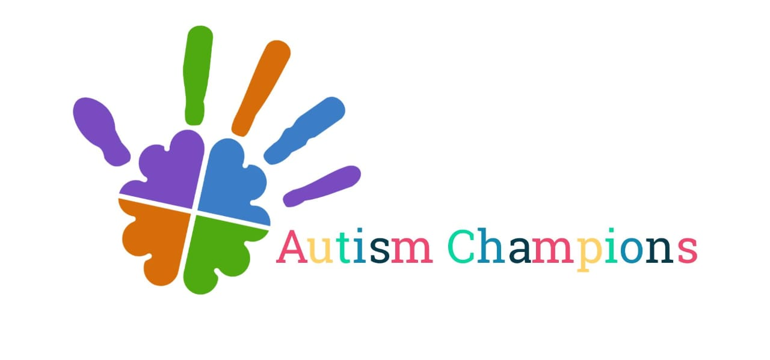

Mohamed Ahmed Osman **ID:2101204**

Shahd Ashraf Ramadan **ID:2101609**

Mariam Mohamed Rajab **ID:2101006**

Safy Hussien Moawad **ID:2101947**

Mariam Omar Hussein **ID:2102078**

Hams Khateeb Mousa **ID:2100762**

Mennatallah Soliman Mohamed **ID:2101087**

**Supervised by:**

Dr: Mohamed Abdel Latif Abdel Aal Zidan

TA: Toka Ashraf

[Fayoum]-2025

Pg.1 2024-2025

# Abstract:

The website "Autism Champions: Committed to Autism Detection and Early Intervention" is a thesis project to identify early signs of autism in children aged 2 to 8, combining the latest deep learning solutions through the use of the Xception model.

The purpose of the project is to the early diagnosis of autism to guide families toward medical intervention and support providing the first line of defense against the condition. The in-depth system provides functions that families and medical practitioners may use to manage autism formidably.

The main thing that gives the Autism Champions website its depth is the deep learning model, which is the central autism detection tool.

Through the analysis of photographs, the model detects early signs of autism, allowing doctors to start necessary treatment earlier.

This early detection method along with a set of tools primarily aimed at improving communication and providing support to families are also included to the system.

The major aspects of the platform are the chat with an artificial therapist with the chatbot, parents are directed to appropriate autism-related information

The platform includes a feature to allow patients to schedule an appointment online, thereby, to alleviate the congestion that comes along with in-person visits at the hospital.

Moreover, the website additionally includes an array of articles and movies which are intended for the purpose of that raising awareness and giving advice on favorable means of supporting children with autism, leading to an educated and compassionate community.

This project is an effective tool for both early diagnosis and ongoing therapeutic assistance, and at the same time, it is focused on reducing the social and psychological safety of autistic children, for instance, bullying and isolation.

Through bringing together the latest technology along with social activism, Autism Champions are ready to become a real game changer in improving the quality of life for autistic children and their families.

Pg.2 2024-2025

# Acknowledgement:

We are pleased to treat our incompleteness to the tutor and researcher Mohamed Abdel Latif Abdel Aal Zidan. We are grateful for your academic, advice, and critical feedback that you have been providing us through the project. His knowledge, commitment, and love for the topic have changed our views and bettered our piece.

We would also like to show our deep appreciation to our technical assistant, Toka Ashraf, who has helped us greatly and has been instrumental in the successful completion of this project. Toka's dedication to deliver high-quality work and her willingness to impart her expertise have been our main source of power.

Furthermore, we would also like to

acknowledge the whole team for their coordinated efforts, steady dedication and

harsh work. Each member has brought in something unique and contributed from

their own perspective which made the project a success.

At last, we are grateful to all the people who have uplifted us during this academic experience. Friends, family, and fellow students have indeed been our cheerleaders. Your patience and empathy are the main reasons' we keep on going.

The honor goes to all of you in bringing this project to life. Your help has been lest to our project being a success, and our appreciation has been immense.

Sincerely,

Autism Champions Team

Pg.3 2024-2025

Contents

Abstract: 2

Acknowledgement: 3

CHAPTER ONE “INTRODUCTION” 9

Introduction: 9

Background and motivation: 9

Importance of problem: 10

Problem Statement and Justification for why this problem is worth solving: 11

Autism Champions Platform Solution: 15

Benefits: 17

Purpose: 18

Scope: 20

General Constraints: 22

Stakeholder Engagement: 24

Chapter Two“RELATED SYSTEMS” 25

Introduction: 26

Existing Systems 26

Overall Problems of Existing Systems: 26

Gaps in Current Solutions 27

Overall Solution Approach: 27

Chapter Three“Planning and analysis” 28

Autism Champions Platform Scenario: 29

Approach Used to Solve the Problem 30

User Stories: 31

Methodology 40

System Requirements: 43

Domain Requirements: 44

Functional Requirements: 45

Non Functional Requirements: 46

Chapter Four“Software Design” 47

Use Case Diagram: 48

Sequence Diagram: 50

ER Diagram: 53

Entities and their Attributes: 54

System Design and Architecture: 56

Architecture 56

Components and Services: 56

Chapter Five 58

“Implementation” 58

Website Design 59

Challenges in Website Development 60

• How the Booking System Works 60

Front-End Samples: 62

Technology Used: 78

Frontend: 78

Backend: 79

Testing: 80

Front-End Workflow Overview: 81

Backend Workflow Overview: 81

Testing Workflow Overview: 82

Chapter Six“Dataset” 83

Dataset Overview 84

Introduction 84

• Purpose: 84

• Objective: 84

Dataset Description 84

• Source 84

• Composition: 84

Data Fields and Attributes 84

Field Names and Types: 84

Description: 84

Data Collection and Preprocessing 85

• Collection Methods: 85

• Data Cleaning: 85

• Preprocessing Techniques: 85

Data Exploration and Visualization 85

Data Splitting 85

Handling Imbalances 86

Challenges and Solutions 86

Conclusion 86

Sample of Data 87

Autism Dataset for train 87

Non Autism for train 87

Reference of dataset 87

Chapter Seven“Model Training and Testing” 88

Model Training (Xception Model for Autism Detection) 89

Training Algorithm: 89

Loss Function: 89

Evaluation Metric: 89

About the Model and Algorithm: 90

1.Xception Model (Extreme Inception) 90

2.Transfer Learning Approach 90

3.Adam Optimizer 91

Libraries Utilized 92

TensorFlow / Keras 92

TensorFlow.keras.applications.Xception 92

TensorFlow.keras.layers 92

TensorFlow.keras.models.Model 92

TensorFlow.keras.optimizers.Adam 92

TensorFlow.keras.callbacks.EarlyStopping 92

NumPy 93

Matplotlib 93

scikit-learn (sklearn) 93

Sample of Code and training: 97

Overall Accuracy 101

Chapter Eight“Testing” 102

Introduction 103

Testing Objectives 103

Testing Methodologies 103

Sample of Test Cases 104

Test Cases for Login 104

Test Cases for Registration 106

*1.* Valid Registration 106

2. Registration with Existing Email 106

3. Registration with Invalid Email 107

Test Cases for PasswordReset 108

Test Cases for UpdateController 112

Summary of Test Cases for UpdateController: 118

Chapter Nine“ Results and Discussion” 119

“Results and Discussion” 120

# CHAPTER ONE “INTRODUCTION”

Pg.8 2024-2025

## Introduction:

In the need of the hour, the "Autism Champions " page is introduced as a breakthrough the project of graduation, which is particularly designed for the prompt detection and support of autistic children.

This program is based on the use of artificial intelligence, focusing more precisely on the Xception deep head-to-head learning model which is trained at recognizing autism in children aged between 2 and 8. The idea is to diagnose autism in children before the symptoms start.

Autism Champions plans to provide the early diagnosis that enables the affected persons to be subjected to the necessary medical interventions in time and to have the educational resources that enable the families to become more informed and thus supportive.

**Background and motivation for the project:**

**AI-Driven Early Detection:**

Early Detection: main aspect of Autism Champions is its AI-driven detection system, which is based on the Xception model and is able to look through images of children and detect the first signs of autism at the earliest stage. This new tool is not only a diagnostic method but also a means for families who are ill-versed in these processes to grab necessary help from Doctors and Therapists.

Its user-friendly layout allows the tool to be conveniently operated online by the initiative users and professionals who are able to swiftly request and find such services.

**Supporting Families:**

Besides detecting, Autism Champions provides to the families the full compendium of services to aid them in their journey. There is a standalone system that is powered by chatbot technology to impart information about autism and a web-based booking system for appointment scheduling which reduces the hassle of paper works. The tool is set to reclaim the unnecessary time that each. These tools are designed to save time, reduce anxiety, and ensure that families have the support they need at every stage**.**

**Strategic Benefits:**

With the early detection, personalized support and access to knowledge that these champions will provide – Autism Champions has a potential of having great positive effect on both autistic children & their families. The platform aims to decrease stigmatization on the societal level by promoting awareness and intervention services for children so that they can become stronger with their parents, preparing communities because of it as a natural part of society's diversity. Consequently, Autism Champions not only enhances health outcomes but also helps to develop a more inclusive culture in society.

In the next parts, we will go through Autism Champions in detail technologically speaking including how it is to be utilized tactics and its core features as well on a grander scale — broader impact that this field of Autistic Champion community should contribute on.

Pg.9 2024-2025

**Importance of the Problem Being Addressed**

1. **Early Detection of Autism is Crucial**

Autism Spectrum Disorder touches the way a child communicates, behaves, and connects with others. Snagging a diagnosis while the child is still quite young opens the door to tailored therapies, special education, and focused healthcare.

* Waiting too long can close developmental windows and leave the child lagging socially and academically for years.
* Research keeps showing that prompt intervention gives language, thinking, and relationship skills a noticeable boost.

1. **Shortage of Specialized Resources**
   * Across countless neighborhoods, the handful of autism specialists are already booked months ahead, and the few intake slots vanish almost overnight.
   * In some far-flung counties the line for a simple developmental check stretches so long that young kids wait years instead of weeks.
   * A simple web-based screener, quick to use on a tablet and easy to read, could flag the children who genuinely need an in-person diagnosis and shift the bottleneck closer to the front door.
2. **Supporting Families Through Awareness and Communication**

You know, it can be really tough for parents and caregivers to find trustworthy information about autism symptoms and, more importantly, how to get help. It’s like navigating a maze sometimes

That’s why it’s super important to offer straightforward resources and educational materials that folks can actually understand. When families have access to this kind of support, it really helps ease a lot of that anxiety and confusion. Honestly, nobody wants to feel lost in these situations.  
  
And let’s not forget about communication! Having secure ways for parents to talk to doctors can make a world of difference. It helps close that gap in care, making support feel more personal and timely. After all, every family deserves the right kind of guidance when they need it most.

1. **Societal Impact**

Autism isn’t just a personal challenge; it reaches into families, schools, healthcare, and even the community as a whole. It’s a big deal, you know?  
  
When we raise awareness and push for early acceptance, it really helps cut down on stigma and bullying. That’s a win for social inclusion, for sure.  
  
Plus, if we invest in early detection and support systems, we can actually save money in the long run—think lower healthcare and educational costs. It really is a smart move for public health, don’t you think?

Pg.10 2024-2025

## Problem Statement and Justification for why this problem is worth solving:

**Managing Factors of Complexities in Autism Champions Services**  
It takes a lot of efforts to support children with autism entails as there are a number of crucial difficulties which have to be overcome to provide children with the opportunities for early diagnostics and early intervention as well as necessary education and assistance. These challenges span across several critical areas:

**Early Detection Barriers:**  
**Challenge:** One of the challenges therefore would be how best to diagnose the disease especially in its early stages. This often means that a child is not diagnosed on time, and therefore the onset of developmental problems cannot be addressed timely. That is why the requirements for more efficient and available screening instruments are only so high.

**Limited Resources for Families and Caregivers:**  
**Challenge:** It is so difficult for parenting and caregivers to find a right kind of supports and information to meet the needs of an autistic person. If a child is not provided enough direction and specific services and assistance, the normal process of his or her development is threatened. These gaps must be filled to enhance the preparedness of families

**Medical and Educational Accessibility:**  
**Challenge:***:* Children with autism and their families frequently encounter barriers to accessing relevant medical and educational services. These barriers can result in limited engagement with critical interventions and hinder the child’s progress.

**Technology Integration in Autism Care:**  
**Challenge:***:* While advanced technology such as AI holds great promise in Autism Champions , implementing these solutions in ways that are accessible and affordable remains a challenge. Many organizations face limitations in adopting such innovations effectively.

**Social and Emotional Support for Families and Caregivers:**  
**Challenge:** Families and caregivers of children with autism often experience social isolation and emotional stress, making it essential to provide mental health support and community connections that help them navigate their journey.

**Generalized Support and Resources:**

**Challenge** :The challenge lies in providing comprehensive, generalized resources that are still highly effective in supporting the varying needs of autistic children and their families.

Pg.11 2024-2025

**Objectives**

**Main Objective**

To develop a web-based platform that facilitates the **early detection of autism in children aged 2–8 years** using artificial intelligence, while also providing **medical support services**, **educational resources**, and **secure communication** between families and healthcare professionals.

**Specific Objectives**

1. **Design and Train an AI Model for Autism Detection**

* Implement deep learning through Xception architecture to analyze children's facial images for identifying autistic and non-autistic conditions.
* Obtain high accuracy, precision and recall scores from testing on new data that has not been previously seen.

1. **Develop an Interactive Chatbot**

* Build a chatbot that uses autism-related intent training to provide answers to general questions and assist users with their needs.
* Add screening functions that use M-CHAT-R evaluation criteria.

1. **Create a secure doctor-patient chat system which maintains confidentiality and security of all messages.**

* Enable private family communication with doctors through a special chat_pass code.
* Make sure messages stay secure and confidential through an anonymous system which avoids using phone numbers for identification.

1. **Enable Online Appointment Booking**

* Parents should use an online calendar-based system to schedule consultations with specialists.
* Make sure the system prevents double booking by prohibiting the selection of already reserved time slots.

1. **Provide Educational Content**

* Distribute videos together with articles and tips which focus on autism education and beginning therapy methods.
* Parents will get assistance through content that explains typical development progression together with typical obstacles.

Pg.12 2024-2025

1. **Support User Management and Role Differentiation**

* The system needs to develop different functional capabilities for medical personnel and family users.
* The system needs to implement role-based capabilities that let users perform different actions including message responses and booking approvals.

1. **Ensure Usability and Accessibility**

* The interface needs to be designed as an easy-to-use responsive platform which works well with different digital skill levels of users.
* Implement contemporary UI/UX design principles to enhance user satisfaction alongside improved engagement levels.

**Summary of Objectives**

The project creates a web-based system that identifies children between ages 2 to 8 who show signs of autism through an AI-based model while providing medical services and educational materials and secure communication between families and doctors.

**This project aims to accomplish several specific targets:**

* The project aims to develop an advanced deep learning system that detects autism.
* The project will integrate an AI-powered chatbot which serves both user support functions and autism screening operations.
* The project will create a secure communication system for doctors to interact with their patients through chat. Through the platform users will be able to schedule appointments which include time-based restrictions.
* The platform will supply educational content in the form of articles and videos together with practical advice to increase autism awareness.
* The system will protect session information and handle multiple user categories with security measures. The system provides an interface which is simple and accessible for all users.
* All system components will undergo testing through PHPUnit and Postman.
* The project works to decrease social exclusion and stigma by spreading awareness among the community.

Pg.13 2024-2025

## Autism Champions Platform Solution:

**Innovations Brave New World For Autism Care & Support**

**Early Detection Solutions:**

* **AI-Powered Screening Tools:**  
  innovative use of artificial intelligence to design cost-effective and accurate diagnostic tools that allow families to consider initialization of autism in children as young as two years old. This early detection will enable appropriate early interferences, hence better developmental results.
* **User-Friendly Online Assessment:**  
  Design a user friendly web based questionnaire that can easily be filled by parents, caregivers and GPs so as to reduce the barrier of early screening.

**Limited Resources for Families and Caregivers:**

* **Centralized Information Hub:**  
  Develop an effective website that can give families accurate information on the disorder as well as treatment, education and support within their area.
* **Personalized Resource Recommendations:**  
  Enact integrated sets of AI solutions that inform children about choices of therapies and interventions and indicate the available services within regions of interest

**Medical and Educational Accessibility:**

* **Telehealth and Virtual Consultations:**  
  Permit telehealth opportunities and make available allow the patient and the kids’ to have online appointments with doctors, therapists, and educators regardless of geographical location.
* **Online Booking System:**  
  Establish a simple online booking that enables the parent to book appointments for consultations or therapy without crowding the sites that offer essential services.

**Technology Integration for Autism Care:**

* **AI-Driven Chatbot for Autism Champions :**  
  Addition to that, AI can help to develop an enhanced chatbot, to discuss specific details about autism and guide families whenever they need it.

Pg.14 2024-2025

**Social and Emotional Support for Families and Caregivers**:

* Leverage the experiences of families who have successfully navigated similar challenges to offer reassurance and emotional support

. **Generalized Support and Resources:**

* **Provide Comprehensive Educational Resources:** Provide links to articles and videos and external assistance that address the variety of developmental needs that parents may have in order to be able to support their child.
* **Promote Inclusive Support Strategies:** This article is to provide basic principles of helping children with autism, including key developmental issues in autistic children and possible problem areas, making it easy for autistic children and their families to find relevant information.
* **Facilitate Expert Consultations:** Make sure that families can get to the doctors or a specialist who will be able to answer specific questions during a consultation and to solve certain unpretentious issues that may require special approaches and individual plans, which are not needed to be created with the help of the platform.

Pg.15 2024-2025

## Benefits:

The advantages offered by Autism Champions are not only compelling but also transformative, paving the way for a significant shift in how autism is detected and managed in children.

**Early Detection and Intervention:**

The main advantage of using the site is that it helps early detect autism in children through an AI based on deep learning model (Xception). This helps families to get the condition detected earlier so they can take immediate steps, for instance getting medical and therapeutic help that may improve their child's development and quality of life greatly. Not only that, but early intervention is vital to ensure better long-term survival outcomes and Autism Champions puts this life line directly in the hands of families.

**Continuous Access to Support:**

Autism Champions provides a chatbot to help families get support from their homes. This chatbot provides accurate and timely answers to autism related questions, helping families when they need help the most. It allows patient families to communicate real-time with their physicians.

**Cost and Time Efficiency:**

Through its online booking system, Autism Champions eliminates the need for time-consuming, in-person scheduling. Families can easily book appointments with healthcare professionals, reducing waiting times and minimizing the stress associated with traditional appointment methods. This streamlined approach saves both time and resources, allowing families to focus on their child’s well-being instead of administrative hurdles.

**Raises Awareness And Social Support :**

Autism Champions offers articles, videos and advice for coping with autism and is therefore an important building block for change to raise awareness about this condition. The website creates a conducive and supportive atmosphere for autistic kids that helps mitigate psychological burdens induced from societal constructs like social stigmas, bullying as well as isolation. Families learn to be better.

In essence, Autism Champions is so much more than a mere diagnosis tool — it's an integral transformative platform executed to change the lives of autistics children and their families. By pairing an array of useful tools with a modern easy-to-use design, it liberates those who use to own their healing and alleviating the support burden over time for real results. Later in this article, we will delve into some powerful mechanisms that lead to these impacts.

Pg.16 2024-2025

## Purpose:

About Autism Champions Our overarching mission is to change the game in early diagnosis and longitudinal support for children at-risk of autism, through a unique tool that merges early detection with long-term care. Focused on serving a higher calling by helping to solve some of the most common challenges faced by families and care providers, whilst promoting autism awareness & understanding through our strategic objectives.

**Transformational Vision:**

* **Purpose:** Rethink the way autism detection and assistance has been practiced traditionally.
* **Why:** Developing an adaptive but overarching vision of a solution for families and healthcare professionals to detect autism spectrum disorder earlier, more effectively support children with their care needs.

**AI-Powered Innovation:**

* **Purpose:** Leverage the Xception model for early autism detection.
* **Why:** To utilize cutting-edge deep learning technology, providing families with a reliable and advanced tool for early autism detection without requiring complex setups, ensuring accessibility and accuracy, so targeted intervention can be started as soon as possible

**Strategic Value Demonstration:**

* **Purpose:** Provide value to families and health systems.
* **Why:** Improve the process of autism detection, Communication between families and doctors’ offices, Scheduling appointments Fastly follow-up care more aggressively to improve care outcomes.

**Awareness and Education Excellence:**

* **Purpose:** To further understanding of autism with clear and accessible information..
* **Why:** To enable families and society to understand (and one day become the best parents) of children with Autism, reduce social stigma(s) among others.

**Round-the-Clock Support:**

* **Purpose:** To provide ongoing, consistent assistance to families..
* **Why:** We want to make sure that families are able to find information about autism and get help, for reassurance or when needed support while busy doctors focus on the more complex cases.

Pg.17 2024-2025

**Cost-Efficiency Through Automation:**

* **Purpose**: Optimize support costs for families and healthcare providers.
* **Why:** Automation of process such as appointment booking and follow up required a lot of time & money.

**Improve User Satisfaction:**

* **Purpose:** ensure higher user satisfaction and foster greater trust in the platform**.**
* **Why:** To facilitate good experiences for both families and clinicians with speedy accurate responses, trust in the services Autism Champions provides, and ensure full support along their journey.

**Exploration of Video-Based Educational Tools:**

* **Purpose:** Explore innovative ways to provide educational content.
* **Why:** To consider utilizing video content to offer parents and caregivers detailed information on autism management, supporting both education and emotional well-being through visual and interactive resources.

Pg.18 2024-2025

## Scope:

The Autism Champions' scope is very wide, with the idea of conversion of how families providers recognize autism and provide assistance to autistic children. It carries along several tools created for the resolution of major problems that disturb families as well as the general public's lack of awareness and unjust criticism of people with autism. the understanding of families is improved:

**Early Autism Detection:**

* **Scope:** Enhancing early detection of autism in children aged 2 to 8.
* **Details:** The website's main functionality focuses on using the Xception deep learning model to help detect autism early, allowing for timely intervention and support.

**Information Dissemination:**

* **Scope:** Providing clear, accessible resources about autism.
* **Details:** Autism Champions serves as a central hub where families and caregivers can access articles and videos that raise awareness and increase understanding of autism, ensuring an informed user experience.

**Empowerment Tools:**

* **Scope:** Offering tools beyond autism detection.
* **Details:** Autism Champions expands its scope by providing families with practical tips on supporting autistic children and fostering a community where they can engage with healthcare professionals via the chat app.

**Strategic Benefits Realization:**

* **Scope:** Achieving long-term benefits for families and autistic children.
* **Details:** The scope includes reducing the psychological challenges autistic children face, such as bullying, by promoting societal acceptance and encouraging natural interactions.

**Communication Quality:**

* **Scope:** Ensuring seamless communication between families and healthcare providers.
* **Details:** Autism Champions offers a chat app that allows for private communication, without the need for phone numbers, to ensure secure and continuous follow-up care.

Pg.19 2024-2025

**Continuous Support:**

* **Scope:** Providing 24/7 access to information.
* **Details:** While the chat app facilitates communication during scheduled follow-ups, the website offers continuous access to resources and booking services, ensuring families can receive assistance at any time.

**Cost Optimization:**

* **Scope:** Optimizing operational efficiency for families and healthcare providers.
* **Details:** The scope includes reducing the need for in-person consultations by offering online services, such as booking appointments, accessing resources, and utilizing the chatbot for general autism-related inquiries. This minimizes the burden on medical staff, leading to significant cost and time savings for both families and healthcare providers.

**User Satisfaction Enhancement:**

* **Scope:** Enhancing user satisfaction and trust.
* **Details:** The scope involves providing a streamlined interface where families can easily access information, book appointments, and communicate with doctors, fostering a positive user experience. The focus is on building trust and reliability in the medical and support services offered by Autism Champions .

**Support Tools Improvement:**

* **Scope:** Improving tools for continuous support and care.
* **Details:** The scope includes developing more advanced tools within the platform, such as the chatbot, to provide families with real-time information about autism care. These tools are designed to create a seamless and responsive support experience, reducing waiting times for assistance and enhancing user satisfaction.

**Exploration of AI Models for Autism Detection:**

* **Scope:** Exploring innovative AI models for early autism detection.
* **Details:** The scope includes evaluating and refining AI models like the Xception architecture to improve the accuracy and reliability of autism detection through image analysis, ensuring the best outcomes for early diagnosis.

Pg.20 2024-2025

## General Constraints:

While Autism Champions offers a transformative approach to early autism detection and support for families, certain constraints and limitations must be acknowledged. Understanding these constraints is key to managing expectations and ensuring the platform's success.

**Technological Limitations:**

* **Constraint:** Implementing advanced AI models for autism detection requires significant technical expertise.
* **Mitigation:** Families and doctors may encounter challenges in managing or understanding the AI results, so offering clear guidelines and support will be necessary to simplify their experience.

**Resource Constraints:**

* **Constraint:** The platform may face limitations in terms of healthcare providers' availability and the resources needed to maintain continuous services.
* **Mitigation:** Prioritizing key services such as early autism detection and online booking, while gradually expanding resources, will help manage constraints.

**Dependency on External Resources:**

* **Constraint:** Certain features, such as retrieving up-to-date medical articles or integrating external autism resources, rely on external systems and their availability.
* **Mitigation:** Regular updates and continuous monitoring of external sources will ensure information reliability and smooth integration.

**AI Learning Curve:**

* **Constraint:** Users, especially families, might find it challenging to adapt to interacting with AI tools for autism detection or booking medical appointments.
* **Mitigation:** Offering user-friendly tutorials, guided interfaces, and clear documentation can reduce the learning curve and help users engage with the platform effectively.

**Cost Implications:**

* **Constraint:** While the platform aims to reduce healthcare-related costs, the initial setup of AI models and maintaining medical services might pose financial challenges for healthcare providers.
* **Mitigation:** Careful financial planning and leveraging cost-effective technologies will help overcome this barrier, while the long-term benefits of early autism detection can justify the initial investment.

Pg.21 2024-2025

**User Data Security Concerns:**

* **Constraint:** Handling sensitive medical data requires strict compliance with privacy regulations and standards.
* **Mitigation:** The platform will implement robust data encryption and strict compliance with healthcare privacy laws (such as HIPAA), ensuring transparent communication on how user data is handled.

**Integration Challenges:**

* **Constraint:** Integrating the Autism Champions platform with existing healthcare systems, patient databases, and online booking tools may present technical challenges.
* **Mitigation:** A thorough system analysis, close collaboration with IT specialists, and a phased integration plan will help minimize disruption and ensure seamless connections between different systems.

**Chatbot Limitations:**

* **Constraint:** The effectiveness of the chatbot in answering queries depends on the quality and range of available autism-related resources and FAQs.
* **Mitigation:** Regularly updating and expanding the chatbot's knowledge base with up-to-date medical articles, family support guides, and frequently asked questions will enhance its functionality and relevance.

**Continuous Maintenance:**

* **Constraint:** Ongoing maintenance, including updates to the AI model and system, is essential for the platform's performance, which can be resource-intensive.
* **Mitigation:** Implementing automated maintenance processes, regular system performance assessments, and routine updates will help keep the platform running efficiently without overwhelming resources.

Pg.22 2024-2025

## Stakeholder Engagement:

Understanding the needs and expectations of various stakeholders is crucial for the success of the Autism Champions platform. By carefully addressing their diverse perspectives, the platform can create meaningful value for everyone involved, fostering a positive and supportive environment for families, doctors, and caregivers.

**Types of Stakeholders:**

* **Children with Autism:** The platform is designed with their needs in mind, aiming to offer early detection, access to supportive therapies, and educational materials tailored to their specific challenges. The better the platform serves their caregivers and doctors, the more beneficial it will be for their overall development and quality of life.
* **Families of Autistic Children:** Benefit from early detection tools, educational resources, and accessible communication with healthcare providers. The platform helps them understand autism and access appropriate support services.
* **Healthcare Providers (Doctors, Therapists):** Use the platform to offer personalized advice, track patient progress, and provide consultations through the chat app. The online booking system helps reduce congestion and improve the efficiency of patient care.
* **Platform Development Team:** Responsible for building and maintaining the Autism Champions ers platform, ensuring the deep learning models for autism detection, chatbot functionality, and user experience are up to date and effective.

Pg.23 2024-2025

# Chapter Two

# “RELATED SYSTEMS”

Pg.24 2024-2025

## Introduction:

This chapter will look at some available technologies for diagnosing and handling Autism explaining the features of their effectiveness. Drawing from experiences in early diagnosis, medical care, and social reintegration, this paper seeks to develop Autism Champions, an application that will foster the gaps noted above.

Existing Systems**:**

Autism-related services are currently supported by several systems available in the market today. Here, are a few types of existing system:

**Autism Diagnostic Tools and Apps**: It is possible to take several tests and use many apps and online platforms to screen children for autism. Such tools include the Modified Checklist for Autism in Toddlers (M-CHAT) and the Autism Spectrum Quotient (AQ) test that are basic screening tools, although these tools may present the essential dataset for early diagnosis from a behavioral perspective.

* **M-CHAT-R (Modified Checklist for Autism in Toddlers, Revised):** A widely used screening tool for children aged 16-30 months. It consists of a questionnaire for parents.
* **STAT (Screening Tool for Autism in Toddlers and Young Children):** An interactive screening tool that assesses a child's social communication skills through play-based activities.
* **ASQ (Ages and Stages Questionnaire):** A general developmental screening tool that can identify delays in various areas, including communication and social skills.

**Educational Websites and Forums**: Several websites and online communities provide articles, guides, and discussion forums for parents and caregivers of autistic children. However, the content is often generalized, and the platforms typically do not offer integrated medical services or tools for individualized detection.

## Overall Problems of Existing Systems:

While the existing systems provide valuable resources, they are often limited by several key challenges:

**Limited Early Detection Capabilities**: Most of the systems use simple forms of questionnaires or the parents’ assessment of behaviors, which can keep the diagnosis of autism for a long time. Other existing models must also seek to identify autism spectrum disorders at an early age that a child must be prevented from developing other conditions through delayed diagnosis.

**Fragmented Services**: Present systems generally provide a selection of functionalities, which can be specific services, like screening tools or informative material. Some of these do not correlate diagnostic tools with follow- up medical consultations, caregiver support or awareness creation and users have to transfer between different systems.

**Inadequate Social Support:** While some platforms provide educational materials, they often fail to adequately raise societal awareness about autism or offer tools to reduce stigma and bullying of autistic children.

**Reliance on Human Observation**: Most tools currently used for autism detection rely heavily on human observation, such as parental or clinician assessments. This can lead to errors or inconsistencies, as interpretations of behaviors can vary from person to person, potentially resulting in delayed or incorrect diagnoses.

Pg.25 2024-2025

## Gaps in Current Solutions

## Existing AI tools which identify autism remain experimental and fail to operate within practical platforms used by end users.

## The available platforms fail to bring together autism diagnosis tools and expert communication functions and educational materials all within a single unified platform.

## The current solutions do not focus on children between ages 2 and 8 despite this period being crucial for early intervention.

## Most chatbots which serve users today do not provide autism-specific features including M-CHAT-R assessment tools.

## The current lack of secure anonymous communication channels between doctors and families creates privacy risks and increases social stigma.

## Overall Solution Approach:

Despite the current systems’ various drawbacks, Autism Champions seeks to offer a holistic multi-touch system that focuses especially on differentiation, early detection, accessibility, and social inclusion include:

**AI-Powered Early Detection**: Because of the deep learning applied in the Xception model, Autism Champions will contribute towards early diagnosis of children with autism as young as two years and therefore enhance the prospects of correct interventions to ensure the children get better developmental results

**Integration of Medical Services:** Early detection will be paired with easy connection to the healthcare providers on the platform. Families can set appointments for meetings, review the plan of actions and discuss any concerns and ideas with the doctors on a constant basis through a safe messaging application which keeps the treatment process integrated.

**Accessible and Affordable**: Autism Champions will hence endeavor to offer fairly priced services with the inclusion of advance booking in addition to telephone and online consultation options. This reduces the physical consulting required thus lowering the expenses and making the opportunity available for clients with many children in remote or regions with little resource.

**Societal Awareness and Education:** These will include articles and videos that are to enlighten the society on autism with the aim of having people interact with autistic children naturally without discrimination. In this regard, this effort aims at providing safe space for children with autism, and no bullying or social pressure.

Overall, presently available systems for autism support have various problems: The services are disintegrated; the number of instruments for the early diagnosis is also limited; and, finally, there is a problem with individual, affordable and effective support. Autism Champions aims to cover the whole rubric of the autism problem as a disease: its early diagnostics, medical treatment, and social acceptance by the society. Eliminating these challenges thus befits the platform to improve the quality of care for the autistic children and families thus improving their developmental and inclusion outcomes.

Pg.26 2024-2025

# Chapter Three

# “Planning and analysis”

Pg.27 2024-2025

## Autism Champions Platform Scenario:

Think of radical concept of an online social network that will help families, caregivers and physicians in management of autism. The Autism Champions platform is designed with unmatched precision to offer a means of early intervention tools, education, and support services that are relatively easy to access and more importantly, personalized to suit the users’ needs.

At the heart of this platform are two critical components: the self-diagnostic noninvasive platform based on artificial intelligence for autism detection and the family support platform that provides families with physicians. Currently, the platform uses an AI detection tool incorporating the best algorithms to detect images and behaviors of children of the age 2-8 for the detection of autism. It also provides family critical information and lets them start to make change efforts at an early time.

The interactive support portal is a rescue for families and caregivers, with best-of-the-best articles, videos, and other tools including guides and tutorials. For example, parents can get details concerning autism as a condition, developmental milestones that should be achieved, and other usual difficulties. Although it does not make an intervention plan unique to a particular child, it provides families with exceptional service by providing a myriad of generalized materials concerning different levels of autism care.

On the professional side fill in the role of advisors and give professional advice. An appointments schedule allows families to make appointments with doctors, and instead of waiting for a long time they can get help immediately. Live conversation possibilities enable concise caregivers/specialists interaction, catering immediate answers to emergent questions/entries.

By providing both technology that helps in early identification to general support, the Autism Champions platform enables families, eliminates gaps in medical care, and cultivates a supportive community for children with autism. It then leaves it as a holistic, progressive intervention approach to difficulties experienced by families in Autism care.

Pg.28 2024-2025

## Approach Used to Solve the Problem

The project implements multiple strategies along with integration to detect autism at an early stage and provide support to children between 2 and 8 years of age. Deep learning together with natural language processing and secured communication systems form the foundation of this solution approach. The method contains the following essential components:

**1. Deep Learning for Autism Detection**

* Model Architecture: The system adopts an Xception-based CNN architecture which performs image classification tasks.
* Input Data: The system receives colored 2D child face images which include autistic and non-autistic samples from 2 to 8 years old.
* Output: The system analyzes facial features to determine whether a child demonstrates autism.

**2. Natural Language Processing Chatbot**

* Purpose: The application delivers a question-answer system which lets people inquire about autism through a user-friendly interface.
* Technology: The system employs tokenization and lemmatization together with intent classification based on fixed intents and responses.
* Integration: The system features M-CHAT-R (Modified Checklist for Autism in Toddlers, Revised) symptom screening capabilities.

**3. Secure Doctor-Family Communication**

* Chat System: Through a secure anonymous chat interface the system enables parents to talk with doctors directly.
* Access Control: The system uses role-based credential identification to protect both doctor and user identities while maintaining professional standards.
* No Phone Number Required: The system provides families with an easy way to contact professional assistance through discreet channels.

**4. Online Booking and Scheduling**

* Booking System: Parents use the system to choose doctor appointments during screening times which are available.
* Real-Time Availability: The system makes sure that once a time slot becomes taken it turns unavailable for other users to prevent scheduling problems.

**5. Educational Resources**

* Awareness Content: The system delivers educational videos and articles together with helpful tips that help parents understand autism better while providing support.
* Expert Advice: The platform delivers professional advice which provides parents with trustworthy support during their child's developmental early stages.

## User Stories:

|  |  |
| --- | --- |
| **Use case Number** | **01** |
| **Use case Name** | **User Registration** |
| **Overview** | User Sign up to the site |
| **Actor(s)** | One of the parents of the child |
| **Pre-condition(s)** | User connect to the internet |
| **Scenario flow** | 1.Open website  2.Click Sign up  3. Enter the full required information  4.display registration successfully |
| **Alternate flow** | 4a-if the user don’t enter all required information the website display error message go to step 3 |
| **Post Condition** | The system will display login page |

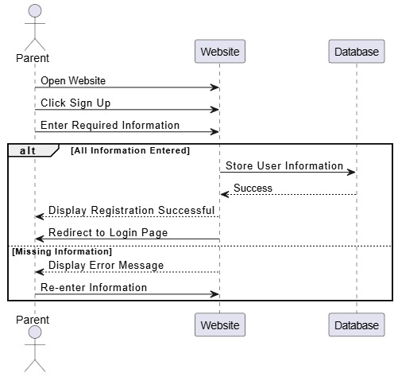

Pg.30 2024-2025

|  |  |
| --- | --- |
| **Use case Number** | **02** |
| **Use case Name** | **User Authentication** |
| **Overview** | User Login to the site |
| **Actor(s)** | One of the parents of the child |
| **Pre-condition(s)** | User connect to the internet and **Registered** |
| **Scenario flow** | 1.Open website  2.Click Login  3. Enter Email & password  4.display Login successfully |
| **Alternate flow** | 4a-if the Email or password not correct the website display error message go to step 3 |
| **Post Condition** | The system will display main page |

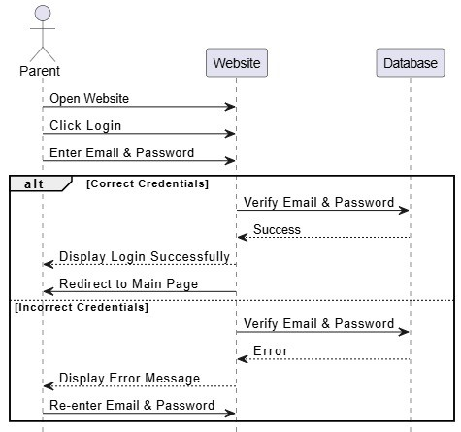

Pg.31 2024-2025

|  |  |
| --- | --- |
| **Use case Number** | **03** |
| **Use case Name** | **Chatbot Interaction** |
| **Overview** | Chatbot answers user questions regarding information about autism |
| **Actor(s)** | **User** (Parent or caregiver using the chatbot for autism-related information) |
| **Pre-condition(s)** | The user is connected to the internet |
| **Scenario flow** | 1. The user opens website’s chatbot  2. The user types a question into the chatbot interface.  3. The chatbot processes the question and checks if it is in a supported language and if the question can be answered based on its knowledge base  4. chatbot responds accordingly and the conversation continues |
| **Alternate flow** | **4a**: If the chatbot does not understand the question or the question is asked in an unsupported language, the chatbot replies: “Sorry, I do not understand your question." The user is then prompted to continue the conversation by asking another question and go to step 2 |
| **Post Condition** | The conversation continues until the user gets the required information or decides to exit the chatbot session and go to main page |

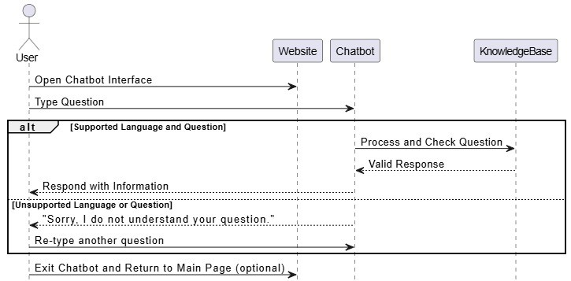

Pg.32 2024-2025

|  |  |
| --- | --- |
| **Use case Number** | **04** |
| **Use case Name** | **Watch Autism-Related Videos** |
| **Overview** | Access and watch autism-related videos provided on the Autism Champions platform. |
| **Actor(s)** | **User** (Parent or caregiver interested in watching videos related to autism awareness). |
| **Pre-condition(s)** | The user is connected to the internet |
| **Scenario flow** | 1. The user navigates to the "Videos" section of the Autism Champions platform. 2. The user browses through the list of available videos. 3. The user clicks on a video they want to watch. 4. The system streams the selected video and starts playback on the user's screen |
| **Alternate flow** | **4a**: If the video cannot be played due to network issues, unsupported video format, or other technical problems, the system displays an error message: "Sorry, we are unable to play this video at the moment. Please try again later or select another video." The user can then return to the video list to choose another video or retry later go to step 2 |
| **Post Condition** | The video plays successfully, and the user can watch it to completion and go "Videos" section. |

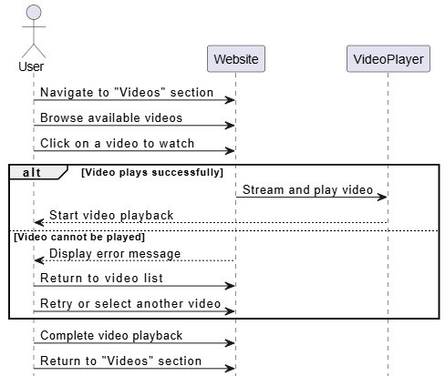

Pg.33 2024-2025

|  |  |
| --- | --- |
| **Use case Number** | **05** |
| **Use case Name** | **Read Autism-Related Articles** |
| **Overview** | User reads articles of autism on website |
| **Actor(s)** | One of the parents of the child |
| **Pre-condition(s)** | The user is connected to the internet. |
| **Scenario flow** | 1. The user navigates to the "Articles" section of the Autism Champions platform. 2. The user browses the list of available articles. 3. The user clicks on an article title to open and read it. 4. The system displays the full content of the selected article for the user to read. |
| **Alternate flow** | **4a**: If the article cannot be loaded due to network issues or other technical problems, the system displays an error message: "Sorry, we are unable to load this article at the moment. Please try again later or select another article." The user can then return to the article list to choose another article or retry later go to step2 |
| **Post Condition** | The article is displayed successfully, and the user can read it to completion. |

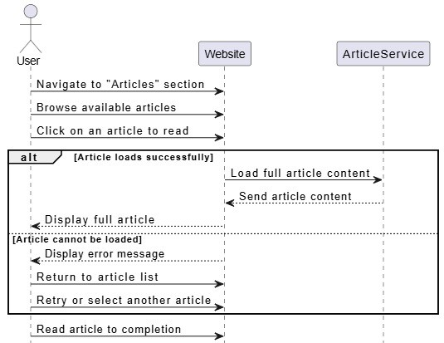

Pg.34 2024-2025

|  |  |
| --- | --- |
| **Use case Number** | **06** |
| **Use case Name** | **Booking form online** |
| **Overview** | The user books an appointment online for the examination at the doctor |
| **Actor(s)** | One of the parents of the child and Assistant Doctor |
| **Pre-condition(s)** | The user is logged in and connected to the internet. |
| **Scenario flow** | 1. The user selects a doctor. 2. The user opens the booking form on the website. 3. The user selects an available time slot. 4. The user enters the necessary information in the booking form. 5. The user submits the booking form. 6. The website sends a booking confirmation email to the user. |
| **Alternate flow** | **3a**: If the user enter Time already booked go to step 3  Technical Issue During Submission  User Cancels the Reservation |
| **Post Condition** | The booking is confirmed, and the user receives an email confirmation. |

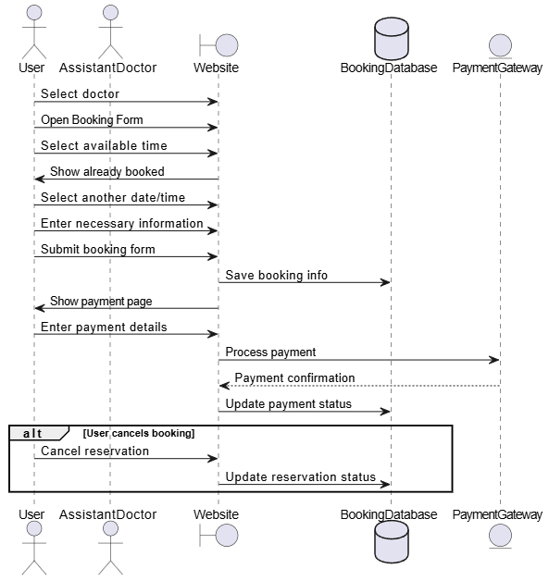

Pg.35 2024-2025

|  |  |
| --- | --- |
| **Use case Number** | **07** |
| **Use case Name** | **Detecting Autism** |
| **Overview** | The user uploads a picture of a child to determine if he has autism or not |
| **Actor(s)** | **User** (Parent or caregiver using the chatbot for autism-related information) |
| **Pre-condition(s)** | The user is connected to the internet and The child's age should be between 2 to 8 years The picture of the child must be in the normal state. |
| **Scenario flow** | 1. The user go to the "Detecting Autism" section of the Autism champions platform. 2. The system shows the message "The child must be 2 to 8 years old for autism detection to succeed" 3. the user enter the child's age 4. The system shows the place designated to upload the image 5. The user uploads the picture of the child. 6. The system verifies that the image is clear 7. The system makes sure that the picture of a person 8. The system submits the picture to the AI model for autism detection. 9. The AI model processes the image and returns a result:  * **Autism** * **Normal**  1. The system displays the result of the analysis to the user. |
| **Alternate flow** | **3a**: the system display error message” Autism detection directed children with 2 to 8 years to ensure the validity of the results” go to step 3  **5b**: If the photo cannot be upload due to network issues or other technical problems go to step5  **6c:** the system display message “The image is not valid: it is too blurry please enter good image” go to step 5  **7d**: the system display message"Please enter a picture of a person please enter good image” go to step5 |
| **Post Condition** | User can move to any section of website |

Pg.36 2024-2025

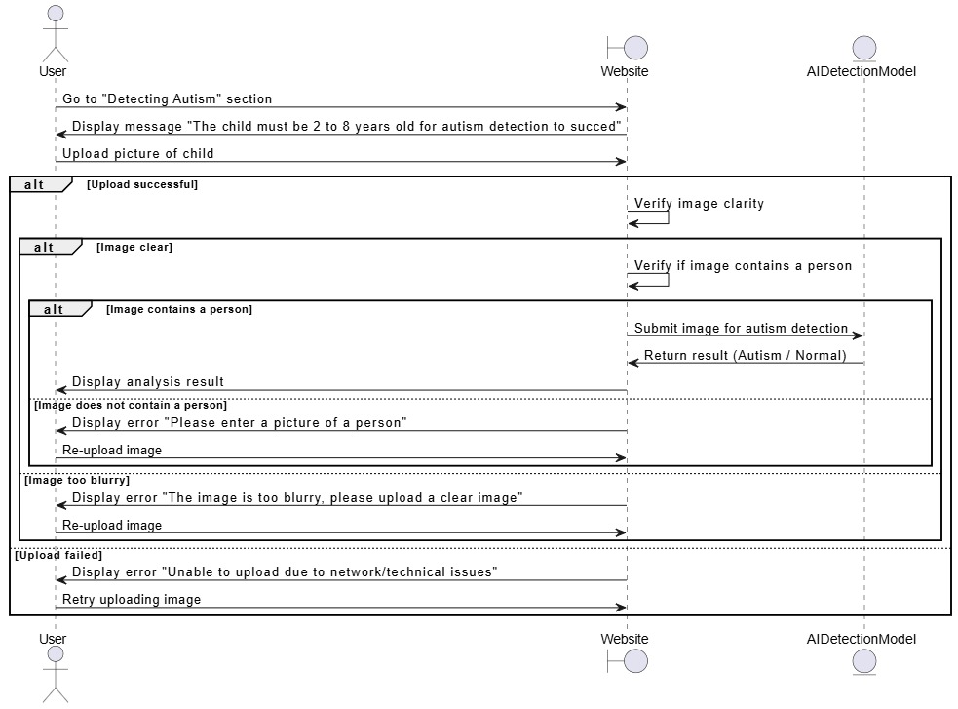

Pg.37 2024-2025

|  |  |
| --- | --- |
| **Use case Number** | **08** |
| **Use case Name** | **Follow up** |
| **Overview** | The user chat with doctor To continue after the examination |
| **Actor(s)** | **User** (Parent or caregiver using the chatbot for autism-related information) |
| **Pre-condition(s)** | The user is connected to the internet and Registered on website and He booked a doctor's appointment and did the examination with him already and received a pass chat |
| **Scenario flow** | 1. The user go to the "Chat App" section of the Autism champions platform. 2. The user selects a doctor Who was detected to start a chat 3. The system prompts the user to enter a password. 4. The user enters the doctor's hemorrhoid after receiving it from the doctor 5. The system checks the password with the database. 6. the system opens the chat window. 7. User send to doctor 8. The doctor responds to the user’s messages, allowing for a real-time conversation. |
| **Alternate flow** | **5a**: If the password is incorrect, the system displays an error message, “Incorrect password.” Go to step 4 |
| **Post Condition** | The user can continue the chat with the doctor if the password was correct, or leave the chat. |

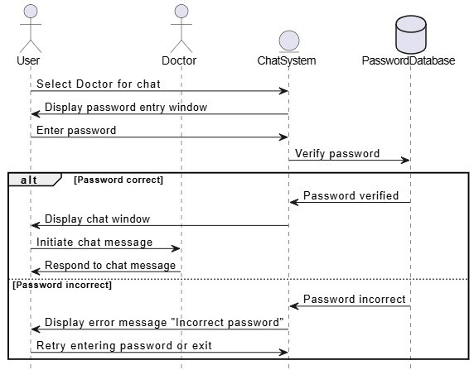

Pg.38 2024-2025

Methodology**:**

As an organizer of support for Autistic people, Autism Champions platform focuses on progressive approaches in the sphere of early diagnosis and aid provision. Adopting some principles from the modern agile frameworks, as well as from cooperation methodologies, the project adheres to the clearly defined structure which guarantees the success of the enlisted features. The developmental cycle combines problems, cycles, user feedback and robust technological principles that meet developmental goals required for project fulfillment.

***Discover***:

**Objective**: Determine a purpose of the project, who the project is intended for and what needs of those individuals should be fulfilled.

**Activities:**

* Interview stakeholders in order to determine the goals and purpose of the Autism Champions platform.
* Conduct analysis on user personas as the on the needs of parent, caregivers and medical practitioners.
* What are some outcome measures of a project, for instance, identification of early signs of autism, flexibility in doctor booking, and increasing the community’s awareness.

***Define:***

**Objective:** Identify precisely the scope of the platform, user stories and technical requirements of the platform.

**Activities:**

* Involve other stakeholders in deciding what features should be given attention such as the chatbot, chat app, the online booking, articles and the videos.
* See user stories – tips, for example “When I am a parent, then I want to receive the tips connected with autism in order to help my child.”
* Determine the technical architecture with an ability for adding new features such as integration with deep learning using the Xception model.

***Develop:***

**Objective:** Develop the Autism Champions platform concept by concept.

**Activities:**

* Work with sprints as an agile project with an inventory of core functionalities, including early detection and chatbots.
* Use front-end framework such as React to develop an adaptive website front-end part and PHP to develop back-end system which is extensible and use google colab for deep learning .
* Include the Xception deep learning model in the system to offer a means of detecting autism.
* Create microservices for making bookings, for communication and for content.

Pg.39 2024-2025

***Deliver:***

**Objective:** Implement the platform and make sure that users go through a perfect experience.

**Activities:**

* Create an integration and continuous delivery pipeline using tools on Jenkins for the purpose of deployment.
* Keep GitHub to be used for control version and collaboration.
* In manual testing it is necessary not only to check the work of all those functions which directly concern the platform but also to exclude any possibility of its failure.

***Scale:***

**Objective:** Make sure it can tackle a growing number of users.

**Activities:**

* Make sure to use containers in the form of Docker for similar environment deployment.
* Implement the use of Kubernetes when you are growing the user base in terms of microservices.
* This is in an effort to use load balancing to balance the traffic during peak usage particularly for deep learning queries.

***Operate:***

**Objective:** Sustain the availability, integrity, and performance of the platform.

**Activities:**

* System check should be done using monitoring tools such as ELK Stack.
* That is why it is necessary to use protocols aimed at achieving data protection that is familiar with modern user rights and medical records.
* Ensure frequent update of dependant footings and improve efficiency to avoid occasions of down time.

***Learn:***

**Objective:** Collect information to help shaping the further development of the platform.

**Activities:**

* Gather users’ responses using surveys within applications and also using feedback widgets.
* Employ the analysis of user activity with the help of preferably remote analytics tools in order to determine the frequency of visits to various features as well as possible weaknesses.
* End of development cycle should involve retrospectives to point out the successes made and the difficulties encountered.

Pg.40 2024-2025

***Iterate:***

**Objective:** Sustain the platform improvement by the analysis of users’ reaction and the appearance of new necessities.

**Activities:**

* Improve platform features, for instance by increasing the chatbot’s competence, or better organizing booking processes.
* Tem with newer tools and frameworks, as well as debug the page and fix issues that become apparent with newer software.
* Collaborate with the stakeholders with a view of synchronizing new specifications with the goals of the project..

By following this methodology, the Autism Champions platform ensures an innovative and user-centric approach to achieving its mission of early autism detection and comprehensive support for families and society.

Pg.41 2024-2025

## System Requirements:

System requirements describes the characteristics and capacities needed by the Autism Champions platform to perform its roles without hitch and meet its goals.

***AI Processing Power:***

* The platform need high end computational capacity to handle sophisticated models for identifying features of autism
* The deep learning model Xception requires the use of GPUs or high-performance CPUs for efficient images analyses.

***User-Friendly Interface:***

* Consequently, the platform has to offer an easily navigable interface that can be mastered by parents, caregivers and doctors alike.
* Informed by the principles of User Interface Engineering, minimalistic features like menus and well-identified buttons covering sizes are used.

***Continuous Availability:***

* It should run at all times in order to ensure that there is always assistance as seen with the chatbot as well as the appointment booking portion of it.
* The platform should be also linked with other external services like database of healthcare organizations

***Scalability:***

* The system has to expect and be adaptable to a growth in the number of users as well as in the amount of data generated by the application as usage increases.
* The increase in the number of families seeking help and doctors using the application must be provided by the further development of similar infrastructure.

***Cost-Effective Infrastructure:***

* The use of the platform should also not contribute high operational cost to the owners while at the same time should yield good results.
* Software hosted on the cloud may be efficient in cost and computation capabilities that can be utilized in offsetting each other.

***Data Privacy and Security:***

* The system involves, therefore, requires that special means of protecting user’s data particularly those which are sensitive like the medical records and the communication logs are taken.

Pg.42 2024-2025

## Domain Requirements:

The domain requirements are related to specific needs of families with children with autism and doctors and physicians working with them.

***Early Autism Detection Support:***

* The platform should be equipped with AI features for image analysis leading to early diagnosis of autism
* The Results should be presented in a clear, actionable format for families

***Educational Resources:***

* Families should have access to articles, videos and guides about Autism and support strategies that the platform can present.
* Resources should be grouped in the subject matter, the sort and age of children, the development stages, and the difficulties faced.

***Family and Medical Partnership***

* Facilitate secure communication between parents and healthcare providers, enabling updates on child progress, sharing medical data, and discussing treatment plans.
* Support the exchange of recommendations for therapy and interventions.

***Role-Based Functionalities***

The platform should provide tailored features for different users:

* Parents: Screening tools as well as educational materials and a way of booking an appointment with a knowledgeable Health Care Provider.
* Doctors: To review patient data and provide useful information.

**System design on a large scale must be both extendible and secure.**

* Provide growth scalability, become prepared for growth in the number of daily users when word of the platform gets out.
* Exercise high levels of data protection to avoid loss of health and personal information.

Pg.43 2024-2025

## Functional Requirements:

Functional requirements specify the essential features and capabilities of the Autism Champions platform to meet user needs effectively.

**1. User Registration and Authentication**

* Allow users (parents) to register and create accounts with secure authentication mechanisms (e.g., Email, password).
* Implement role-based authentication to provide specific access rights for parents, doctors, and administrators

**2. AI-Autism Detection**

* Enable users to upload child images for AI-based autism detection using the Xception model.
* Present results in a user-friendly format, indicating the likelihood of autism

**3. Chatbot for Autism Queries**

* Include a multilingual(English , Arabic ) chatbot to answer frequently asked questions about autism.
* Provide information on symptoms, treatments, and best practices for interacting with autistic children.
* Display a fallback response (“Sorry, I don’t understand. Can I help you with something else?”) for unrecognized queries.

**4. Follow up Communication (Chat App)**

* Facilitate secure communication between families and doctors using a chat app that does not require phone numbers.
* Assign a unique chat password for each doctor to ensure privacy and enable follow-up consultations.

**5. Online Appointment Booking**

* Allow users to book doctor appointments online

**6. Educational Content**

* **Articles:** Provide a repository of articles covering topics such as autism awareness, parenting tips, and therapeutic approaches.
* **Videos:** Include instructional and awareness videos

**7. doctor Dashboard**

* It allows the doctor to view and control patients' bookings.

Pg.44 2024-2025

## Non Functional Requirements:

Non-functional requirements define the qualities and constraints that the Autism Champions Platform must meet to deliver a robust, secure, and user-friendly experience.

**Performance**

* The system should respond to user actions (e.g., chatbot queries, page navigation, or booking requests) within **two seconds** to ensure a smooth user experience.
* It must support a concurrent user load of at least **1,000 users** without significant performance degradation.

**Reliability**

* The platform should maintain a minimum uptime of **99.9%**, ensuring reliable access for families, doctors, and administrators.
* Regular system maintenance should be scheduled during **off-peak hours**, minimizing disruptions to users.

**Scalability**

* The platform architecture should be designed for horizontal scalability to handle growth in user numbers, appointments, chatbot interactions, and content.
* AI-based autism detection models should scale efficiently with increased image analysis requests.

**Security**

* User data, including uploaded documents and personal information, should be encrypted during transmission and storage.
* The system should implement secure user authentication mechanisms to prevent unauthorized access.

**Usability**

* The user interface should follow the best practices for usability and user experience (UX) design.
* The chatbot's responses should be clear, concise, and easily understandable by users from various backgrounds.

**Compatibility**

* The system should be compatible with major web browsers, ensuring a consistent experience for users regardless of the browser they choose.
* It should also support mobile devices to cater to users accessing the portal from smartphones and tablets.

**Accessibility**

* The system should comply with web accessibility standards (e.g., WCAG) to ensure that it is usable by people with disabilities.
* Accessibility features, such as alternative text for images and keyboard navigation, should be implemented.

Pg.45 2024-2025

# Chapter Four

# “Software Design”

Pg.46 2024-2025

## Use Case Diagram:

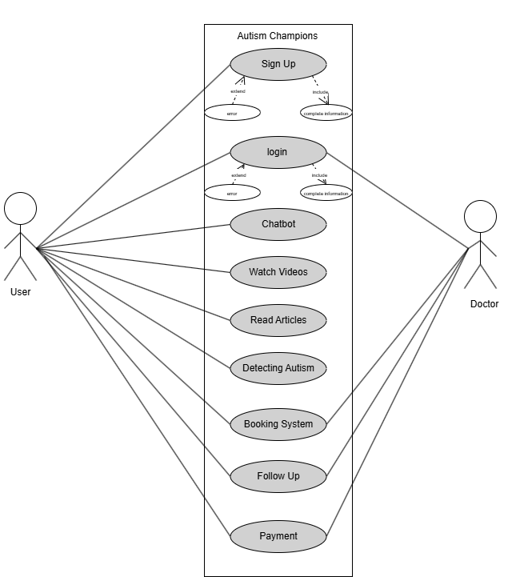

**Figure use case Diagram.**

Pg.47 2024-2025

The **Use Case Diagram** for Autism Champions platform the interactions between two key roles: **Users (Families)** and **Doctors**, showcasing the functionalities provided by the Autism Champions platform.

**Actors**

* **User (Families):**  
  Individuals seeking information, support, and autism-related services for their children.
* **Doctor:**  
  Healthcare professionals who provide medical consultations, guidance, and follow-up for autism cases.

**User (Families) Can Perform the Following:**

**Sign Up:** Creating an account is allowed and does provide all the tools the platform has to offer.

**Login:** A client can log in to their account.

**Chatbot:** Users can decide to speak to the chatbot to find information about autism and other resources.

**Watch Videos:** Autism can also be explained to families through educational videos so that they acquire support strategies.

**Read Articles:** As it provides articles, the user can find information about autism, its treatments, and how to help children with autism.

**Detecting Autism:** The tool involves the use of artificial intelligence to carry out autism detection within the application Users provide images of children for analysis.

**Booking System:** People can fix an appointment to see doctors of their choice for consultations about Autism.

**Follow-Up:** Families can chat with the doctors to monitor the progress of their child in regard to developmental landmarks or aspirations.

**Doctor Can Perform the Following:**

**Login:** Doctors can log in to their accounts to manage appointments, interact with families.

**Booking System:** Doctors can manage bookings, schedule appointments, and provide availability slots.

**Follow-Up:** Doctors can track and update progress on individual cases to provide tailored advice or intervention strategies.

Pg.48 2024-2025

## Sequence Diagram:

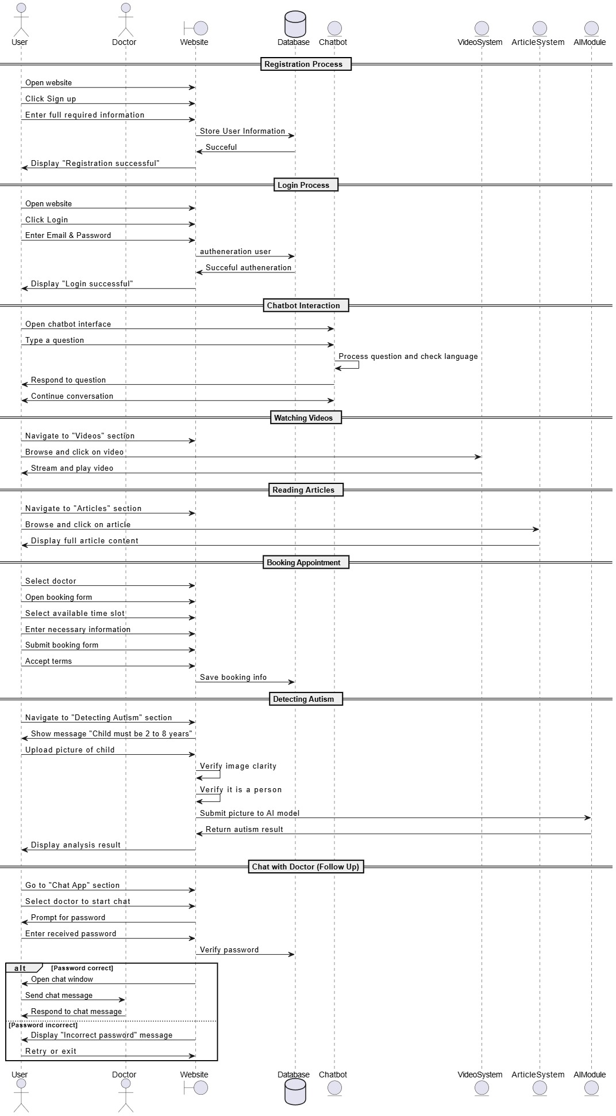

Figure: Sequence Diagram for Users Representative

Pg.49 2024-2025

**1. User (Patient/Parent) Representative:**

* **Registration:** Registers by entering data needed for creating an account.
* **Login:** Logs in to the system using email and password.
* **Chatbot Interaction:** Provide questions and gets answers from the chatbot.
* **Watching Videos:** Uses and views lessons on the internet.
* **Reading Articles:** Browses and reads articles**.**
* **Booking Appointment:** Tends to choose a doctor, then decides on a time for the appointment and makes the appointment.
* **Detecting Autism:** Uses the application to upload a child’s picture for autism analysis.
* **Chat with Doctor (Follow Up):** Uses a password to start a conversation with a doctor

Pg.50 2024-2025

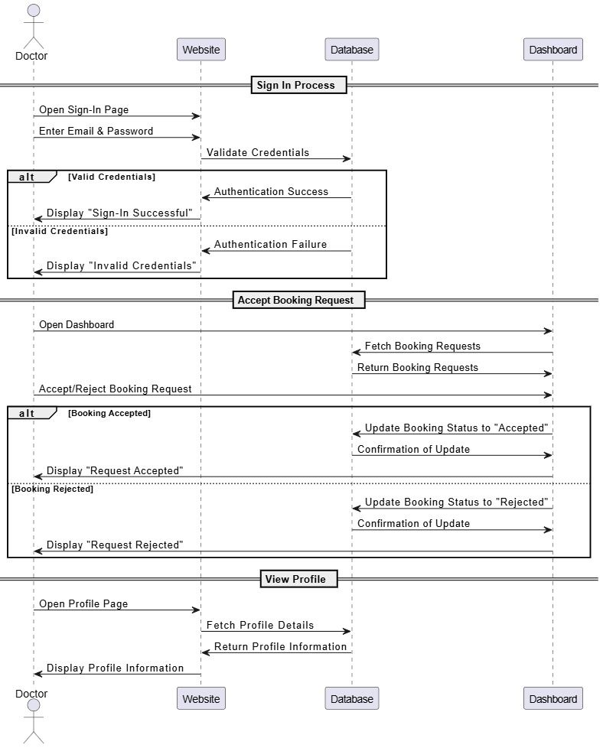

Figure: Sequence Diagram for Doctors Representative

**2. Doctor:**

* **Sign-In:** Opens the sign-in page and enters their email and password.
* **Views Dashboard:** Opens the dashboard to see booking requests.
* **Accepts/Rejects Bookings:** Interacts with the dashboard to accept or reject pending booking requests.
* **Views Profile:** Opens their profile page to view their information

Pg.51 2024-2025

## ER Diagram:

The Entity-Relationship (ER) Diagram for the **Autism Champions** visually represents the data model, showcasing the relationships between key entities and their attributes within the system.

Entity-Relationship (ER) is a critical element of the project's documentation, offering a detailed view of how data is structured and interconnected to enable core functionalities, such as early autism detection, medical appointment booking, personalized chatbot interactions, and access to educational resources like videos and articles.

By clearly defining the data organization, the ER diagram ensures seamless integration and support for all platform features, facilitating an efficient and user-friendly experience for families, doctors, and other stakeholders.

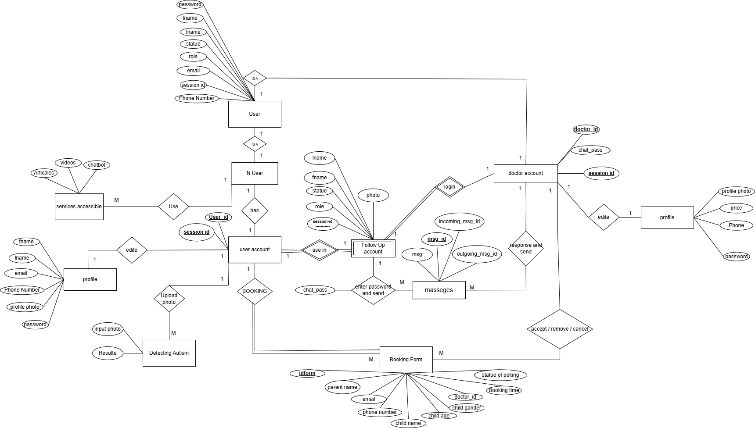

Figure: ER Diagram

Pg.52 2024-2025

### Entities and their Attributes:

**Entity :** An entity represents a real-world object or concept that you want to store information about in your database

**attribute:** An attribute is a specific property or characteristic of an entity. It describes the entity and helps to distinguish it from other entities of the same type.

**Entities of project:**

1. **User:**

* Represent individual or parent of child that interacts with the system
* **Attributes:** Password , fname , lname, Statue , Role, Email, SessionID , Phone Number

1. **User account :**

* Represent information of account who that interacts with the system after sign up
* **Attributes:** Password, fname , lname, Statue , Role, Email, SessionID, Phone Number, User id

1. **Doctor account:**

* Represent information of doctor who that interacts with the system
* **Attributes:** Password, fname,lname, Statue,Role, Email, SessionID, Phone Number, doctor id,chat pass

1. **Profile user:**

* Represent basic information of account and make use if can update some his information
* **Attributes:** fname,lname, Email, Phone Number, Password, profile photo

1. **Profile doctor:**

* Represent basic information of account and make use if can update some his information
* **Attributes:** doctor photo , price ,phone , available time , password

1. **Detecting Autism:**

* Represent ai model that detect if child have autism or not
* **Attributes:** input photo , Result

1. **Booking form:**

* Represent form that user can booking for go to doctor.
* **Attributes:** idform , parent name , email , phone number , child name, child age , child gander , doctor-id , booking time ,state of booking

Pg.53 2024-2025

1. **Follow up account :**

* Represent chat account for parent or doctor To follow up the disease after the examination
* **Attributes:** session-id , fname ,lname ,statue , role ,photo

1. **Messages:**

* Represent messages between doctor and user
* **Attributes:** msg-id , msg ,incoming_msg_id , outgoing_msg_id

1. **Services accessible :**

* Represent Services that user can access or use them without needing to sign up
* **Attributes:** chatbot , videos , articales

Pg.54 2024-2025

## System Design and Architecture:

The "Autism Champions" platform uses AI technology for web-based assistance in autism detection among young children while delivering education materials and connecting families with physicians. Autism Champions integrates specialized modules which serve users of all types from children to parents to medical staff through its easy-to-use operational framework.

### Architecture

**Modular Monolith with Microservice Readiness**

The system follows a **modular monolith architecture**, ensuring maintainability, scalability, and clear separation of concerns. Each module can be independently scaled and transitioned into a microservice when the need arises, enabling efficient scaling and future-proofing.

### Components and Services:

**1. Autism Detection Service**

* **Description**: This system uses deep learning capability to examine pictures which assist autism diagnosis.
* **Key Features:** Xception model acts as the image classification framework. The system lets users upload pictures of children for autism detection analysis. The system presents diagnostic outcomes together with an accuracy measurement. It links service results with platform profiles through system integration.
* **Technologies**: The system runs on TensorFlow as an inference server through its Python-based framework that operates through REST API.

**2. Chatbot Service**

* **Description**: An AI automated chatbot system helps users get answers regarding autism questions across different languages.
* **Key Features**: Supports both English and Arabic. The platform includes the M-CHAT-R testing system (Modified Checklist for Autism in Toddlers) as part of its screening instruments. The system delivers explanations about autism symptoms and children's strengths together with disability challenges along with relevant resource listings. The platform connects this service to its knowledge base which ensures accurate responses adapt to the current context.
* **Technologies**: TensorFlow, Flask API.

Pg.55 2024-2025

**3. Booking and Scheduling System**

* **Description**: Our application includes a parent scheduling system which lets them make reservations for doctor appointments.
* **Technologies**: PHP and Laravel backend with MySQL, JavaScript for frontend interactivity.

**4.Follow up messages services**

* **Description:** Facilitates secure communication between parents and doctors.
* **Key Features**: by pin number the user receive it after coming to doctor
* **Technologies**: PHP backend .

**5. Educational Resources services**

* **Description**: Provides educational content to raise awareness about autism.
* **Key Features**: Articles and videos on autism-related topics.
* **Technologies**: PHP, JavaScript frontend.

**6. Doctor Account Management**

* **Description**: Dedicated features for doctors to manage bookings and profiles.
* **Key Features:** Doctors can view, accept, or decline booking requests from their dashboard, Manage profile information, including availability and contact details.
* **Technologies:** PHP backend

**Integration and Communication**

* The numerous services communicate through secure APIs, ensuring data integrity and confidentiality.
* Authentication and authorization mechanisms are implemented to control access to sensitive data and functionalities.

**Scalability and Reliability**

The architecture is designed to scale horizontally, allowing for the addition of new instances of microservices to oversee increased loads. Load balancing and redundancy mechanisms are in place to ensure high availability and reliability.

**Data Management**

* **Database**: Relational database (MySQL) for structured data such as users, doctors, bookings, and messages.

Pg.56 2024-2025

# Chapter Five

## “**Implementation”**

Pg.57 2024-2025

### Website Design

Autism Champions provides users with an intuitive system that enables families doctors and individuals to find autism-related content easily through its efficient accessible and user-friendly website interface. The website contains simple design elements which promote ease of access and user-friendly responsiveness between various devices.

#### **Design Elements:**

1. **User-Centric Interface:**

* The user interface design must be simplistic and easy to follow so every user from any level of proficiency can navigate without difficulty.
* The platform displays its content through a logical menu that integrates autism diagnosis with a chatbot platform that supports doctor booking plus chat skills educational resources.

1. **Responsive and Adaptive Layout:**

* Every aspect of the website adapts to any screen type making it work faultlessly between desktops tablets devices and mobile screens.
* The application implements glass morphism as a design technique that creates modern visual appeal inside pop-up windows.

##### C**onsistent Theme and Branding:**

* Represented design elements from a soothing color spectrum blend with suitable typography to build an accepting and peaceful interface.
* The site uses visual icons and symbols as signs for users to easily discover features along with functionalities.

##### **Secure and Private Communication:**

* The system features secure methods for authentication and login procedures that protect users.
* The doctor-to-patient chat system upholds medical privacy because it blocks patients from obtaining doctor contact numbers.

##### **Efficient Data Flow and Integration:**

* This application integrates a chatbot system to automatically respond to popular questions regarding autism.
* Quick image processing functions along with feedback occur seamlessly inside the platform through the autism detection model.
* Doctor booking manages patient scheduling conflicts by displaying immediate operational periods for appointments.

Pg.58 2024-2025

## ****Challenges in Website Development****

##### **Providing a Smooth and Accessible UI**

* **Challenge**: Designing an interface that caters to all users, including those with disabilities or limited technical skills.
* **Solution**: Following WCAG accessibility guidelines, using simple navigation structures, and ensuring high contrast and readable fonts for better user experience.

##### **Enhancing the Autism Detection Model**

The autism detection model examines face images of children from 2 to 8 years old by employing the Xception architecture. Using deep learning methods the model evaluates if children show autistic behavior.

**Challenges in Autism Detection**

* The model receives training through 3340 face images which belong to a Kaggle dataset.
* The model requires optimization to enhance its performance at recognizing autism while correctly identifying cases of non-autism patients.
* The system needs to function consistently on images of children from different backgrounds and under varying illumination conditions

**Solution:** Fine-tuning the Xception-based model, increasing dropout regularization, adjusting the learning rate, and expanding the dataset for better performance.

**How the Autism Detection Model Works**

* The first step in the process involves transforming the size and normalizing the face images.
* The computer utilizes Xception's convolutional layers to extract features which relate to autistic patterns.
* Classification: The final layers output a probability score for autism or non-autism.
* Results shown on the website include assessment recommendations that directs users to seek further medical evaluation if necessary.

##### **Managing Doctor Availability in Booking System**

* **Challenge:** Ensuring that a booked time slot is not available for another user to avoid schedulingconflicts**.**
* **Solution:** Implementing session-based management and real-time database updates to block out unavailable slots dynamically.

### ****How the Booking System Works****

1. **User Registration/Login:** Patients and doctors authenticate via PHP sessions.
2. **Time Slot Selection:** Available time slots are displayed dynamically.
3. **Confirmation & Notification:** Patients receive an email upon successful booking.

Pg.59 2024-2025

##### **Patient-Doctor Chat System**

Secure text-based patient-doctor communication happens through this feature which protects all involved from giving out their personal phone numbers.

**Challenges in Chat System**

* The system ensures both encryption of messages and secure storage of all data.
* The system distinguishes patients from doctors during their communication through the chat platform.
* Seamless Experience: Keeping the chat interface intuitive and responsive.

**How the Chat System Works**

* Users traverse to the system by entering their distinct credentials each time they want to access the platform.
* Users exchange messages through the platform where messages are stored using PHP encryption.
* Patients access doctor associations through their respective chat_pass.

##### **Chatbot**

* A challenge exists in ensuring the chatbot provides honest and relevant answers following trained data instead of presenting unexpected responses.
* Quality results accompany a well-built training process for the chatbot alongside preprocessing logic that handles user requests properly.

##### **Ensuring Data Security and Privacy**

* The fundamental problem resides in stopping unauthorized access to user data particularly in chat systems and medical documentation.
* Protected sensitive information using proper authentication security together with encrypted communication and data validation on the server.

Pg.60 2024-2025

### Front-End Samples:

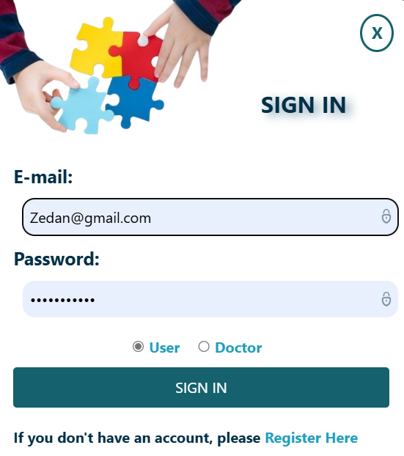

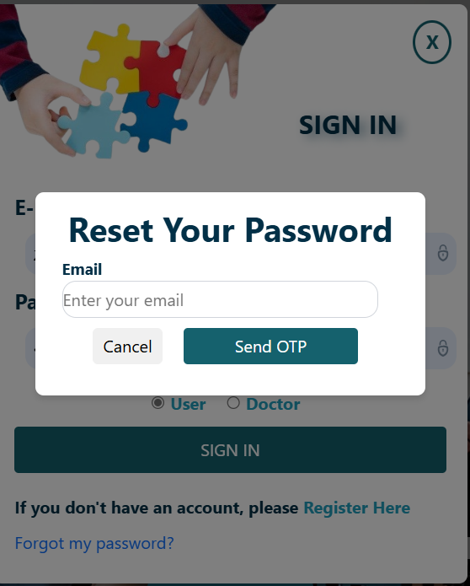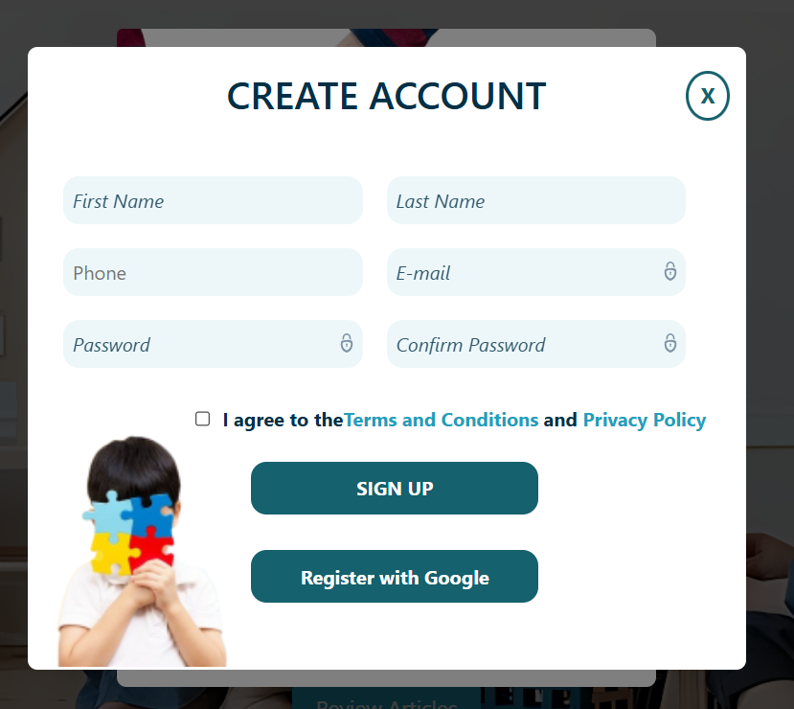

Figure: Login and Sign UP pages

Pg.61 2024-2025

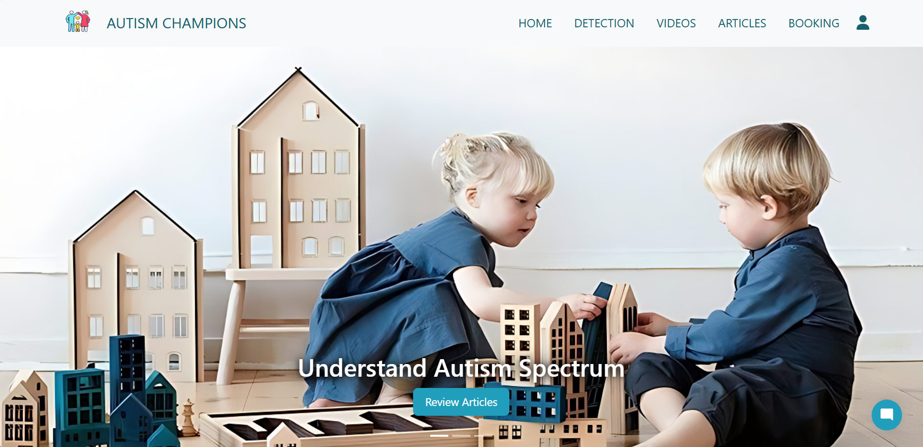

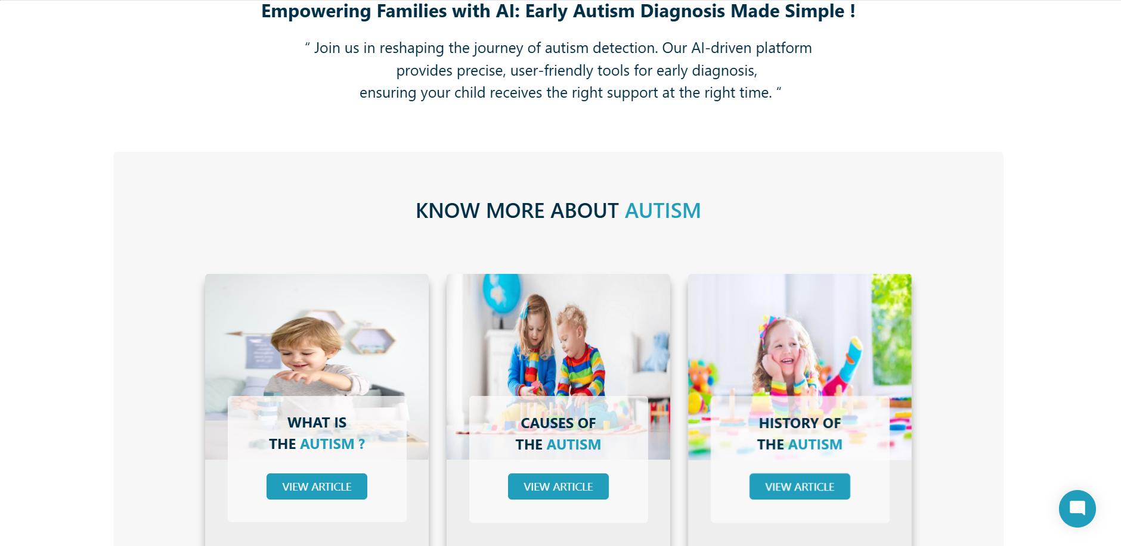

Figure: Home page

Pg.62 2024-2025

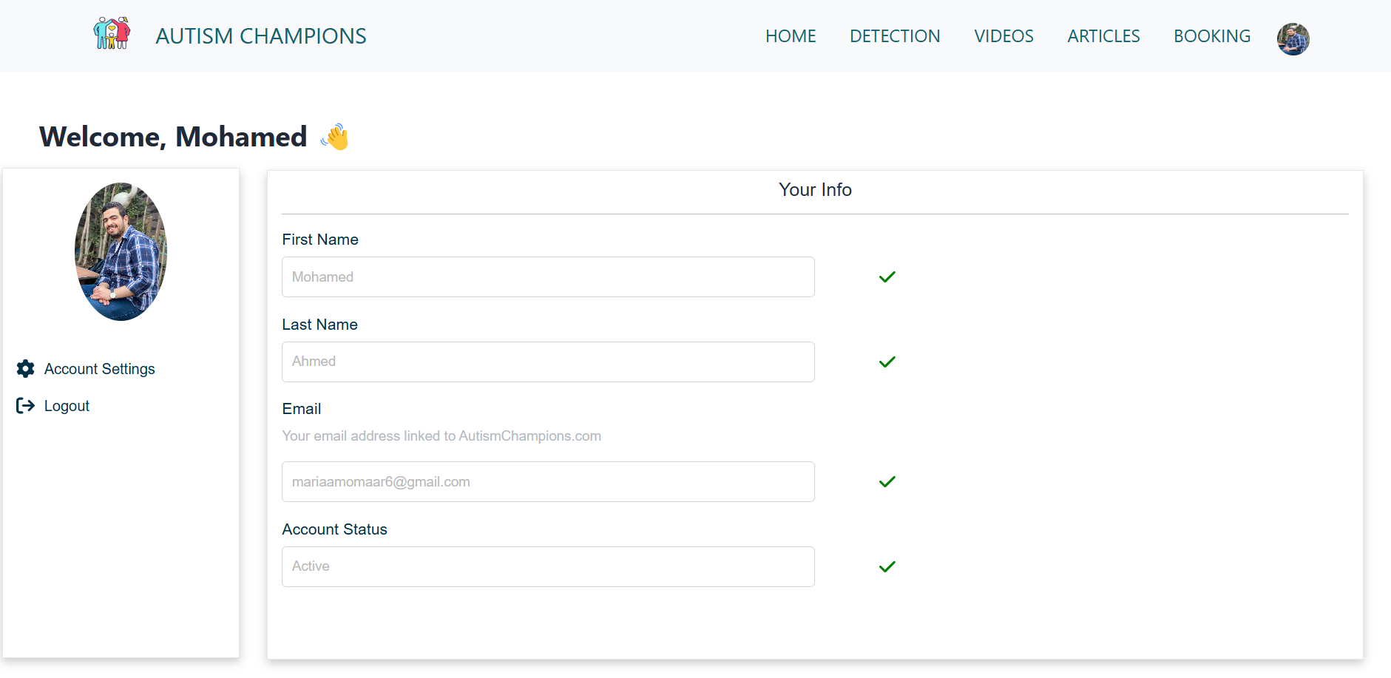

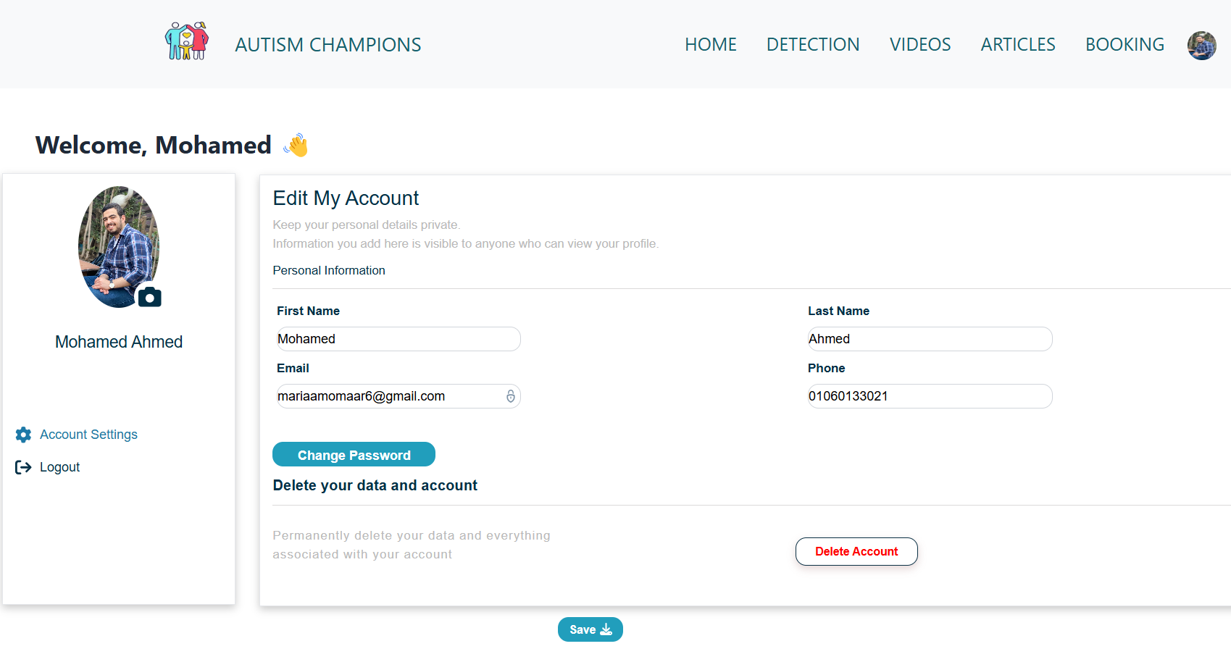

Figure: Profile and Edite page

Pg.63 2024-2025

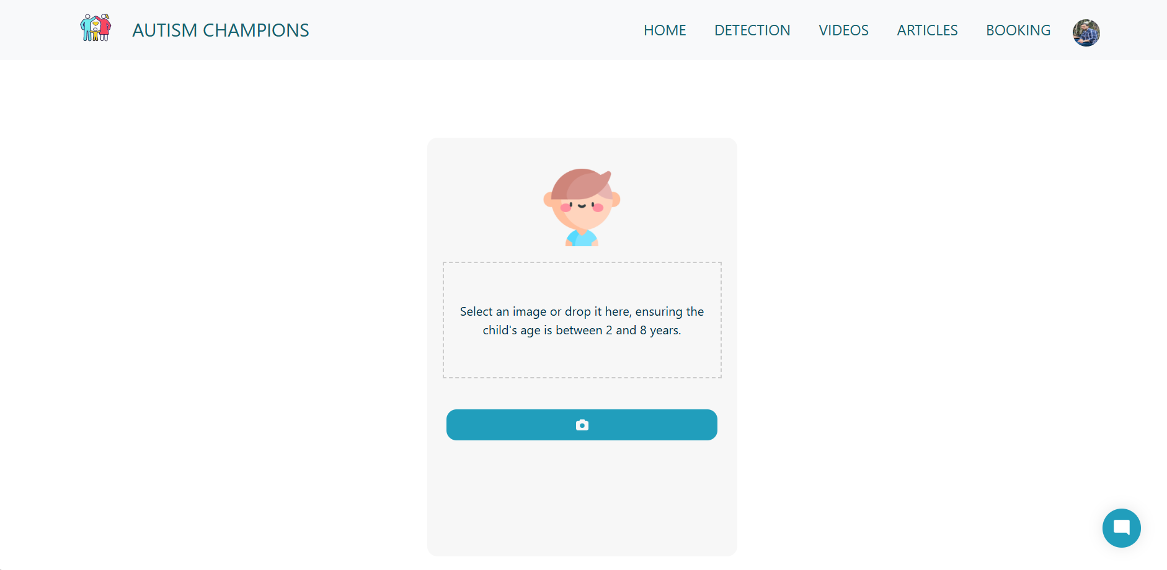

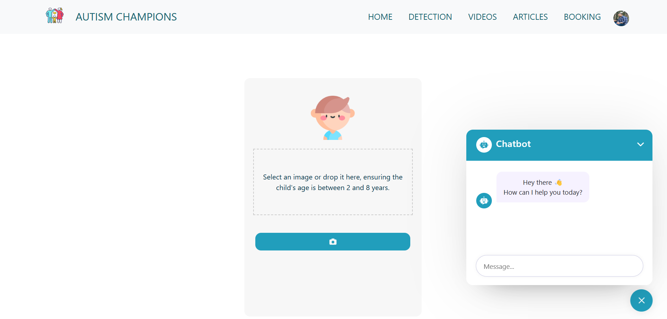Figure: Detection page

Figure: ChatBot

Pg.64 2024-2025

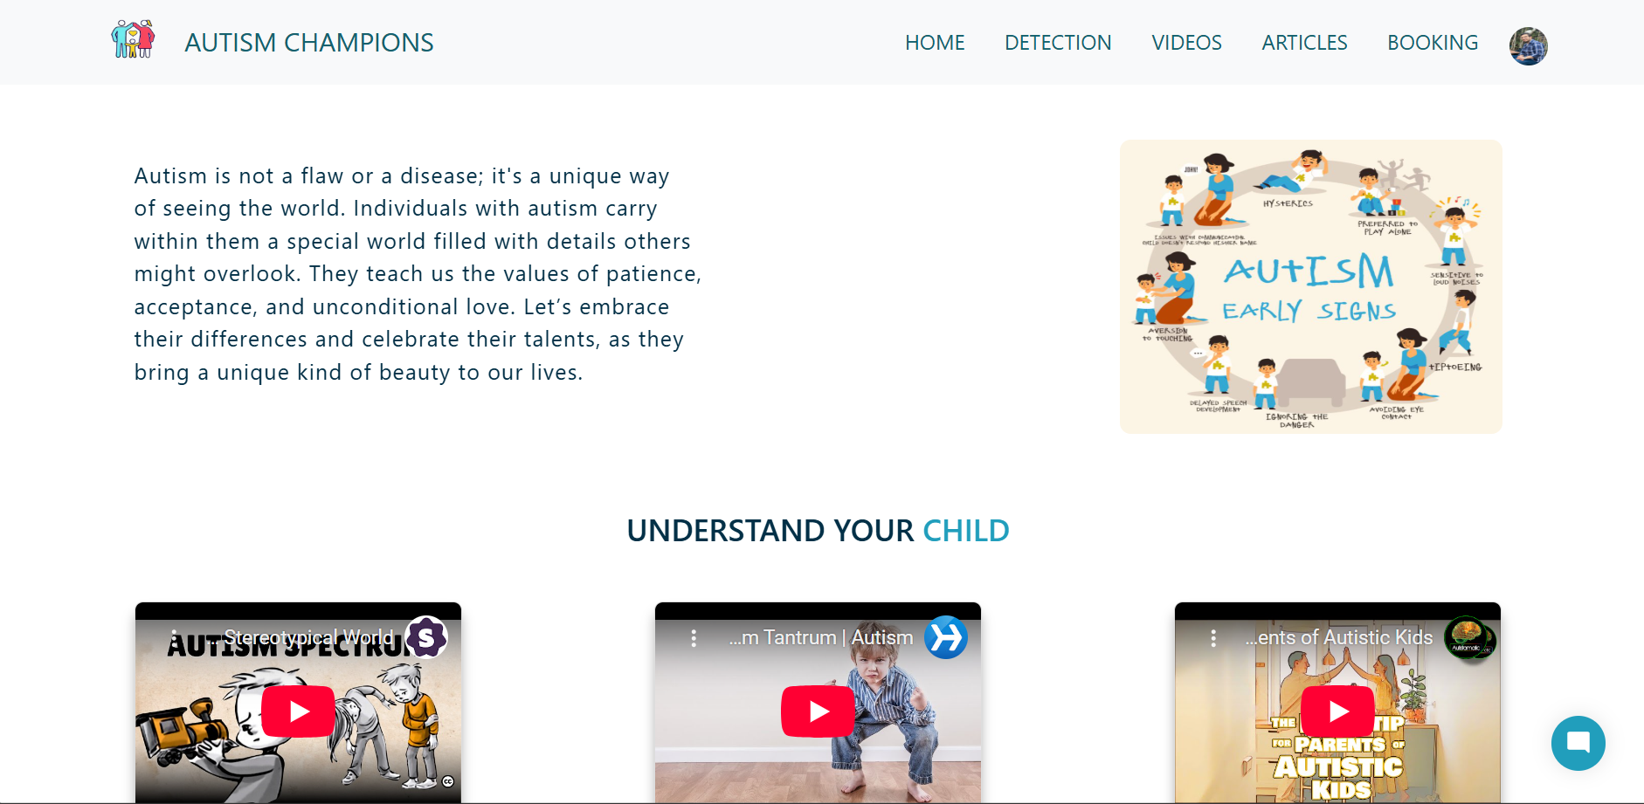 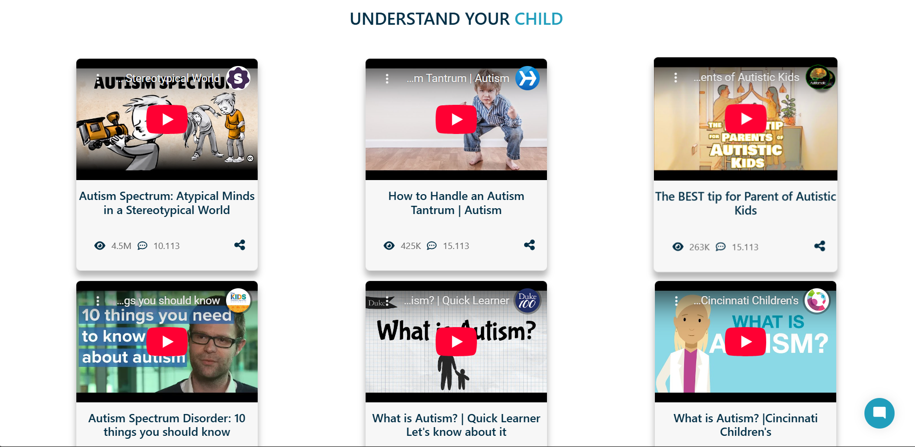

Figure: Videos page

Pg.65 2024-2025

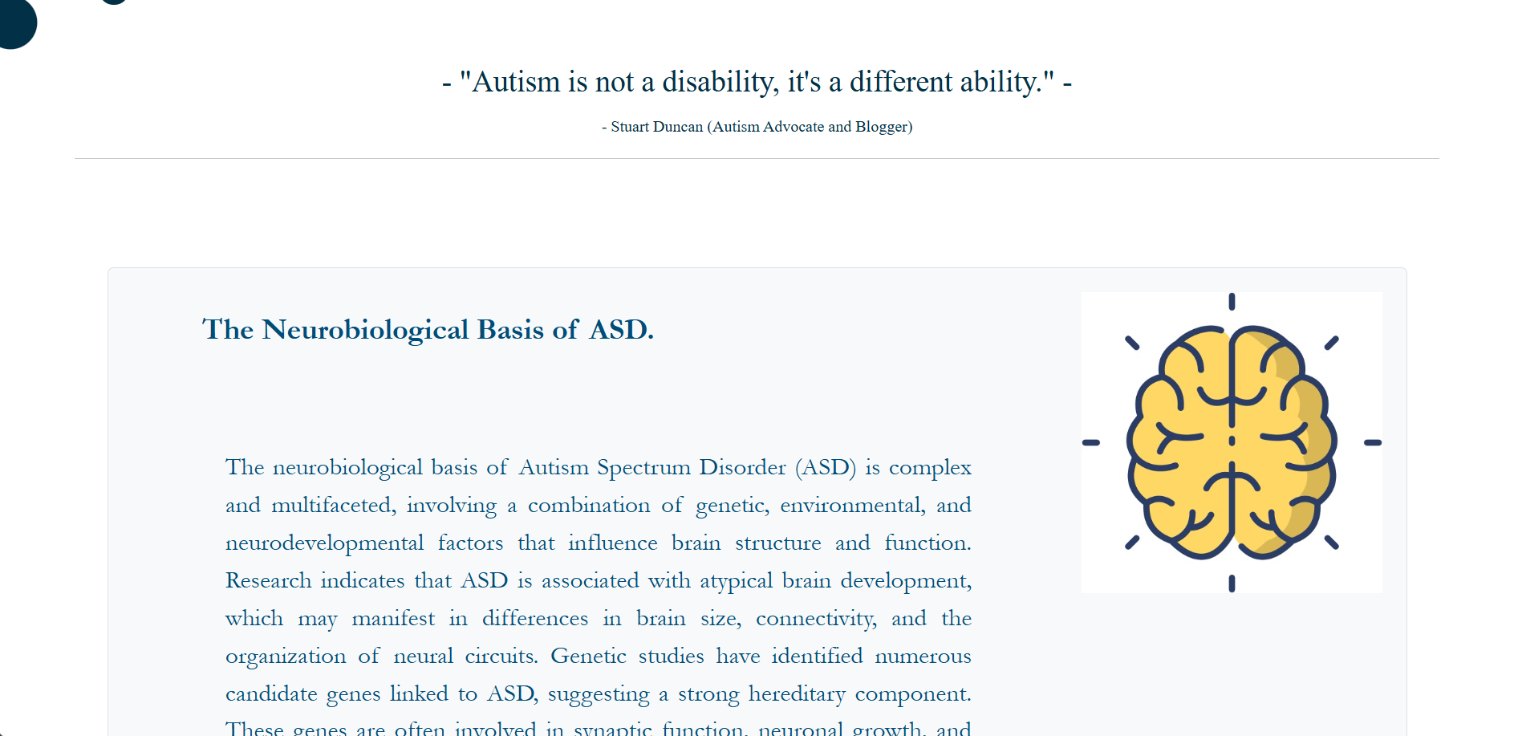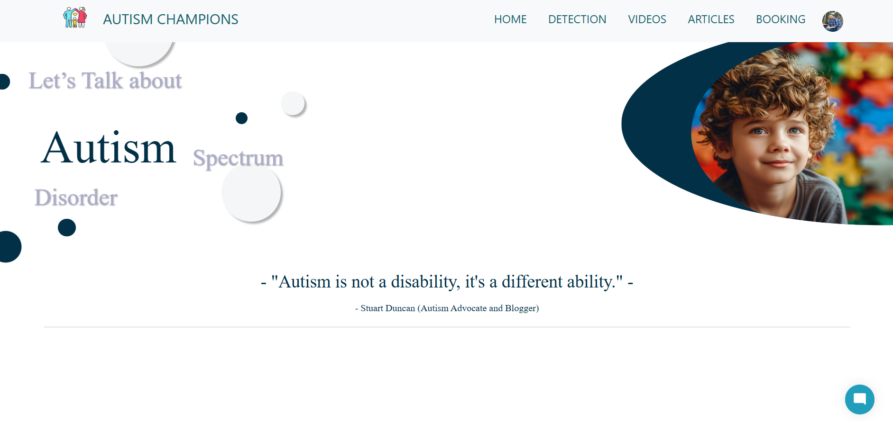 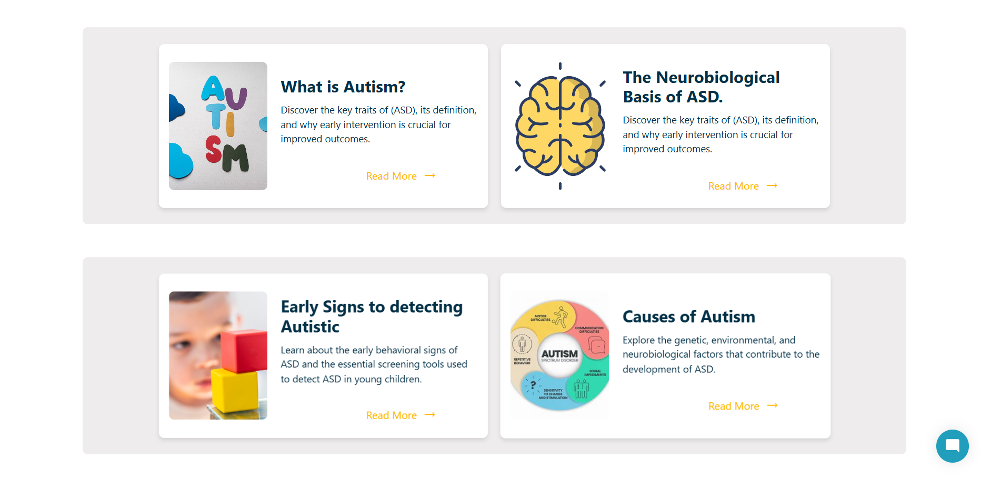

Figure: Articles pages

Pg.66 2024-2025

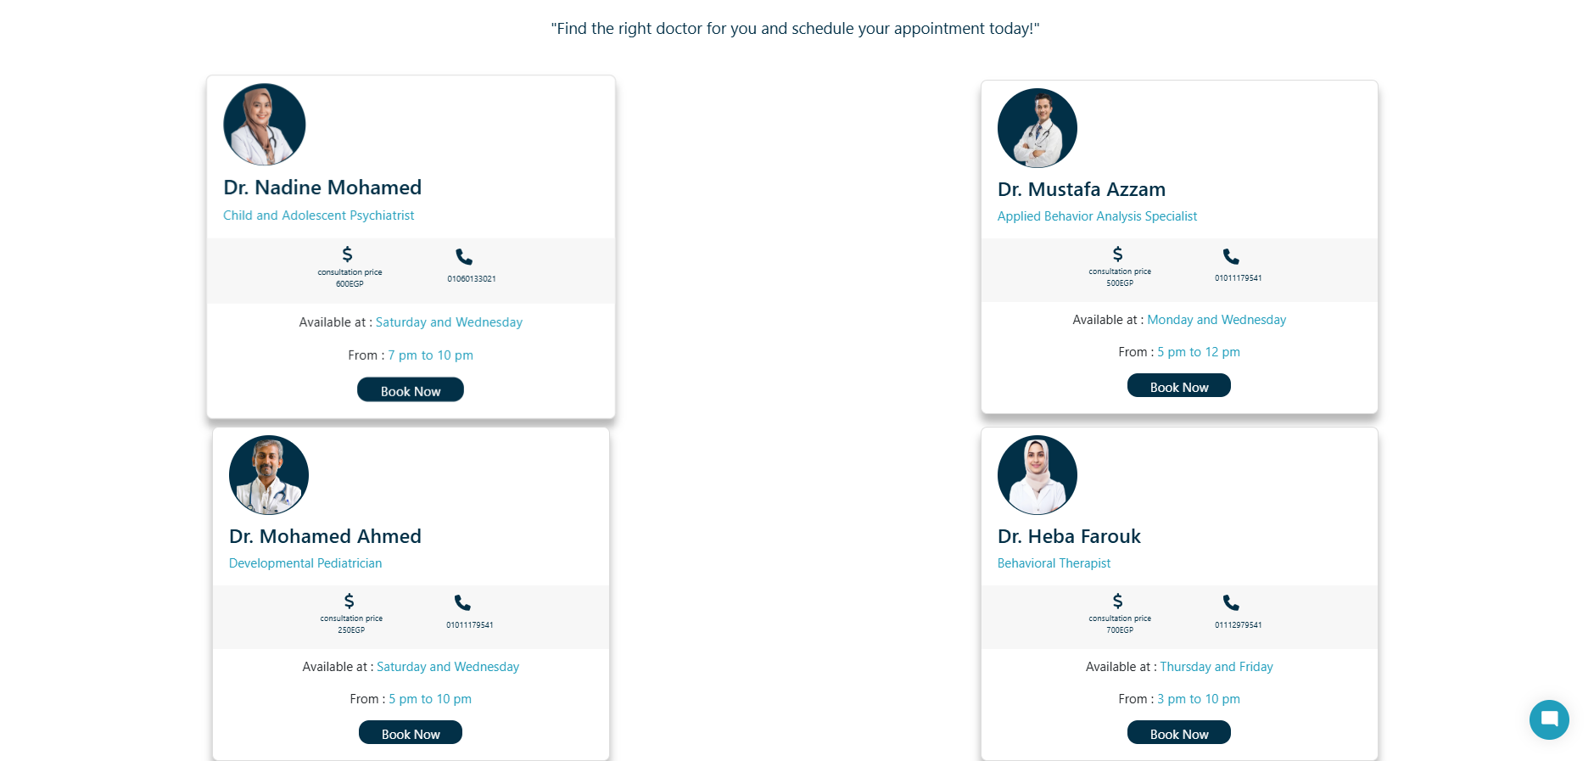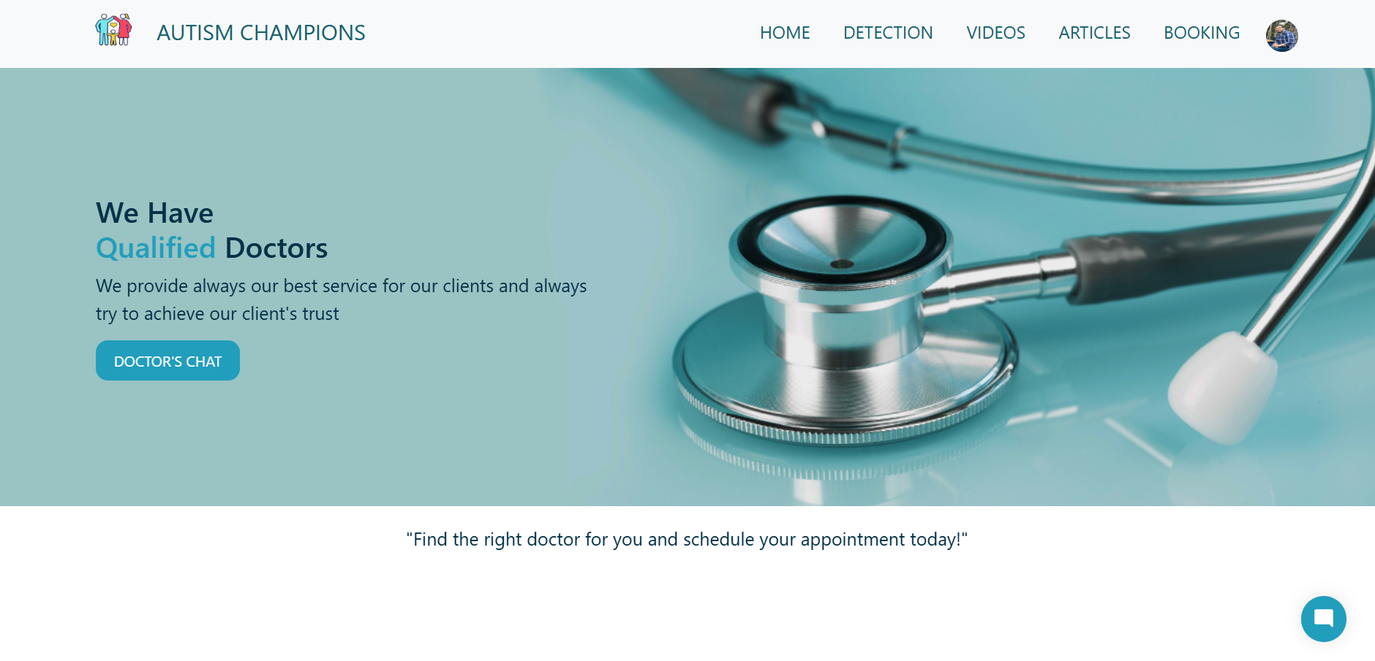

Figure: Doctors pages

Pg.67 2024-2025

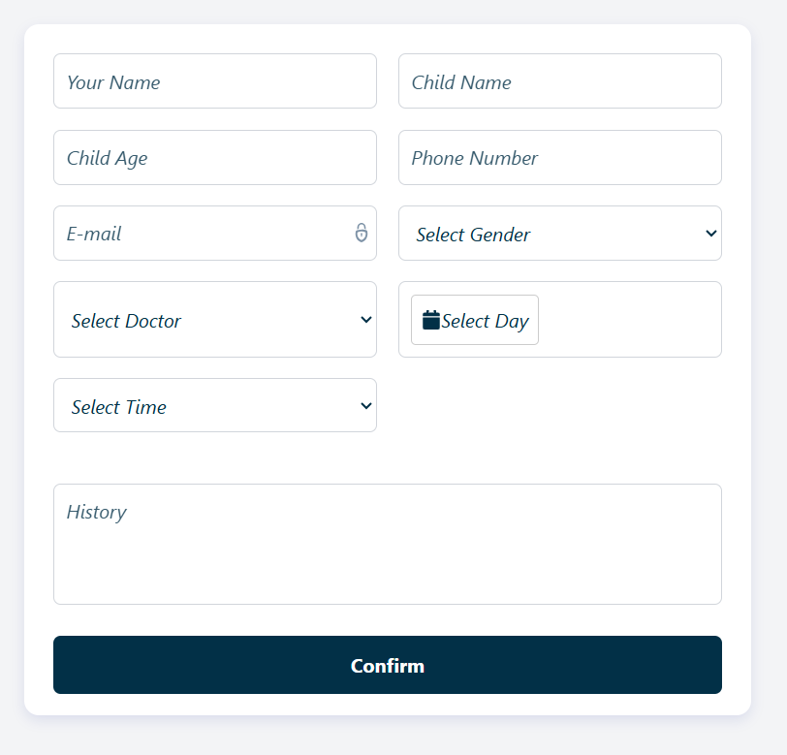

Figure: Appointment form

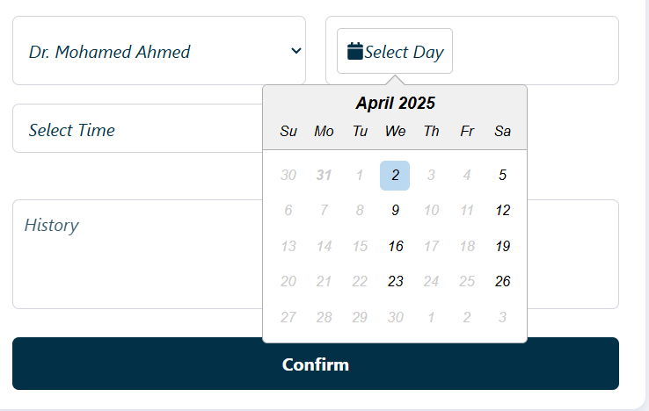

Figure: Appointment Scheduler.

Pg.68 2024-2025

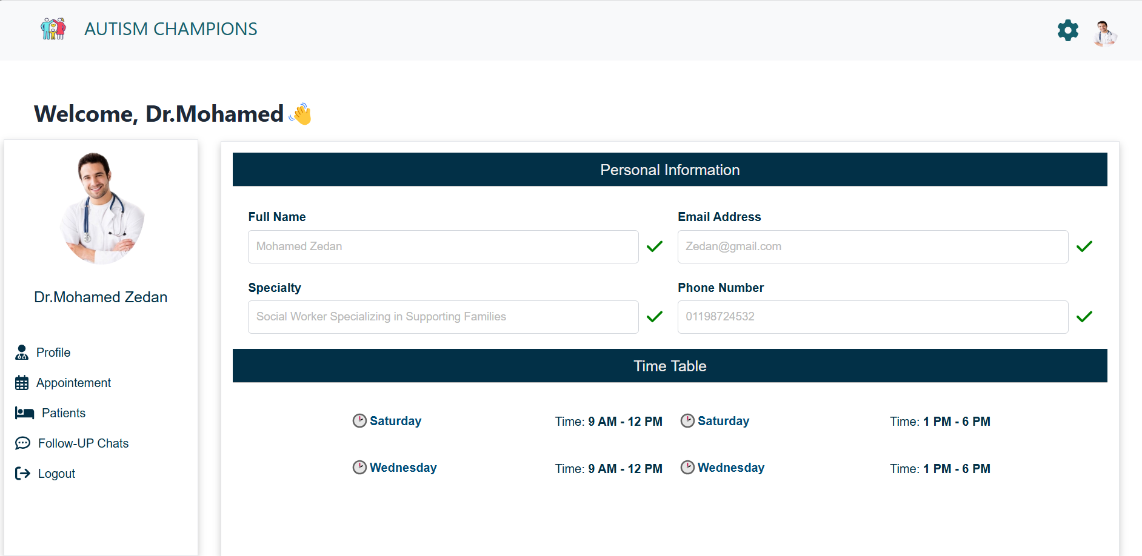

Figure: Doctor Profile

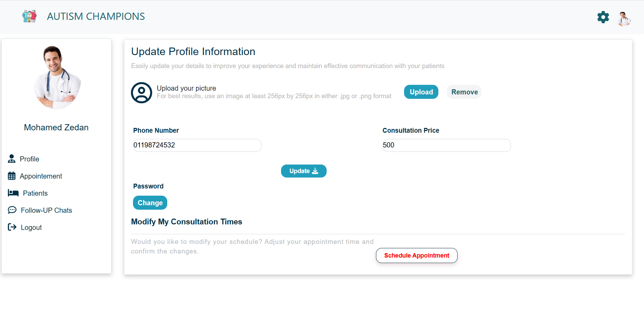

Figure: Doctor Profile edite

Pg.69 2024-2025

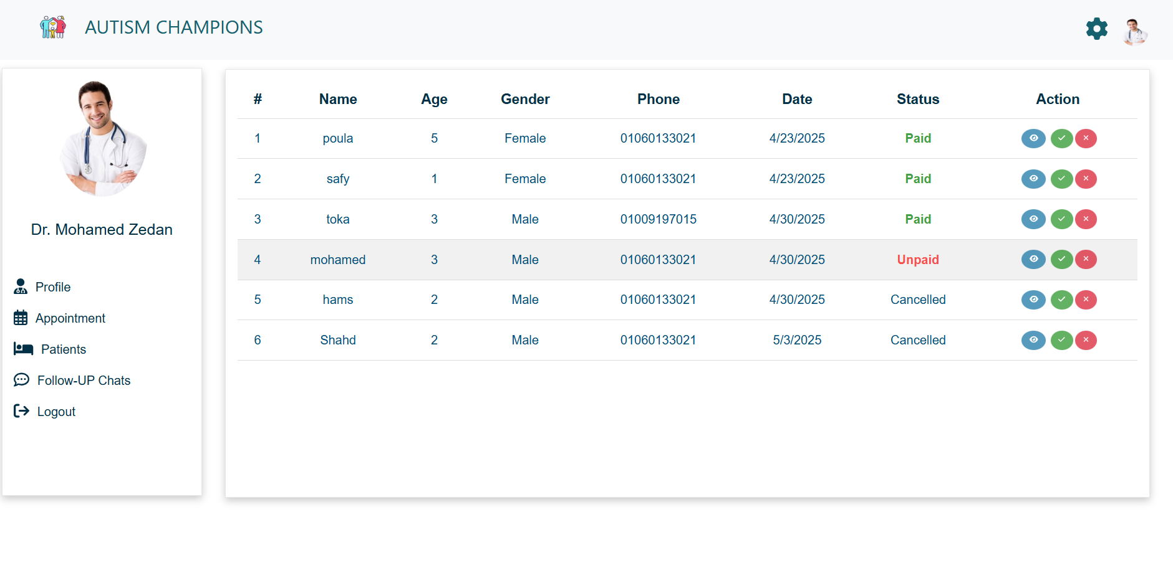

Figure: Doctor Appointment

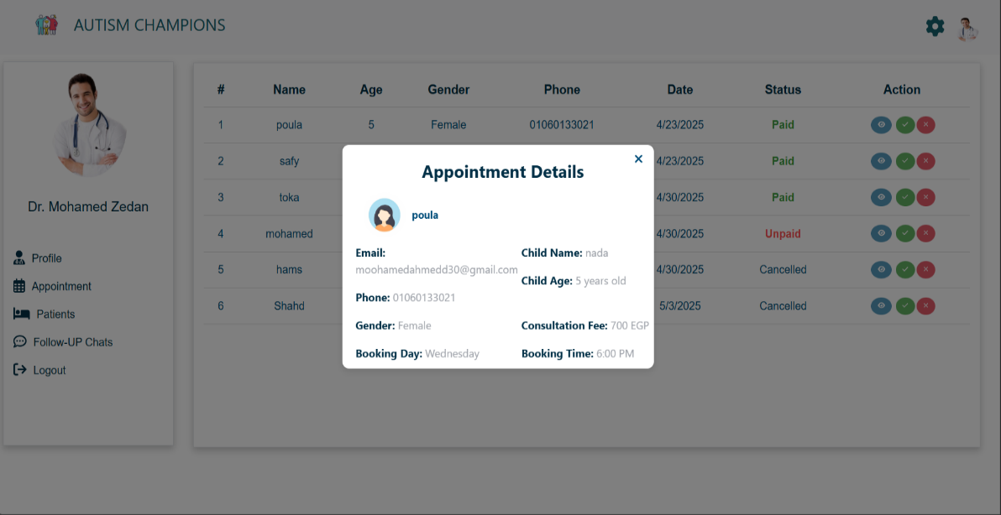

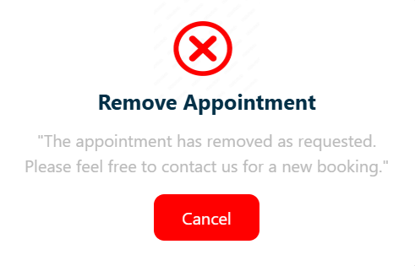Figure: Appointment details

Pg.70 2024-2025

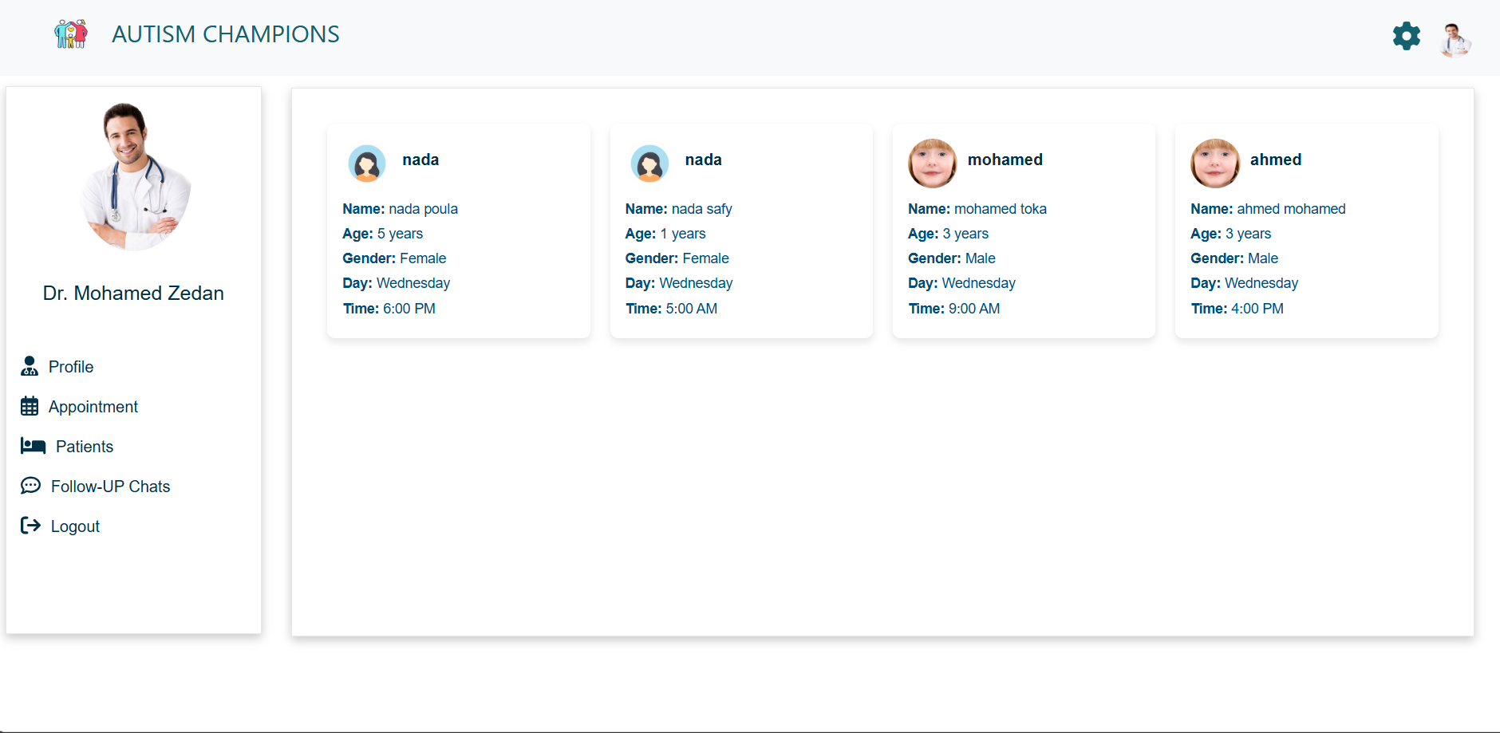

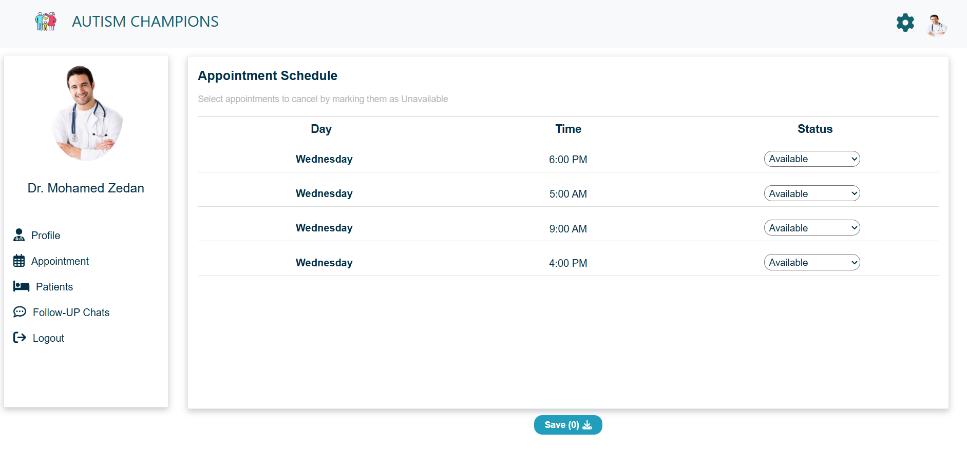Figure: Patients

Figure: Doctor schedule

Pg.71 2024-2025

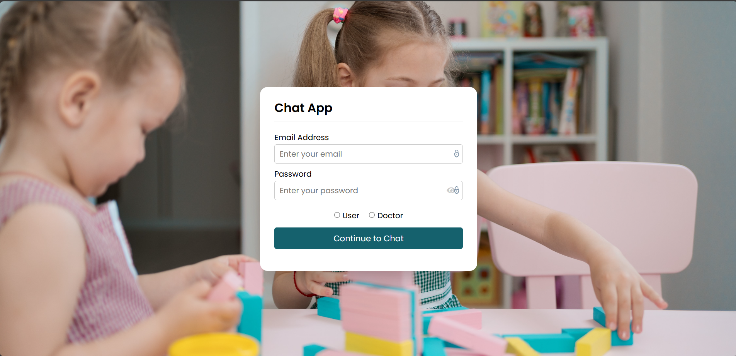

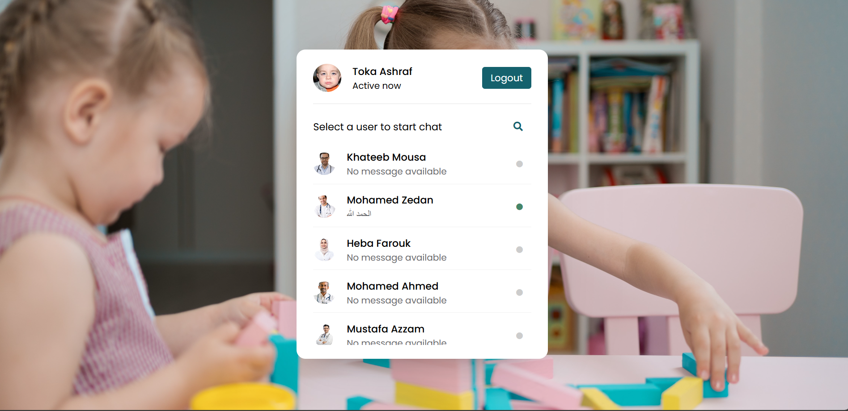Figure: Follow up chat

Figure: Follow up chat of users

Pg.72 2024-2025

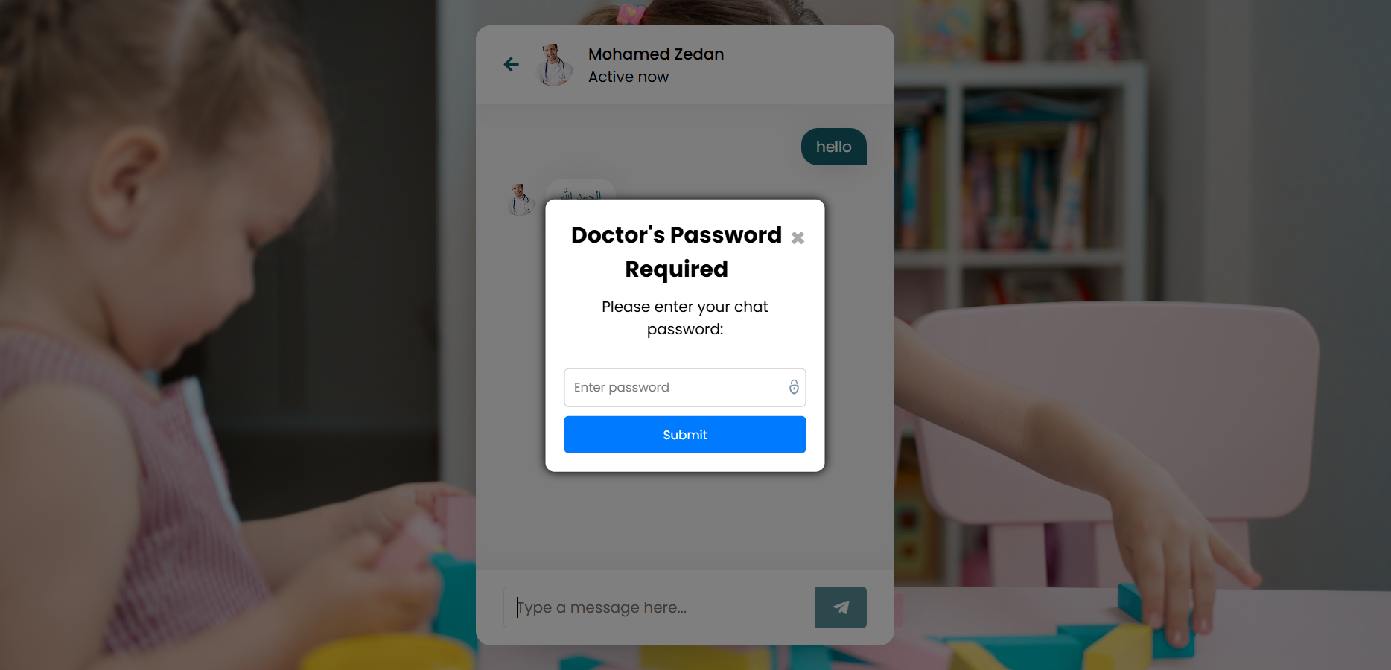

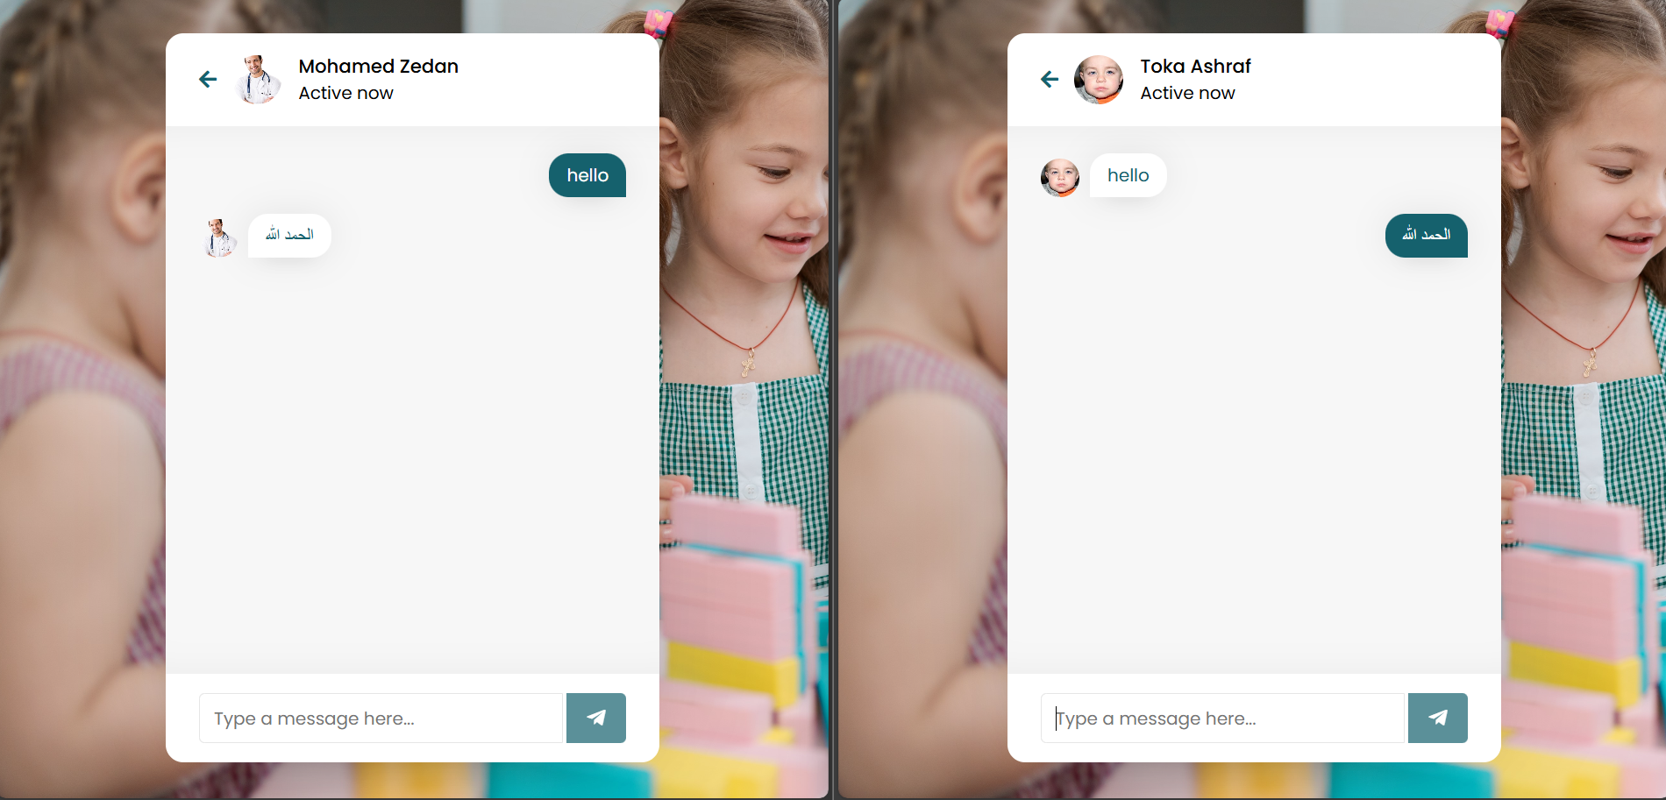Figure: Follow up chat pass

Pg.73 2024-2025

**Code Samples :**

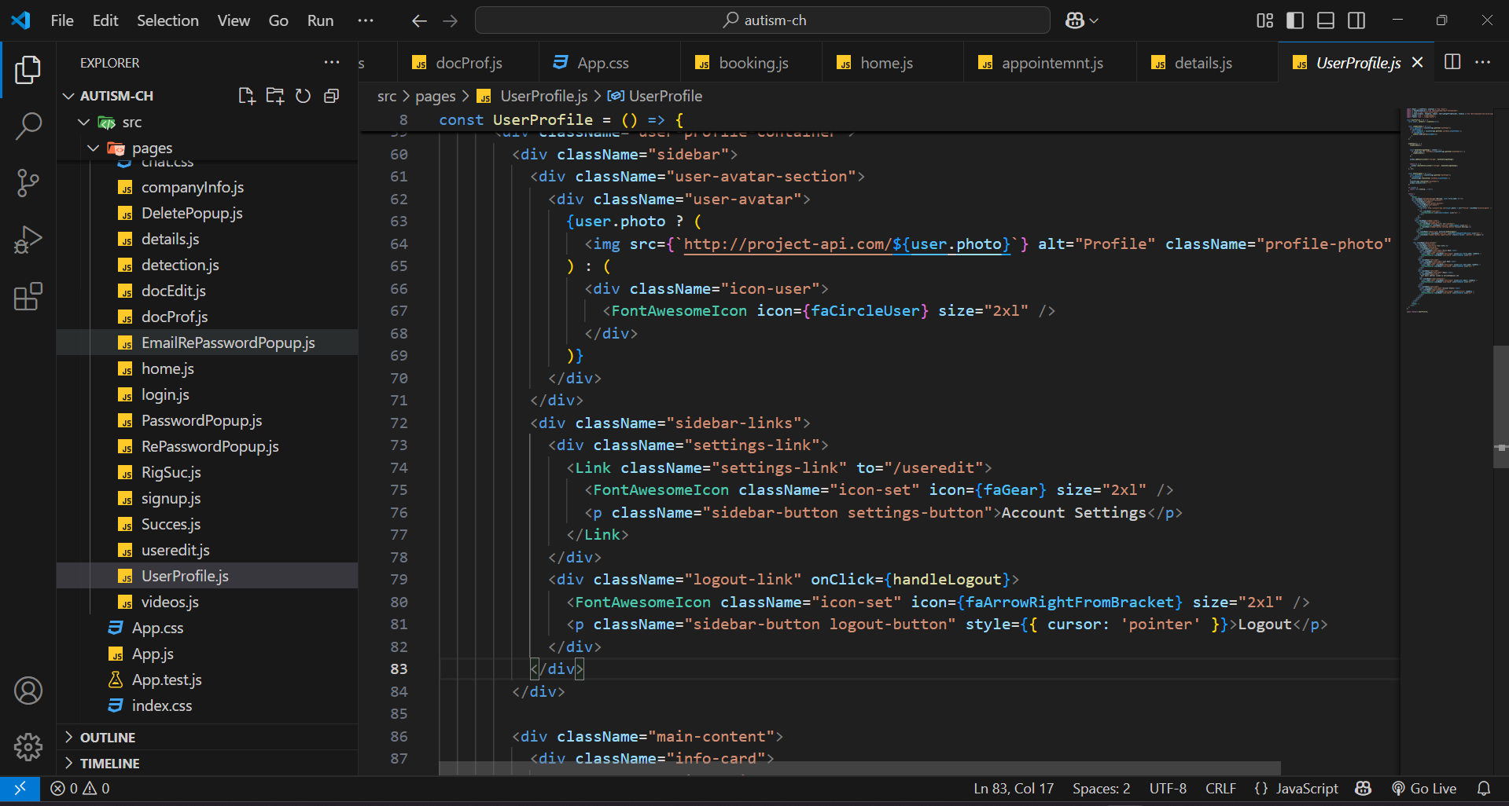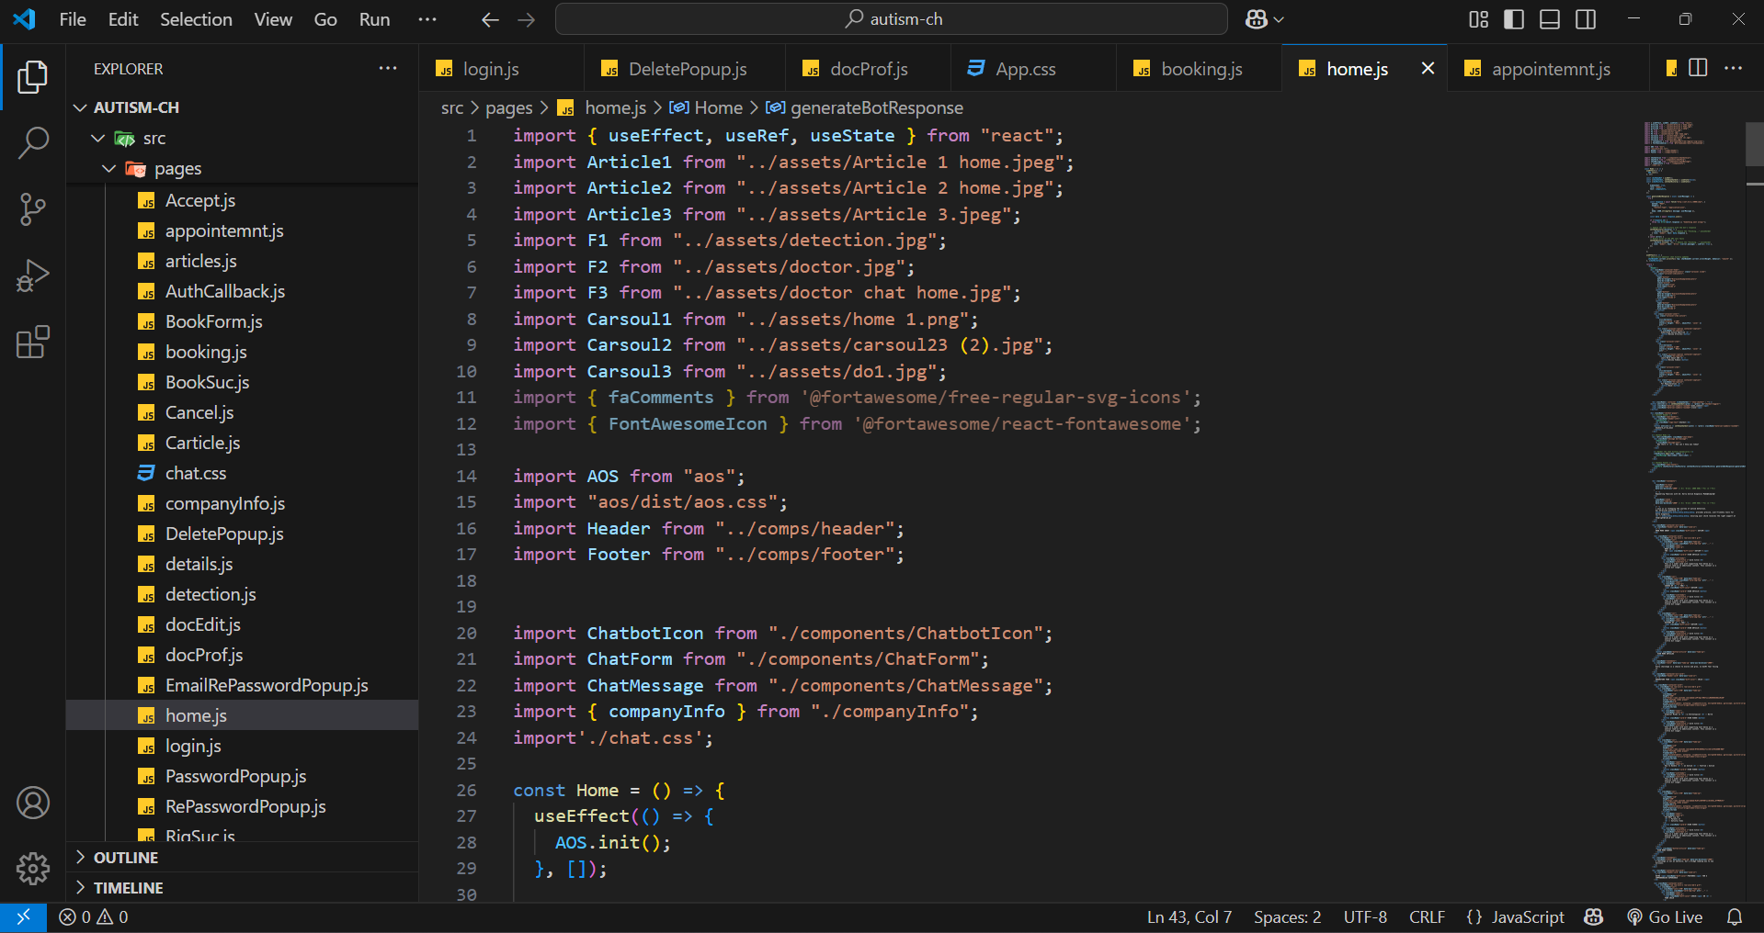

Pg.74 2024-2025

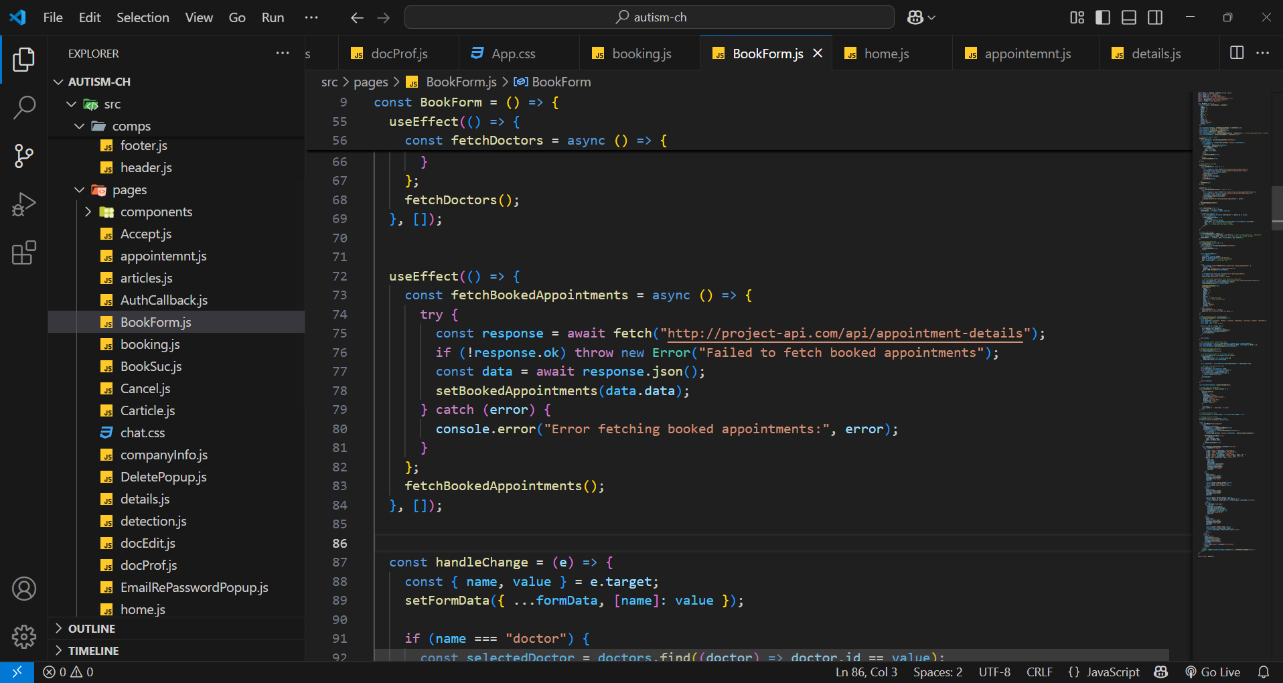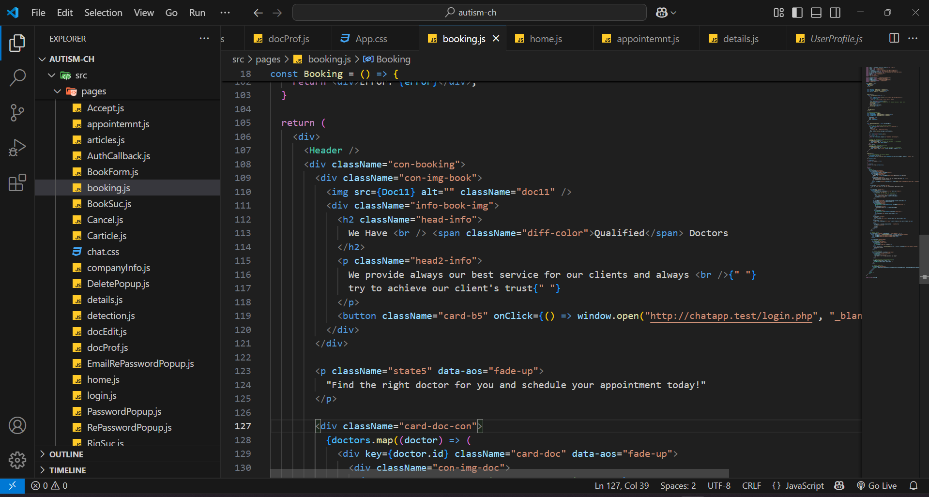

Pg.75 2024-2025

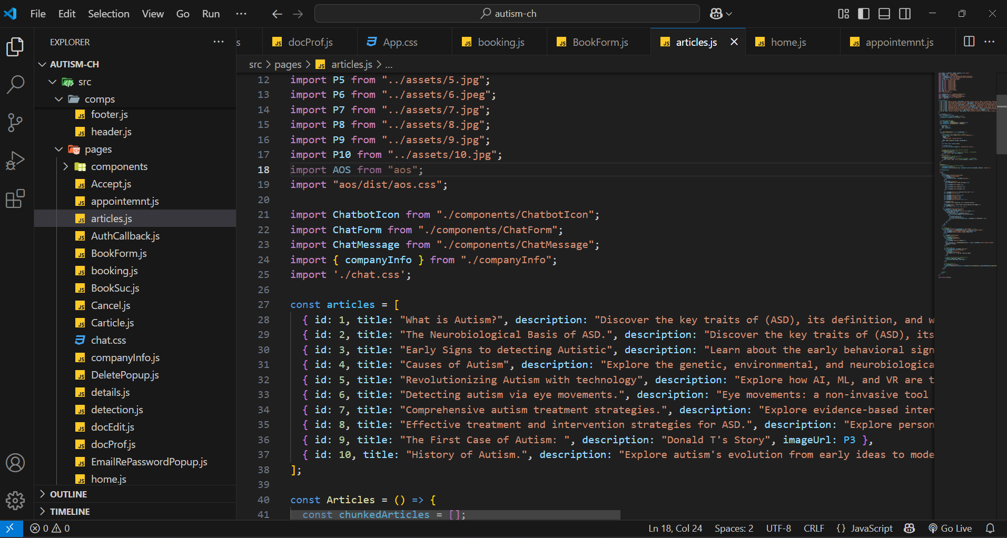

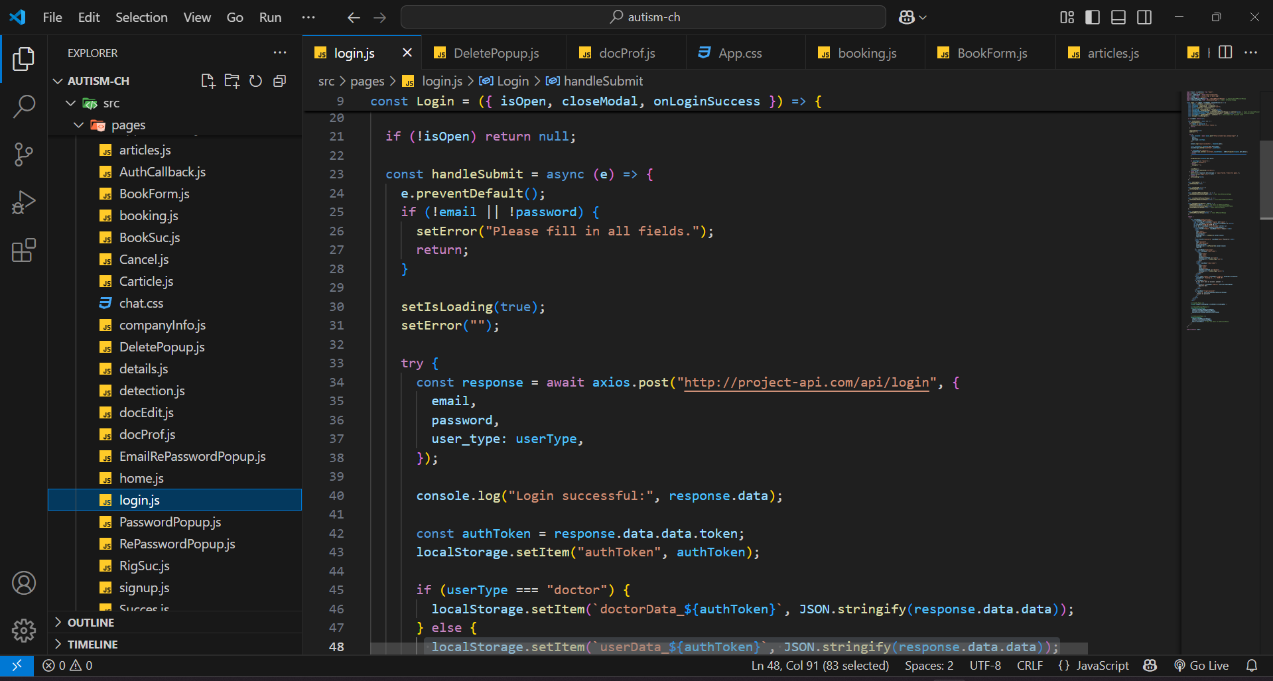

Pg.76 2024-2025

## Technology Used:

### Frontend:

**1. HTML (Hypertext Markup Language):**

* + - **Description:** HTML is the standard markup language for creating web pages. It defines the structure and layout of content on the web.
    - **Role in the Project:** HTML is used to structure the content of the user interface (UI)

**2. CSS (Cascading Style Sheets):**

* + - **Description:** CSS is a style sheet language used for describing the presentation of a document written in HTML. It defines the visual appearance and layout of the UI elements.
    - **Role in the Project:** CSS is employed to style and format the HTML elements, ensuring a visually appealing and consistent UI design.

**3. JavaScript (JS):**

* + - **Description:** JavaScript is a programming language that enables dynamic and interactive behavior on web pages.
    - **Role in the Project**: JavaScript is used for implementing client-side logic, handling user interactions, and making the user interface dynamic and responsive.

**4-React:**

* + - **Description:** React is a JavaScript library for building user interfaces. It allows for the creation of reusable UI components.
    - **Role in the Project**: React is used to build the user interface of the Autism champions , providing a component-based architecture for efficient development and maintenance.

Pg.77 2024-2025

### Backend:

**1.PHP (Hypertext Preprocessor)**

* **Description**: PHP is a widely used, server-side scripting language designed for web development. It is well-suited for handling dynamic content, database interactions, and backend logic.
* **Role in the Project**: PHP serves as the core backend programming language, processing requests, handling authentication, and managing interactions between users, doctors, and services.

**2.Laravel Framework (Optional for Scalability & Structure)**

* **Description**: Laravel is a PHP framework that simplifies development by offering built-in features like routing, authentication, and ORM (Eloquent) for database management.
* **Role in the Project**: If used, Laravel would enhance code maintainability, security, and rapid development for the **Autism Champions** platform.

**3.MySQL Database**

* **Description**: MySQL is a powerful relational database management system (RDBMS) known for its scalability, security, and reliability.
* **Role in the Project**: MySQL stores user data, chat logs, appointments, screening results, and doctor-patient interactions while ensuring efficient retrieval and management.

**4.PHPMailer**

* **Description**: PHPMailer is a widely used library for sending emails in PHP applications.
* **Role in the Project**: It enables sending **confirmation emails** after registration, notifications for appointments, and chatbot-generated responses.

**6.API Integration**

* **Description**: RESTful APIs allow communication between the chatbot, deep learning model, and other external services.
* **Role in the Project**: APIs handle **chatbot requests**, **screening test results**, and potential third-party integrations (like telehealth services).

**7. Flask (Python) for API Development**

* **Description**: Flask is a lightweight Python web framework used for building RESTful APIs. It allows efficient integration with deep learning models and other services.
* **Role in the Project**: Provides an **API endpoint** for the **autism detection model** (Xception CNN) to process and classify images. Integrates **chatbot** and other web services for smooth communication.

Pg.78 2024-2025

**8.JSON (JavaScript Object Notation):**

* + - **Description**: JSON is a lightweight data interchange format that is easy for humans to read and write and easy for machines to parse and generate.
    - **Role in the Project:** JSON is used as the data format for communication between different components of the backend, facilitating data exchange in a readable and structured manner.

### Testing:

**1.PHPUnit (Unit Testing for PHP) :**

* **Description:** Through its PHP testing framework PHPUnit gives developers the tools to create unit tests which help validate the accuracy and operating functionality of their code.
* **Role in the Project:** This system tests the functionality of chatbot responses combined with authentication and database interactions. This testing toolautomatically determines PHP code verification status for backend functional units.

**2.Postman (API Testing):**

* **Description:** Postman operates as an API testing solution which sends requisitions to RESTful APIs while confirming their results.
* **Role in the Project:** Tests Flask API endpoints for image classification and chatbot responses. enables correct PHP and Flask interaction with API call mechanisms. The tool system performs automated checks to validate request data used by autism detection and chatbot functionalities.

**3.Xdebug (Debugging for PHP)**

* **Description:** Xdebug functions as a PHP extension providing developers with product debugging and performance profiling capabilities.
* **Role in the Project:** Xdebug offers PHP script developers tools to detect and solve running program errors. Performance analysis becomes more effective when API requests receive profiling from the system. The system facilitates effective troubleshooting both for chatbot responses and end-user communications.

Pg.79 2024-2025

## Front-End Workflow Overview:

**1. UI Structure:** Web pages use HTML to determine the presentation order of their User Interface components.

**2. Styling:** CSS formatting including Tailwind CSS utility classes executes the job of preventing inconsistent UI element presentation.

**3. Client-Side Logic:** Processes written with JavaScript enable web applications to become interactive through dynamic behavior which responds to user actions. Interface

**4. React Components:** Each modular section of the user interface uses React components for developing programable structures that users can reuse.

## Backend Workflow Overview:

**1.Development**

* The backend functions of authentication and appointment control run on PHP as the principal programming language.
* The deep learning-based autism detection model implements Flask (Python) as its programming environment to deliver an API functionality for image analysis.

**2.Database Management:** The structured relational data involved in user profiles and chat logs screening results appointment scheduling exists in the MySQL system.

**3. API Development and Testing**

* Through Postman users can develop and test APIs while validating their functional integrity.
* PHPUnit enables developers to conduct tests on PHP backend components to establish system stability for user authentication methods and database transactions and response processing.
* Xdebug assists PHP program testing by delivering profiling features that help developers track bottlenecks to improve backend performance.

**4.** **Data Exchange**

* JSON functions as the data interchange standard that makes PHP communicate efficiently with Flask and frontend components.
* uses RESTful API architecture to create efficient ways for data exchange with the Flask AI model and the React-based frontend.

Pg.80 2024-2025

## Testing Workflow Overview:

**1. Performance Testing**

The Apache JMeter tool enables performance testing while running multiple user simulations to evaluate system response under varying workload situations for stable operation of the appointment booking and AI model API and the chatbot.

**2. Test Case Management**

The core platform Jira functions as a single educational hub to track test cases issues and project tasks and enable respondents to manage their assignments efficiently.

**3. API Testing**

Postman functions as an API development platform which verifies reliability and accuracy of endpoint interactions between PHP backend, Flask AI model and frontend components

**4. Debugging & Profiling**

Xdebug serves developers by helping them debug PHP applications to improve backend speed as well as profiling the chat system and AI model integration.

Pg.81 2024-2025

# Chapter Six

# “Dataset”

Pg.82 2024-2025

## Dataset Overview

## Introduction

* Purpose: Our deep learning model achieves accurate autism detection from facial images through its use of the Autism Face Image dataset. Visual data within this dataset enhances the development of methods that detect autism at an early stage.
* Objective: The dataset enables us to create an AI detection system which analyzes facial features for early diagnosis of autism. This dataset enables the model's training together with validation steps and testing which leads to high accuracy results.

## Dataset Description

* Source: The Kaggle repository stands as our main source for the dataset particularly designed for autism detection through facial imaging.
* Composition: The facial image collection includes 3,340 high-quality colored images of children between 2 and 8 years.

The dataset arranges into two major classification classes:

* **Autistic**
* **Non-Autistic**

The dataset is organized into three subfolders:

* **Training Set:** 2,940 images
* **Validation Set:** 100 images
* **Test Set:** 300 images

## Data Fields and Attributes

### Field Names and Types:

* **Image ID:** Unique identifier for each image
* **Class Label:** Categorical data (Autistic / Non-Autistic)

Description:  
Each image provides essential visual cues that may help in detecting autism-related facial patterns. The dataset enables supervised learning for training deep neural networks.

Pg.83 2024-2025

## Data Collection and Preprocessing

* Collection Methods: Publicly accessible medical and autism research resources provided the real facial images which constitute this dataset. The platform exists to serve machine learning applications in autism detection while maintaining a specific data structure.
* Data Cleaning: Several preprocessing operations are applied to the dataset before high-quality training data can be ensured.
* ***Noise Reduction****:* Removal of low-quality and blurry images
* **Data *Balancing****:* Ensuring equal representation of both classes Manual verification of label correctness serves as one of the preprocessing steps.
* Preprocessing Techniques:
  + ***Resizing****:* Standardizing images to a fixed input size (e.g., 224x224 pixels)
  + ***Normalized*** *pixel values range from zero to one during this process*. The model's performance can be improved through augmentation methods that combine transformations which include flipping and rotational changes and adjustments to image brightness levels.
  + **Augmentation:** Applying transformations such as flipping, rotation, and brightness adjustments to improve model generalization

## Data Exploration and Visualization

**• Visualizations:**  
We employ histograms, bar charts, and sample image visualizations to assess dataset balance and feature distributions.

## Data Splitting

**• Training and Testing Split:**  
To ensure a robust model, the dataset is divided as follows:

* **80%** for training (2,940 images)
* **10%** for validation (100 images)
* **10%** for testing (300 images)

Pg.84 2024-2025

## Handling Imbalances

* **Class Distribution**: We investigated the distribution of classes in the dataset to determine if it would negatively impact model operational effectiveness.
* **Techniques Used**: We applied oversampling methods to compensate for detected class imbalance because they stabilized the training dataset for an effective model.

## Challenges and Solutions

**• Data Quality Issues** such as:

* Removing low-resolution or blurry images
* Handling incorrect or missing labels
* Ensuring a diverse representation of facial features

**• Limitations:**  
We acknowledged the dataset’s limitations, including potential biases in the image samples, and implemented strategies to mitigate their impact on the model's performance.

## Conclusion

**• Summary:** the primary importance of the Autism Face Image dataset to our AI project and explains how it was assembled with its characteristics and how collection and preprocessing and analytic processes unfolded.

**• Next Steps:** Our model training will rely heavily on this dataset to fulfill its objective of using AI for early autism detection while supporting healthcare for autistic children.

Pg.85 2024-2025

## Sample of Data

### Autism Dataset for train

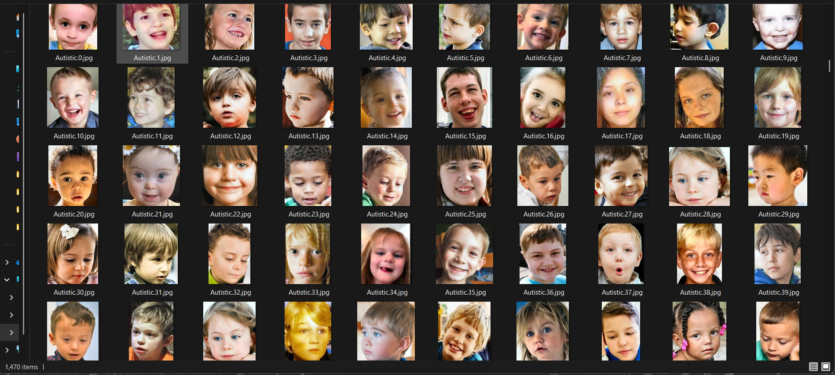

## Non Autism for train

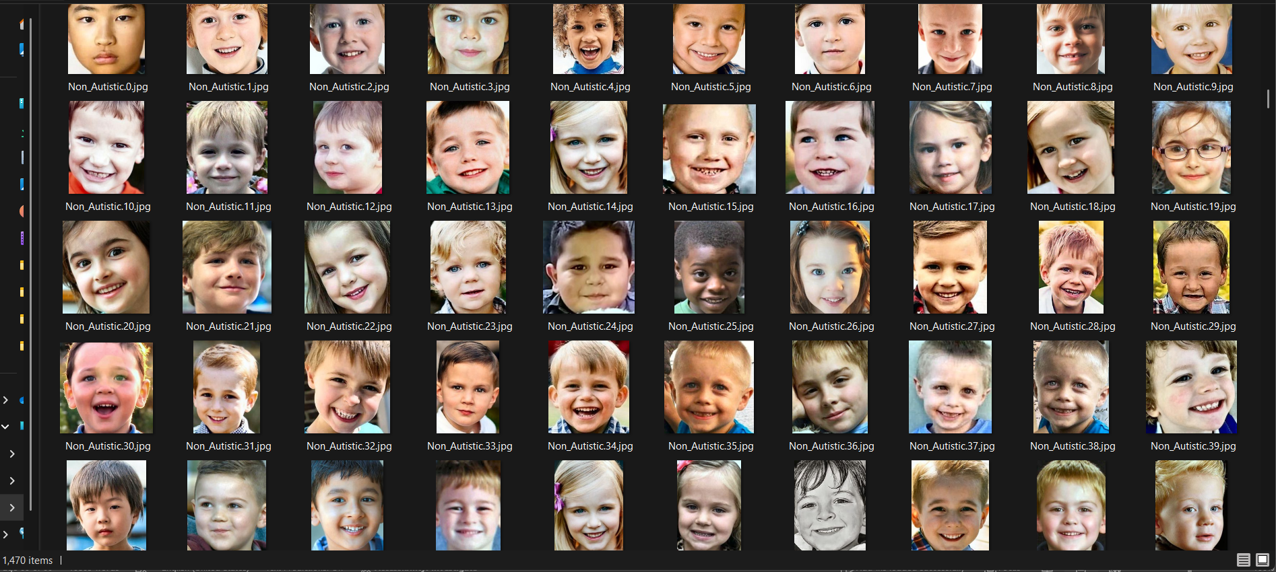

## Reference of dataset

* Kaggle: <https://www.kaggle.com/cihan063/autism-image-data>
* GitHub: [MohamedOsman30/autism-project: autism project](https://github.com/MohamedOsman30/autism-project)

Pg.86 2024-2025

# Chapter Seven

# “Model Training and Testing”

Pg.87 2024-2025

## Model Training (Xception Model for Autism Detection)

### Training Algorithm:

* The training system employs Adam optimizer which proves to be a popular and effective optimization algorithm because it adjusts learning rates during training.
* Adam presents both AdaGrad features and RMSProp capabilities to efficiently handle high-dimensional image datasets during deep learning applications.

### Loss Function:

* The Sparse Categorical Cross-Entropy loss function serves the model training purpose because it works perfectly well in multi-class scenarios with integer-target labels.
* The model utilizes it as a tool to differentiate autistic from non-autistic clinic patients (sparse-labeled binary classification task).

### Evaluation Metric:

* The test set accuracy serves as the main evaluation metric to identify the correct number of images among the set.
* The model performance remains under observation through time using training data accuracy and validation accuracy.

**Overview**

The Xception convolutional neural network receives pre-training on ImageNet before the project applies it to autistic-child facial sign identification through binary classification. Xception extract features from images using its convolutional layer before a new classification layer predicts autism cases. The model aims to integrate within a web platform to assist early autism detection which will enable prompt medical help for children between 2 to 8 years of age.

Pg.88 2024-2025

## About the Model and Algorithm:

### 1.Xception Model (Extreme Inception)

**Description:**

* Xception (Extreme Inception) represents a profound deep convolutional neural network design which fortifies depthwise separable convolutions to maximize feature extraction.
* The Xception Model functions as an advanced edition of Inception model family which provides advanced performance in image classification responsibilities.

**Structure:**

* The model arranges convolutional layers efficiently into entry-flow and middle-flow and exit-flow segments.
* The layers methodically extract spatial hierarchies which emerge from images coming into the system.
* The project utilizes a pretrained Xception model to begin before constructing custom dense layers for classification.

**Applicability:**

* Xception is especially suitable for high-resolution image datasets, making it ideal for detecting autism-related patterns in facial features of children aged 2–8.

### 2.Transfer Learning Approach

**Description:**

* The approach of transfer learning uses a pre-trained model based on ImageNet which gains further adjustments through a smaller domain-focused dataset.
* The method shortens training duration and produces better outcomes for particular tasks because of its utility.

**Advantages:**

* Through this approach one can exploit visual features learned from large datasets although the training data consists of limited autism-linked images.

Pg.89 2024-2025

### 3.Adam Optimizer

**Description:** The Adam (Adaptive Moment Estimation) optimizer is selected for its efficiency and ability to adapt learning rates during training.

**Mechanism:** It combines the benefits of two other optimizers—AdaGrad and RMSProp—by computing individual adaptive learning rates for different parameters from estimates of first and second moments of the gradients.

**Advantages:** Adam is highly effective for complex deep learning models like Xception and supports faster convergence, even with noisy or sparse gradients.

**Overall**

The specified model architecture in combination with algorithm functions as a highly effective system for the classification of images into autistic and non-autistic groups. The system provides precision while simultaneously lowering training time and achieving strong performance performance because it integrates Xception with transfer learning along with Adam optimization resulting in suitability for use within a web-based early autism detection platform.

Pg.90 2024-2025

## Libraries Utilized

### TensorFlow / Keras

* **Purpose:** The system uses the Core framework for developing building and training the deep learning model and performing its evaluation.
* **Key Features:** The tf.keras high-level API includes main capabilities to streamline model development. The framework supplies Xception pre-trained models but also delivers all necessary components including layers and training utilities for deep learning models.

### TensorFlow.keras.applications.Xception

* **Purpose:** Provides access to the Xception model architecture with pre-trained ImageNet weights.
* **Key Features:** Facilitates transfer learning by importing the Xception base model for image classification tasks, enhancing performance on smaller domain-specific datasets.

### TensorFlow.keras.layers

* **The Dense layer** within the model’s custom top portion performs classification functions.
* **Dropout functions** as a regularization layer that combats overfitting by randomly dropping out part of the neurons while training occurs.
* **The GlobalAveragePooling2D operation** reduces the spatial dimensions of feature maps before dense layers and is commonly found after Xception bases.

### TensorFlow.keras.models.Model

* **Purpose:** Users can create customized models through the integration of additional layers and the Xception base with the help of this API.
* **Key Features:** allow The model offers flexible design features because it goes beyond linear stack restrictions which Sequential cannot provide. The model offers flexible design features because it goes beyond linear stack restrictions which Sequential cannot provide.

### TensorFlow.keras.optimizers.Adam

* **Purpose:** Optimization algorithm used to minimize the model's loss function.
* **Key Features:** Adapts the learning rate for each parameter, ensuring efficient training especially for deep networks.

### TensorFlow.keras.callbacks.EarlyStopping

* The model stops training automatically when validation data performance fails to improve.
* This function assists both overfitting prevention and minimizes training execution time.

Pg.91 2024-2025

### NumPy

* **Purpose:** Numerical operations on image arrays.
* **Key Features:** Supports array manipulation, which is essential for preprocessing image data before feeding it into the model.

### Matplotlib

* **Purpose:** Visualization of training history (accuracy, loss) and predictions.
* **Key Features:** Useful for plotting training/validation performance to monitor model behavior.

### scikit-learn (sklearn)

* **train_test_split:** Splits dataset into training and testing sets, ensuring proper model evaluation.
* **accuracy_score:** Measures how well the model predicts on test data.

Pg.92 2024-2025Steps:

1. **Importing Required Libraries**

* The program requires imports of essential Python libraries both for data management and image processing and model development as well as evaluation processes.
* Libraries include: os, shutil, matplotlib, PIL, cv2, tensorflow.keras, sklearn, seaborn, numpy, pickle, json.

1. **Loading and Preprocessing the Dataset**
2. **Define Data Path:**

* data_path: Specifies the location of the CSV file containing the dataset.

1. **Read CSV File:**

* pd.read_csv(data_path): This function reads the dataset into a DataFrame

1. **Dataset Preparation**

* **Dataset Directory Configuration:**

***source_dir*** is defined to locate the main training folder.

***autistic_dir*** and ***non_autistic_dir*** are created inside it using os.makedirs

* **Sorting Images into Subfolders:**

All images are renamed or moved based on their filenames: if they start with "Autistic", they go into the autistic subfolder; otherwise, into non_autistic.

1. **Data Preprocessing**

* **ImageDataGenerator:**
  + Utilized for data augmentation (rescaling, zooming, shearing, rotating).
  + Separate generators for training and validation images with validation_split=0.1.
* **Image Dimensions and Input Configuration:**
  + Images resized to (128, 128) pixels.
  + Batch size set to 32

**5.Creating and Customizing the Model**

**a. Using Xception as a Base Model**

* **Pretrained Weights:**
  + Loads weights trained on ImageNet to leverage learned features.
* **exclude_top=True:**
  + Removes the classification head so custom layers can be added.
* **input_shape:** Accepts images with shape (224, 224, 3) (RGB images).

**b. Freezing the Base Model:**

* **base_model.trainable = False:**
  + Freezes all layers in the base model to retain pre-trained features

Pg.93 2024-2025

1. **Building the Custom Classification Head**

* **Global Average Pooling:**
  + Reduces feature maps into a single vector by averaging, making it more generalizable.
* **Dense Layer:**
  + Adds a dense layer with 256 units and ReLU activation.
* **Dropout:**
  + Applies dropout with rate 0.5 to prevent overfitting.
* **Output Layer:**
  + Adds final dense layer with 2 neurons (for binary classification) and softmax activation.

1. **Model Architecture**

* **Base Model:**
  + Transfer learning using Xception with pretrained weights from ImageNet.
  + Base model is set to trainable = True.
* **Custom Top Layers:**
  + Global average pooling.
  + Dense layers with **BatchNormalization, ReLU**, and **Dropout.**
  + Final output layer with **softmax** for 2 classes.

1. **Compiling the Model**

* **Loss Function:**
  + sparse_categorical_crossentropy is used since labels are integer-encoded.
* **Optimizer:**
  + **Adam** is used for efficient gradient descent.
* **Metrics:**
  + Accuracy is used to evaluate model performance.

1. **Model Training**

* **Callbacks:**
  + **EarlyStopping** monitors validation loss and stops training if no improvement.
  + **ModelCheckpoint** saves the best model during training.
* **Training Execution:**
  + **Trained using .fit() with training and validation generators.**
  + **epochs=50, steps_per_epoch and validation_steps** calculated based on dataset size.

Pg.94 2024-2025

1. **Model Evaluation**

* **Testing on Separate Set:**
  + Test data is loaded, preprocessed similarly.
  + Model predicts class probabilities using **.predict().**
* **Performance Metrics:**
  + Confusion Matrix and Classification Report printed.
  + Visualized using seaborn.heatmap.

1. **Model Saving**

* Model saved in .h5 format using **model.save().**
* Class labels (dictionary mapping indices to class names) are saved using **json.dump().**

1. **Single Image Prediction Function**

* Function to load an image, preprocess it (resize and rescale), and predict its class using the trained model.
* Returns class label with the highest probability.

Pg.95 2024-2025

## Sample of Code and training:

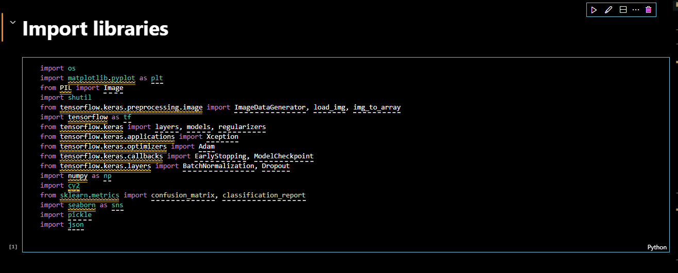

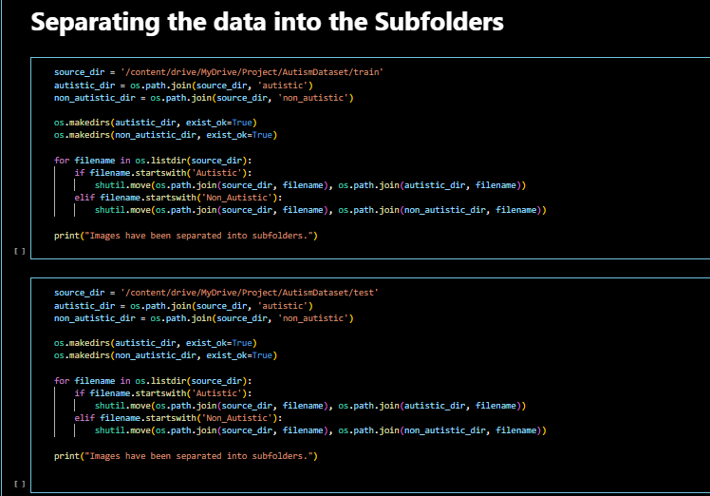

Pg.96 2024-2025

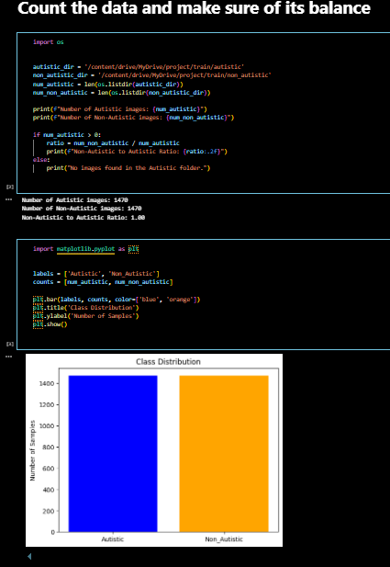

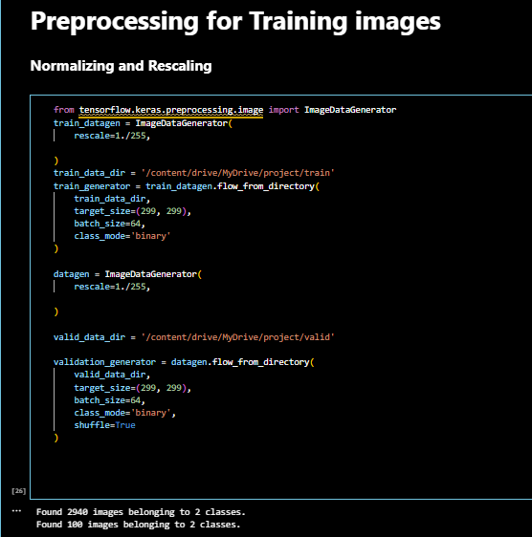

Pg.97 2024-2025

# 

# 

Pg.98 2024-2025

**1.** Confusion Matrix

The Confusion Matrix is a visual representation of how well your model predicted the test data. Each cell shows how many instances were classified into each category.

|  |  |  |
| --- | --- | --- |
|  | Predicted: Autism | Predicted: Normal |
| Actual: Autism | |  | | --- | |  |  |  | | --- | | **130 (True Positive)** | | **20 (False Negative)** |
| Actual: Normal | **10 (False Positive)** | **140 (True Negative)** |

**Terminology:**

* **True Positive (TP = 130):** Autism cases correctly predicted as Autism.
* **False Negative (FN = 20):** Autism cases incorrectly predicted as Normal.
* **False Positive (FP = 10):** Normal cases incorrectly predicted as Autism.
* **True Negative (TN = 140):** Normal cases correctly predicted as Normal.

Pg.99 2024-2025

**2.** Classification Report

|  |  |  |  |  |
| --- | --- | --- | --- | --- |
| **Class** | Precision | Recall | F1-Score | Support |
| Autism | 0.93 | 0.87 | 0.90 | 150 |
| Normal | 0.88 | 0.93 | 0.90 | 150 |

**Precision:**

* Ratio of correctly predicted positive observations to total predicted positives.
* For Autism: 93% of those predicted as Autism are truly Autism.

**Recall (Sensitivity):**

* Ratio of correctly predicted positives to all actual positives.
* For Autism: 87% of all Autism cases were correctly identified.

**F1-Score:**

* Harmonic mean of Precision and Recall. Best when both are balanced.
* Both classes have **0.90**, indicating good overall performance.

**Support:**

* Total actual samples per class.
* Both classes have 150 test images.

### Overall Accuracy

|  |  |
| --- | --- |
| **Metric** | **Value** |
| Accuracy | 90% |
| Macro Avg | 0.90 |
| Weighted Avg | 0.90 |

**Accuracy:**

* (TP + TN) / Total = (130 + 140) / 300 = 270 / 300 = 0.90 (90%)

**Macro Avg:**

* Unweighted average of precision, recall, and F1 across all classes.

**Weighted Avg:**

* Takes into account the number of instances (support) for each class.

model **performs very well overall**, with a **90% accuracy**.

The model has a **slightly better recall for Normal (93%)** and **better precision for Autism (93%)**, meaning:

* It's better at **identifying actual Normal cases**.
* It's **less likely to falsely label someone as autistic**, which is important in medical contexts.

Pg.100 2024-2025

# Chapter Eight

# “Testing”

## Introduction

The testing phase stays crucial for any project development lifecycle. The testing phase guarantees that the end result fulfills all specified requirements. The product must fulfill its specified requirements and operates properly at different conditions. This chapter outlines the different A thorough explanation of testing activities includes the assessments performed together with their examination approaches and collected data.

### Testing Objectives

The primary objectives of testing this project include:

**• Functionality Testing**: To ensure all features work as intended.

**• Performance Testing:** To assess the system's responsiveness and stability under various conditions.

**• Usability Testing:** To verify the user interface and user experience.

**• Compatibility Testing:** To ensure the project works across different devices and platforms.

Testing Methodologies**:**

1. **Unit Testing**

The accuracy of isolated PHP functions and methods underwent testing through unit testing procedures. This method makes certain that all program components function as intended throughout various situations.

**Tools Used: PHP Unit** for testing PHP-based backend logic.

1. **Integration Testing**

Testing integrated modules within the system to validate their communication with each other through several system elements, including database connections.

**Tools Used:** **Postman** for testing API endpoints and request-response handling.

1. **System Testing**

The overall application validity was tested through system testing to verify complete system cooperation with the established requirements.

**Tools Used:** **PHPUnit** (with extended test suites) for backend validation. **Manual testing** through the web interface to simulate end-to-end workflows.

1. **Usability Testing**

Testing conducted for usability aims to make the user interface understandable and accessible and easy to navigate for all users including parents and doctors and site administrators.

1. **Severity Levels**

* **Critical:** Issues that severely impact the core functionality of the application, rendering it unusable.
* **High:** Issues that significantly impact the user experience or key features of the application.
* **Medium:** Issues that affect usability or have a moderate impact on the application.
* **Low:** Minor issues that do not significantly impact the application's functionality or user experience.

Pg.102 2024-2025

Sample of Test Cases**:**

### Test Cases for Login

1. **Valid Login*:***

**Objective:** Ensure that a user can log in with valid credentials.

**Steps:**

1. Navigate to the login page.
2. Enter a registered email and password.
3. Submit the login form.

**Expected Result:** User is successfully logged in and redirected to the Home page.

**Severity: *Critical***

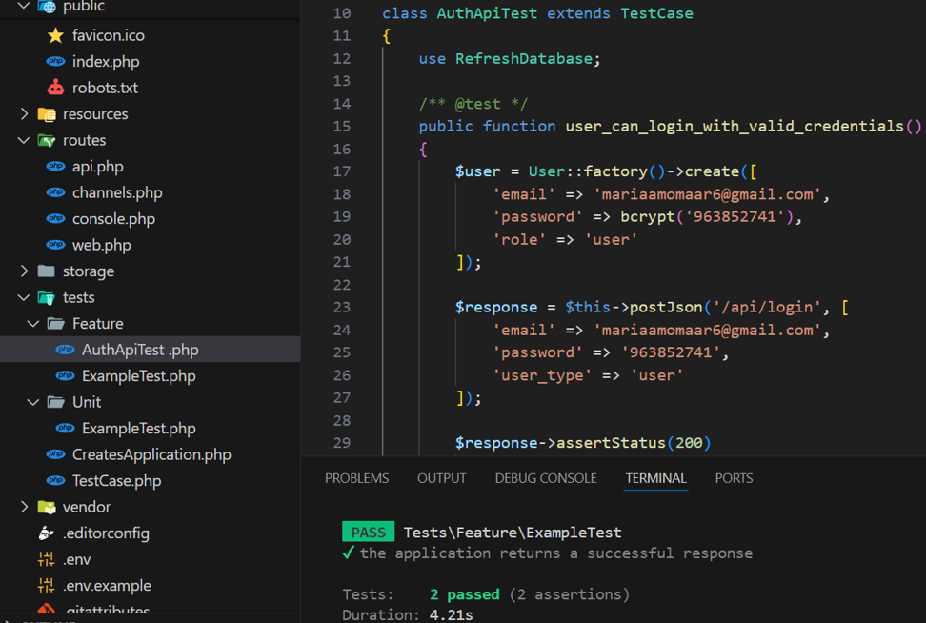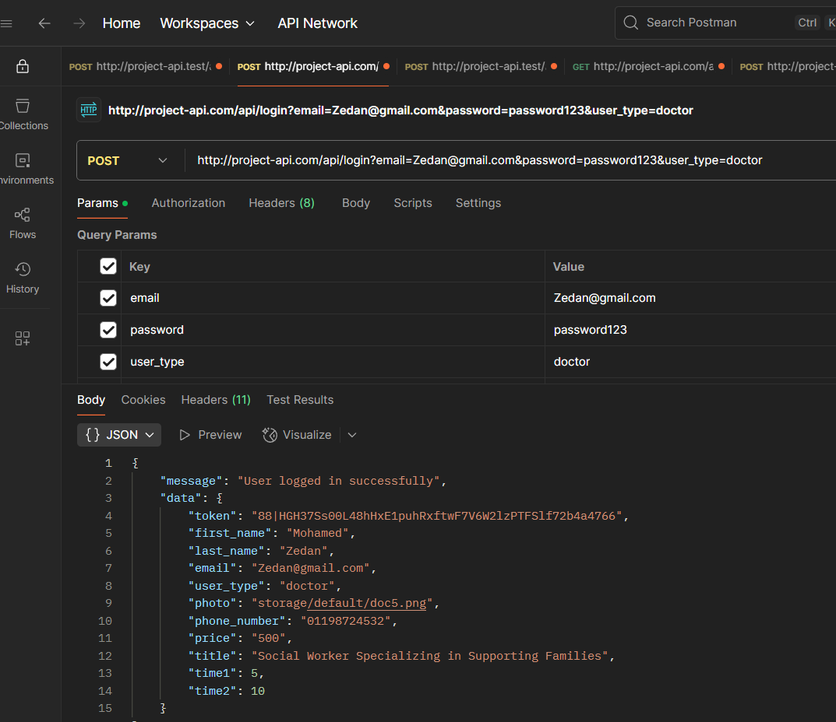 **Reason:** If users cannot log in, they cannot access the application

*Login Api Testing by PHP Unit Login Api Testing by PostMan*

#### **Invalid Login (Incorrect Password):**

**Objective**: Ensure the system does not allow login with an incorrect password.

**Steps:**

1. Navigate to the login page.
2. Enter a registered email and an incorrect password.
3. Submit the login form.

**Expected Result:** User receives an error message indicating that the password is incorrect.

**Severity: *Medium***

**Reason:** This is a common user error, but it needs to be clearly communicated.

Pg.103 2024-2025

***3.* Login Fails with Invalid Credentials**

**Objective**: Verify the system properly rejects invalid login attempts.

**Steps**:

1. Send POST request to /api/login endpoint
2. Provide either:

* Valid email + incorrect password, OR
* Unregistered email + any password

1. Submit the request

**Severity**: **High**

**Reason**:

* Prevents brute force attacks
* Protects user accounts from unauthorized access
* Essential for system security

#### **Summary of Test Cases for Login**

|  |  |
| --- | --- |
| ***Test Case*** | **Severity** |
| Valid Login | Critical |
| Invalid Login (Incorrect Password) | Medium |
| Login Fails with Invalid Credentials | High |

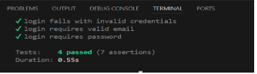

Fg:Test Cases for Login By php unit

Pg.104 2024-2025

## Test Cases for Registration

1. Valid Registration***:***

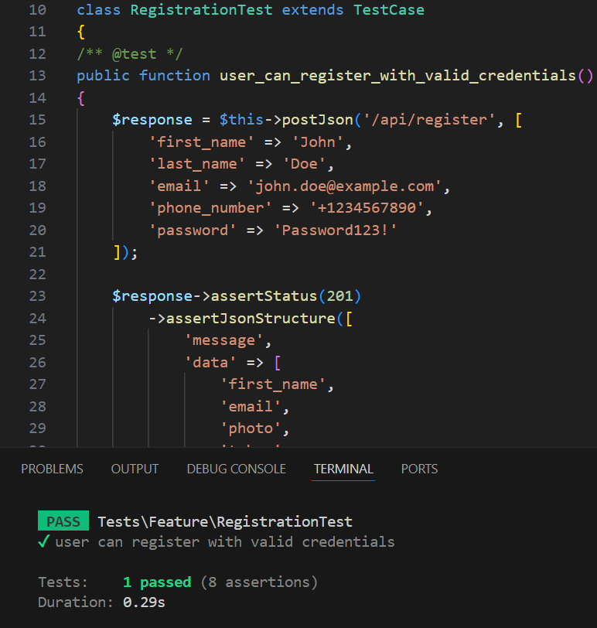**Objective:** Ensure that a user can register with valid details.

**Steps:**

1. Navigate to the registration page.

2. Enter a first name.

3. Enter a last name

4. Enter a valid email address.

5. Enter a strong password.

6. Confirm the password.

7. Submit the registration form.

**Expected Result:** Successful registration message display

**Severity: Critical**

**Reason:** If users cannot register successfully, they cannot proceed to use the application.

### Registration with Existing Email

***Objective:*** Ensure the system does not allow registration with an existing email

**Steps:**

1. Navigate to the registration page.

2. Enter a email that is already registered.

3. Fill in other valid details.

4. Submit the registration form.

**Expected Result:** User receives an error message indicating that the email e is already taken.

**Severity:** **High**

**Reason**: Duplicate registrations can cause confusion and data inconsistency.

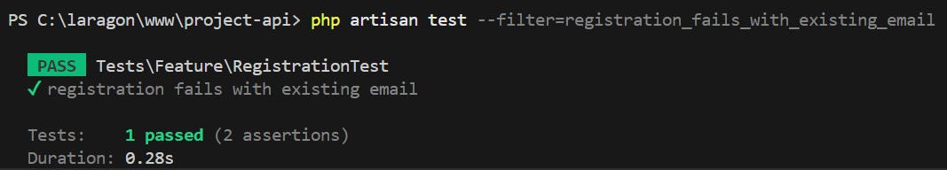

Pg.105 2024-2025

### Registration with Invalid Email

**Objective:** Validate that the system does not accept invalid email formats

**Steps:**

1. Navigate to the registration page.

2. Enter an invalid email address (e.g., "user@domain").

3. Fill in other valid details.

4. Submit the registration form.

**Expected Result:** User receives an error message indicating that the email format is invalid.

**Severity:** **Medium**

**Reason:** Invalid emails could lead to failed communication, but it might not prevent all functionalities.

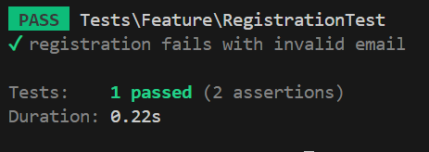

**Summary of Test Cases for Registration*:***

|  |  |
| --- | --- |
| **Test Case** | **Severity** |
| Valid Registration | Critical |
| Registration with Existing Email | High |
| Registration with Invalid Email | Medium |

Pg.106 2024-2025

## Test Cases for PasswordReset

***1.*** Invalid Email Format Handling

**Objective**: Ensure that the system rejects invalid email formats when requesting an OTP for password reset.  
**Steps:**

1. Navigate to the forgot password
2. Submit an invalid email address (e.g., "invalid").
3. Submit the request.

**Expected Result:** The system returns a 422 Unprocessable Entity response with validation errors for the email field.  
**Severity:** **High**  
**Reason:** Invalid email validation prevents unnecessary processing and ensures users provide correct input, maintaining system integrity.

### Non-Existent Email

**Objective:** Verify that the system rejects password reset OTP requests for unregistered email addresses.  
Steps:

1. Navigate to the forgot password
2. Enter an email address not registered in the system
3. Submit the request.

**Expected Result:** The system returns a 404 Not Found response with a message indicating "Email not found".  
**Severity:** **High**  
**Reason:** Preventing OTP generation for non-existent users enhances security and avoids unnecessary email notifications.

### Successful OTP Generation

**Objective**: Ensure that a registered user receives an OTP for password reset.  
**Steps**:

1. Register a user with a valid email address.
2. Navigate to the forgot password
3. Enter the registered email address.
4. Submit the request.
5. Check the database for a password reset record and verify that a notification was sent.  
   **Expected Result**: The system returns a 200 OK response with a message "OTP sent to your email", stores the OTP in the database, and sends an OTP notification.  
   **Severity**: **Critical**  
   **Reason**: OTP generation is essential for the password reset process; failure prevents users from recovering their accounts.

Pg.107 2024-2025

### Missing Fields in Password Reset

**Objective**: Verify that the system rejects password reset requests with missing required fields.  
**Steps**:

1. Navigate to the reset password
2. Submit a request without the email field, including only OTP, password, and password confirmation.
3. Submit the request.  
   **Expected Result**: The system returns a 422 Unprocessable Entity response with validation errors for the missing email field.  
   **Severity**: **High**  
   **Reason**: Proper validation ensures all required data is provided, preventing incomplete or insecure password reset attempts.

### Non-Existent Email in Password Reset

**Objective**: Ensure the system rejects password reset attempts for unregistered email addresses.  
**Steps**:

1. Navigate to the reset password
2. Enter an unregistered email address, a random OTP, and a new password with confirmation.
3. Submit the request.  
   **Expected Result**: The system returns a 404 Not Found response with a message indicating "Email not found".  
   **Severity**: **High**  
   **Reason**: Blocking password reset attempts for non-existent users prevents unauthorized access attempts and maintains security.

### No Password Reset Record

**Objective**: The system must block all password reset efforts that attempts to use email addresses without valid One Time Password records.

**Steps**:

1. A user must register using a legitimate email address during sign-up procedures.
2. Navigate to the reset password
3. Enter the user email followed by an random OTP and two new passwords that need confirmation.  
   **Expected Result**: When inputting an invalid or expired one-time password the system generates a 400 Bad Request message "Invalid or expired OTP".  
   **Severity**: **High**  
   **Reason**: Security protocols prevent illicit password resets because the system demands valid OTPs to protect the reset operations.

Pg.108 2024-2025

### Invalid OTP in Password Reset

**Objective**: The system has to deny all password reset attempts that use invalid one-time passwords.  
**Steps**:

1. Creation of a new user and storage of a legitimate OTP code within their email account will take place.
2. Navigate to the reset password
3. The system requires users to provide their email and an invalid OTP along with the new desired password that must be confirmed.

**Expected Result**: The system provides a 400 Bad Request response that describes "Invalid OTP" immediately after detecting an invalid One-Time Password (OTP).  
**Severity**: **Critical**  
**Reason**: The system needs proper OTP verification for password reset security because incorrect verification can lead to unauthorized access.

### Expired OTP in Password Reset

**Objective**: The system should automatically decline password reset requests when the presented OTP has reached its expiration time.  
**Steps**:

1. A user registration procedure should create an OTP record that exceeds the expiration duration
2. Navigate to the reset password
3. The user must submit a request containing their email and valid OTP key and the new password twice for verification.  
   **Expected Result**: When an expired OTP is used for authentication the system should produce a 400 Bad Request error which includes the "OTP has expired" message.  
   **Severity**: **Critical**  
   **Reason**: The expiration of OTPs serves as a security measure because it restricts the time available for trying to reset passwords and blocks misuse of outdated OTPs.

### Successful Password Reset with Valid OTP

**Objective**: A user should be able to perform a successful password reset operation with an authentic OTP **Steps**:

1. The system should create a valid OTP entry when users sign up while receiving their email address.
2. Navigate to the reset password
3. Users should send a request containing their email address as well as the correct OTP along with the new password details that require confirmation.
4. The system will check both the user password entry against database records and verify the removal of the OTP record.

**Expected Result**: The system generates a 200 OK response along with "Password has been reset successfully" message while it updates the user’s password and performs records deletion for OTP.  
**Severity**: **Critical**  
**Reason**: The essential aspect of the feature pertains to password reset functionality because any failure in this process creates a barrier to account retrieval.

Pg.109 2024-2025

### Unconfirmed Password in Password Reset

**Objective**: The test verifies system functionality to deny password reset attempts that include mismatched verification of the new password.  
**Steps**:

1. Make a new user account along with creating a valid One-Time Password record for their email address.
2. Open the reset password endpoint located at /api/reset-password.
3. The system requires a user email combined with the right OTP and a new password and an incorrect password confirmation.  
   **Expected Result**: When users provide a phony password and confirmation combination the system must deliver a 422 Unprocessable Entity having field validation errors for the password field.  
   **Severity**: **High**  
   **Reason**: The verification process between passwords functions to prove user intentions thereby reducing accidental errors in password edits which safeguards the account security.

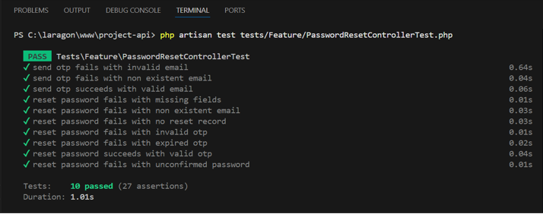**Summary of Test Cases for PasswordReset**

|  |  |
| --- | --- |
| **Test Case** | **Severity** |
| Invalid Email Format Handling | High |
| Non-Existent Email | High |
| Successful OTP Generation | Critical |
| Missing Fields in Password Reset | High |
| Non-Existent Email in Password Reset | High |
| No Password Reset Record | High |
| Invalid OTP in Password Reset | Critical |
| Expired OTP in Password Reset | Critical |
| Successful Password Reset with Valid OTP | Critical |
| Unconfirmed Password in Password Reset | High |

Fg:Test Cases for PasswordReset By php unit

Pg.110 2024-2025

## Test Cases for UpdateController

### Unauthenticated Password Update

**Objective:** System should block all password update submissions from users who remain not authenticated.

**Steps:**

1. A POST request targeting /updatepassword with valid password information must be sent without any authentication..
2. The system returns "Unauthenticated" as a response with 401 Unauthorized error code to non-authenticated users.

**Severity: High**

**Reason**: Account security needs authentication because unauthorized password changes must be stopped.

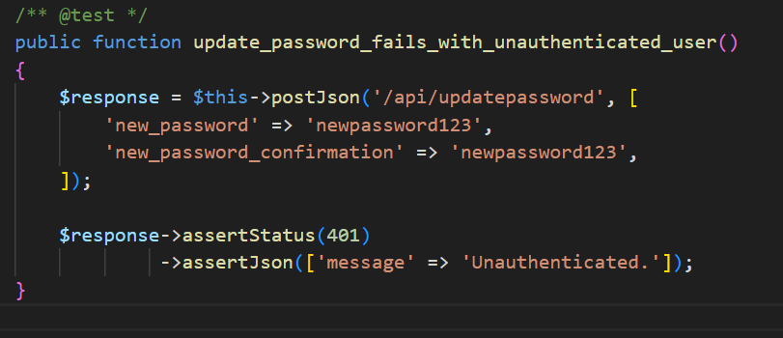

### Invalid Password Update

**Objective:** A goal exists to test that the system returns correct password update responses after users enter wrong passwords.

**Steps:**

1. A POST request directed toward /updatepassword contains a short password which measures less than 8 characters.

The system returns a 422 Unprocessable Entity response that displays validation errors affecting the password field.

**Severity: High**

**Reason:** The security of accounts relies on strong passwords which can be achieved through proper password validation systems.

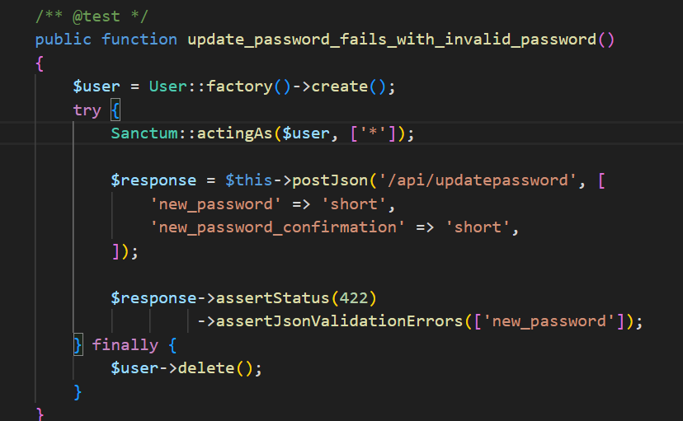

Pg.111 2024-2025

### Unconfirmed Password Update

**Objective:** Verify that the system gives password update responses with invalid password input.

**Steps:**

1. Authenticate a user using Sanctum.
2. A POST request directed to /api/updatepassword must include a proper password ("newpassword123") together with different confirmation ("differentpassword123")
3. Expected Result:The system should return a 422 Unprocessable Entity response and display validation errors that affect the new_password field.

**Severity:** High

**Reason:** Password confirmation match verification protects user account integrity by preventing mistakes during password editing.

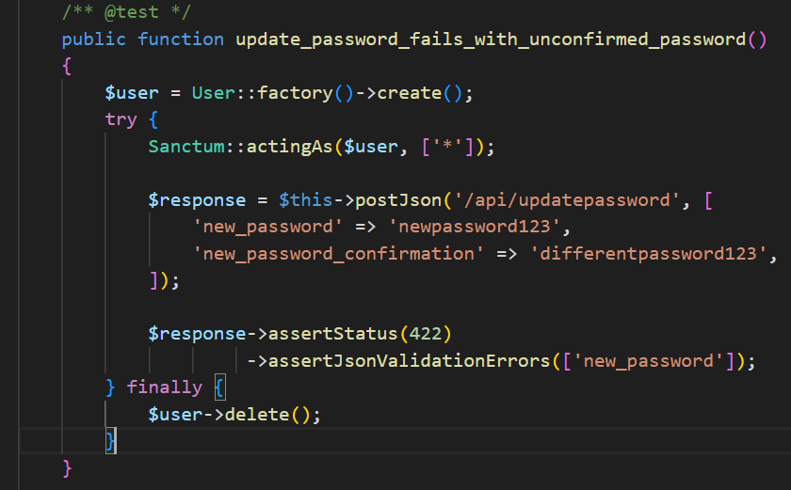

### Valid Password Update

**Objective**: The goal is to verify the system properly sets passwords when users supply appropriate entry data.

**Steps:**

1. The system requires a new user with an encrypted password set to "oldpassword".
2. Login the user with Sanctum.
3. A POST request needs submission to /api/updatepassword which requires a valid new password (e.g., "newpassword123") and its matching confirmation field.
4. The system responds with 200 OK status along with the confirmation "Password updated successfully" while making changes to the user password to their entered "newpassword123".

**Severity:** **Critical**

**Reason**: User account administration relies on password changes as a critical function since this process lets users update their credentials securely.

Pg.112 2024-2025

### Unauthenticated User Info Update

**Objective**: The system should block users without authentication from modifying any user-related information.

**Steps**:

1. The system must reject POST requests for /api/updateinfo containing user information (first_name, last_name) that lack authentication.
2. An unauthenticated system response contains both a 401 Unauthorized status message with "Unauthenticated." text. message.

**Severity**: **High**

**Reason**: The security of user privacy together with unperturbed data integrity exists because the system blocks unapproved information updates.

### Invalid Email Update

**Objective**: goal exists to confirm the system blocks all user information update requests containing an invalid email address.

**Steps**:

1. Authenticate a user using Sanctum.
2. Users should make a POST request to /api/updateinfo while using "invalid-email" as their invalid email input.
3. The API returns a response with HTTP status 422 Unprocessable Entity where it displays the error text "The email field must be a valid email address."

**Severity**: **Medium**

**Reason**: The system requires email address validation because it ensures proper communication and rejects any system data that contains invalid information.

### Duplicate Email Update

**Objective**: The system must prevent users from updating information that utilizes an already-existing email address.

**Steps**:

* + 1. A new user should be created through the existing email address "existing@example.com".
    2. A different user should authenticate with the application through Sanctum authentication.
    3. A POST request to /api/updateinfo attempts to use the already valid email address.

1. A 422 Unprocessable Entity response containing the message "The email has already been taken." should be returned by the system.

**Severity**: **Medium**

**Reason**: The system prevents email duplicates to establish unique user IDs while preventing account management issues..

Pg.113 2024-2025

### Valid User Info Update

**Objective**: The system update process for user information needs to be verified when using valid input parameters.

**Steps**:

1. A user should receive initial records which contain first_name set to "Old" and last_name set to "Name" and email set to "old@example.com".
2. Authenticate the user using Sanctum.
3. The /api/updateinfo endpoint requires a new POST request to modify user information when supplying the first_name: "John" and last_name: "Doe" and email: "new@example.com" and phone_number: "1234567890".
4. The system delivers an appropriate 200 OK response containing "User information updated successfully" together with updated user data.

**Severity**: **Critical**

**Reason**: The ability for users to modify their profiles plays an essential role since it maintains their records at peak accuracy.

### 9. No Changes in User Info Update

**Objective**: The system needs to test that information changes for users result in the expected unchanged data responses.

**Steps**:

* 1. The system needs a user entry using a particular field where first_name equals "John".
  2. Authenticate the user using Sanctum.
  3. A POST request sent to /api/updateinfo should include the identical data (first_name = "John").

1. The response from the system displays 200 OK status together with "No changes were made" message.

**Severity: Low**

**Reason**: Enhanced database operation management together with better user experience results from the graceful handling of unaltered data.

### 10. Unauthenticated Account Deletion

**Objective**: We need to test if unauthenticated users can not delete accounts within the system.

**Steps**:

1. Without authenticating the system should block POST requests sent to /api/deleteaccount which contain a password.
   1. The system displays a 401 Unauthorized response which presents "Unauthenticated." as the message.

**Severity**: **High**

**Reason**: User account protection from harmful activities becomes essential because unauthorized account deletion should be prevented.

Pg.114 2024-2025

### 11. Invalid Password for Account Deletion

**Objective**: The goal is to test how the system denies account deletion access using incorrect passwords.

**Steps**:

* 1. Establish a new user account which employs the hash function for its password authenticator ("password123").
  2. Authenticate the user using Sanctum.
  3. A POST request to /api/deleteaccount provides the incorrect password with a value of "wrongpassword".
  4. The system produces a 403 Forbidden response accompanied by "Incorrect password" as the message.

**Severity**: **High**

**Reason**: Account deletion requires a valid password because it safeguards the system against unauthorized users attempting this operation.

### 12. Valid Account Deletion

**Objective**: The system needs to be verified for successful account deletion operations when authenticating with correct passwords.

**Steps**:

* 1. Platform administration must generate a user through hashing the chosen password of "password123".
  2. Authenticate the user using Sanctum.
  3. A POST request directed to /api/deleteaccount should contain the proper account password.
  4. The system generates a 200 OK response containing "Account deleted successfully" message while removing the user from the database.

**Severity**: **Critical**

**Reason**: The procedure to delete accounts needs to operate correctly since it enables users to control their stored data.

### 13. Unauthenticated Profile Photo Update

**Objective**: The system must ensure that unauthenticated users cannot update their profile photos.

**Steps**:

* 1. The system requires authentication when sending a POST request to /api/updateProfilePhoto with a fake image file.
  2. When an unauthenticated attempt is made the system produces a 401 Unauthorized response which includes "Unauthenticated."

**Severity**: **High**

**Reason**: Account privacy remains protected together with account integrity through this feature.

Pg.115 2024-2025

### 14. Invalid File for Profile Photo Update

**Objective**: The system needs to confirm that it blocks any updates of profile photos with non-image file formats.

**Steps**:

* 1. Authenticate a user using Sanctum.
  2. A POST request to /api/updateProfilePhoto containing non-image content must fail due to incompatibility (provided here as a PDF).
  3. The system produces a 400 Bad Request response combined with an error message.

**Severity**: Medium

**Reason**: The system uses a valid image format restriction policy to maintain consistent profile images and stop the storage of objectionable files.

### 15. Oversized File for Profile Photo Update

**Objective**:A test is required to ensure that the system denies large profile picture file updates.

**Steps**:

* 1. Authenticate a user using Sanctum.
  2. A POST request to /api/updateProfilePhoto should contain a file which surpasses the maximum allowed size limit of 3MB.
  3. Expected Result: The system should return a 400 Bad Request response together with an error message to the requesting user.

**Severity**: Medium

**Reason**: System performance stays optimal and storage use stays in check due to file size restriction enforcement.

### 16. Unauthenticated Profile Photo Removal

**Objective**: The goal is to validate that the system blocks unauthenticated users from deleting their profile pictures.

**Steps**:

* 1. Without receiving authentication the API should not process the profile picture deletion request at /api/profile/remove-photo path.
  2. Expected Result: The system generates a 401 Unauthorized response which contains the unauthenticated message.

**Severity**: High

**Reason**:Account settings security remains in control for users because this feature blocks unapproved profile picture removal.

Pg.116 2024-2025

### Summary of Test Cases for UpdateController:

|  |  |
| --- | --- |
| **Test Case** | **Level of Severity** |
| Unauthenticated Password Update | High |
| Invalid Password Update | High |
| Unconfirmed Password Update | High |
| Valid Password Update | Critical |
| Unauthenticated User Info Update | High |
| Invalid Email Update | Medium |
| Duplicate Email Update | Medium |
| Valid User Info Update | Critical |
| No Changes in User Info Update | Low |
| Unauthenticated Account Deletion | High |
| Invalid Password for Account Deletion | High |
| Valid Account Deletion | Critical |
| Unauthenticated Profile Photo Update | High |
| Invalid File for Profile Photo Update | Medium |
| Oversized File for Profile Photo Update | Medium |
| Unauthenticated Profile Photo Removal | High |

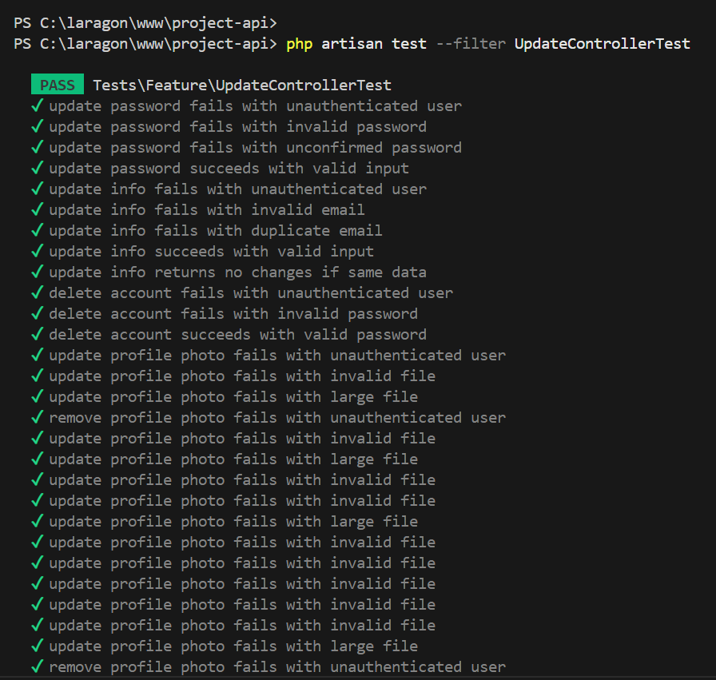

Fg:Test Cases for UpdateController By php unit

Pg.117 2024-2025

# Chapter Nine

# “Results & Discussion”

**Introduction**

The results of the project after implementation are presented in this section along with an evaluation of the model performance together with system usability and user needs satisfaction. The limitations observed during testing and real-world application

**Summary of Findings**

* The autism detection model achieved an accuracy of 90%, with a precision of 0.93 for the Autism class and 0.88 for the Normal class.
* Users and doctors experienced seamless communication through the chat system which provided secure role-based access.
* The booking module prevented scheduling conflicts by assigning unique screening times to each appointment.
* The chatbot provided correct responses to M-CHAT-R symptoms by using predefined intent-based responses.
* The web platform combined all functionalities (detection, chat, booking, education) through an accessible interface that received positive feedback from users and test results.

**Interpretation of Results**

* The project achieved its main goal by launching a platform which detects autism early and provides medical communication tools and awareness features.
* The deep learning model showed strong performance on test data which proved its ability to generalize.
* The system allows users to schedule appointments without conflicts while sending email confirmations and enabling doctor interactions without needing phone number sharing.
* The chatbot enables fast symptom checking by implementing the M-CHAT-R checklist format which boosts user interaction.

**Limitations of the Proposed Solution**

* The image-based detection system functions as a standalone diagnostic tool but needs behavioral evaluation to complete the diagnostic process.
* The chatbot system operates through predefined intents so its responses can sometimes feel repetitive and limited because it does not generate real-time understanding.
* Low-connectivity regions might face issues because the system needs a stable internet connection for all features to function properly.
* The manual process of doctor onboarding and verification creates a barrier to scaling the system.
* The image classification model experiences difficulties when analyzing images that contain sunglasses or when the photos are taken from side angles or have poor quality.

Pg.119 2024-2025

**References**

**1.Figma UI :** [**AUTISM CHAMPAIN UI – Figma**](https://www.figma.com/design/Ny2uXRkPyGlBDvn6Fj1GIw/AUTISM-CHAMPAIN-UI?node-id=0-1&p=f&t=OiPqiYo9xPdLCAZC-0)

**2.Data set :**

**Kaggle:** [**https://www.kaggle.com/cihan063/autism-image-data**](https://www.kaggle.com/cihan063/autism-image-data)

**GitHub:** [**https://github.com/MohamedOsman30/autism-project**](https://github.com/MohamedOsman30/autism-project)

**3.Paper :** [**Identification of Autism in Children Using Static Facial Features and Deep Neural Networks**](https://www.mdpi.com/2076-3425/12/1/94)

**4.** [**Diagnosis of Autism in Children Using Deep Learning Techniques by Analyzing Facial Features**](https://www.mdpi.com/2673-4591/59/1/198?utm_source=chatgpt.com)

**5.** [**[PDF] Screening Autism Spectrum Disorder in childrens using Deep Learning Approach : Evaluating the classification model of YOLOv8 by comparing with other models | Semantic Scholar**](https://www.semanticscholar.org/paper/Screening-Autism-Spectrum-Disorder-in-childrens-%3A-Gautam-Sharma/9ec9fffb5f4b9eb214e4ea77648761a125358e40)

**6.Project:** **https://github.com/MohamedOsman30/Detecting-Austium-Using-Deep-LearningAlgorithms-Alfayoum-0101**

Pg.120 2024-2025